

**COMP 3020 Project Milestone 2**

Presented to: Dr. Patrick Dubois

COMP 3020 A02, Human Computer Interaction 1, Fall 2023

By: Team 27

Nguyen, Khuc (nguye64@myumanitoba.ca)

Khangura, Jaskaranjot (khangur2@myumanitoba.ca)

Bian, Fengfan (bianf@myumanitoba.ca)

Sanyasi, Nishan (sanyasin@myumanitoba.ca)

1. **Project Direction**

Our group has decided to design a bookstore website. The website’s main purpose is to facilitate searching, sharing, rating, and purchasing of textbooks. In addition, we intend to depart from the conventional layout and infuse the website with engaging and exploratory elements.

A bookstore website holds significant value in that it makes searching and buying books more convenient. People don’t need to go to a physical bookstore and spend a lot of time searching for books or line up to buy for it anymore. They can do all the interaction online and have the books delivered to their place. Moreover, a bookstore website is also a place to explore and discover new, interesting books. Because of that, in a way, the website also serves as an advertising and explorative platform. As such, the idea of a bookstore website can provide benefit to many user groups.

We observed user interaction with the UM bookstore website during MS1. The website has done the searching function very well, especially the query by department, courses, and classes feature. However, other functions such as searching by name or book exploring received unfavorable reviews from interviewees. This has piqued our interest in revitalizing the book website as there is so much room for experimentation and improvement. Furthermore, our concept involves the redesign of the screen layout and searching mechanism, which is a challenging, yet intriguing task.

Having a well-designed bookstore website will greatly benefit the student community. It makes their searching and purchasing process more efficient and comfortable. We are committed to fulfilling the needs of students by providing robust support for finding relevant course materials, emphasizing a user-centric approach.

From our interviews, we found that there is a group of users, other than the students, who use such a website simply to explore textbooks instead of searching for one. This group includes people who are planning to attend university, parents of students who are studying in the university and so on. If a website is well-designed to support exploring, this group of users can be more well-served.

The group is excited as this is our first time designing a website for the bookstore. We have a lot of novel ideas for this topic, and we are eager to experiment with them. We also plan to replace the traditional grid and list layout with a more interactive design. We are excited to see how users will react to this change and how long it will take them to learn the new layout.

1. **Ideation**
2. **Tree like bookstore interface**

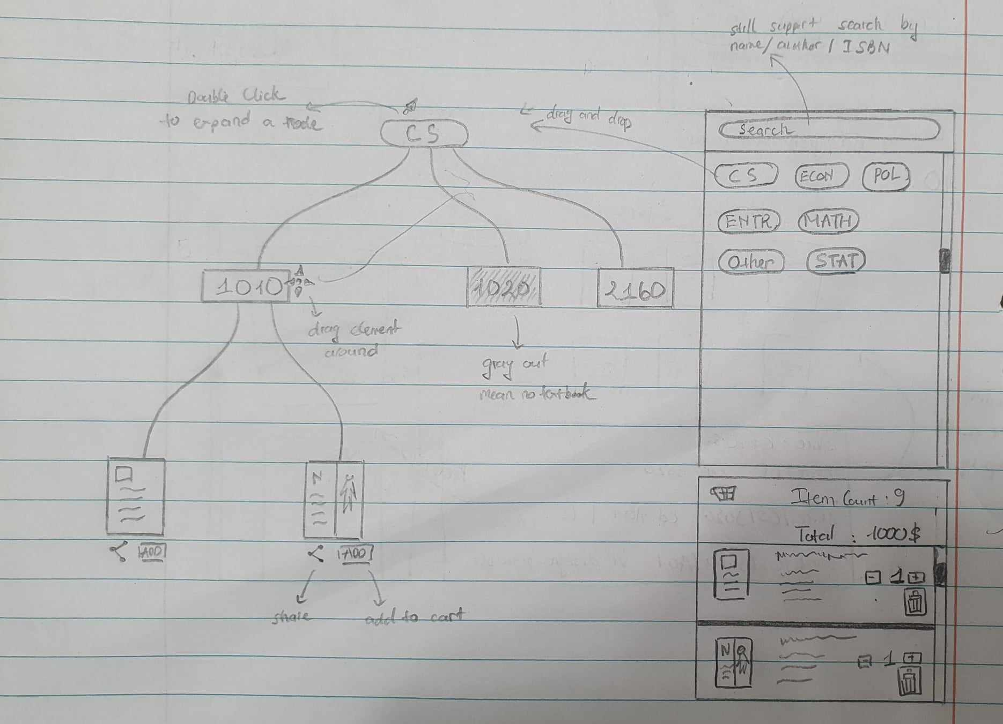

Users start searching for a textbook (or normal book) they like by dragging and dropping a root node from a panel located in the left side. They can then expand the node by double clicking it to find out what else is available under the category shown on the root node. Every node and the canvas can also be moved around. The required book can be found at the leaf node.

We like this idea because firstly, it is very intuitive to navigate and move the node around with the drag and drop system. As such, it is easy to organize the search results in a more organic format (a tree with branches). Secondly, the node and branches system make the exploring process more natural in case the user doesn’t want to find a specific book but instead tries to find out what book they like. Thirdly, by putting the search query in the form of expandable nodes, we give the user more control over how they want to construct their query.

1. **Linux bookstore**

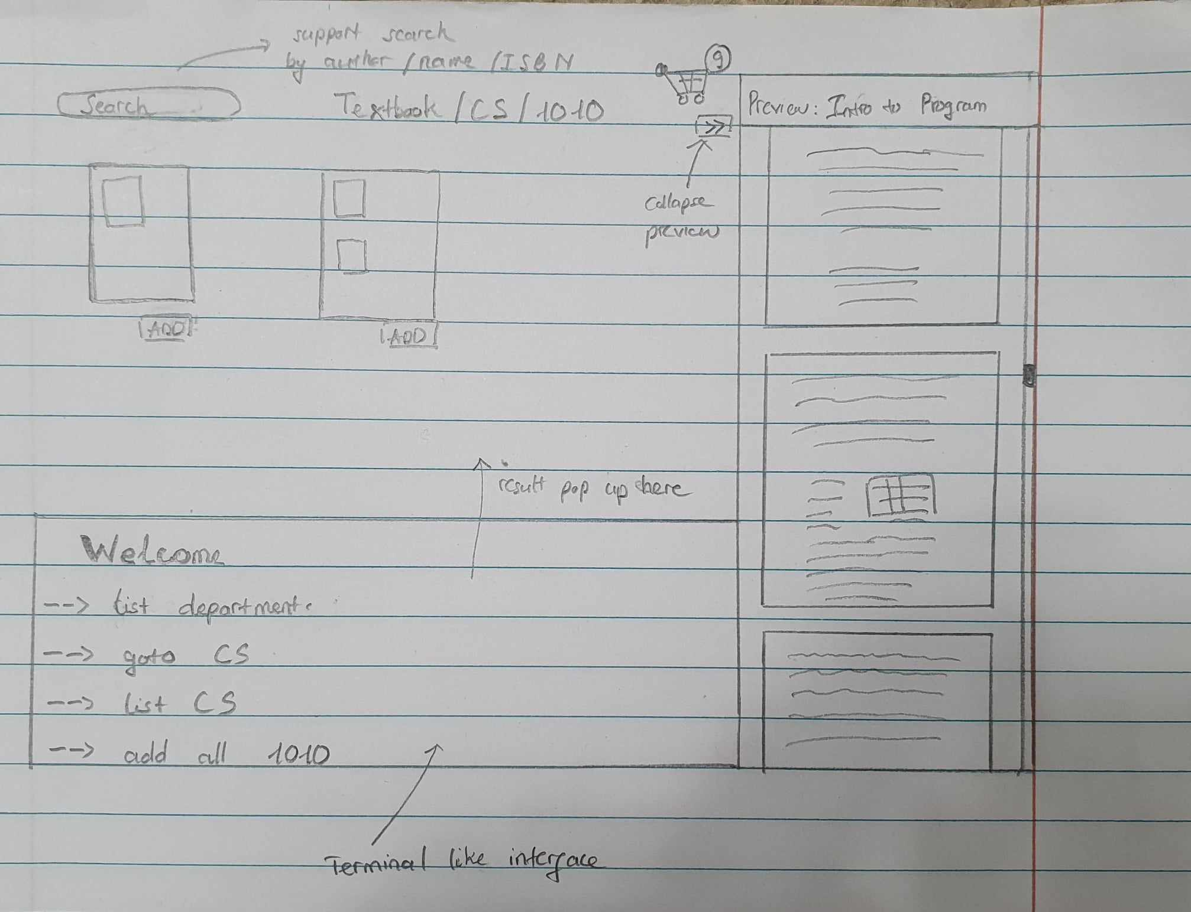

Users can go through the search bar and several buttons to find the book they want. Or they can type commands in the terminal.

The team likes this idea because it resonates with us as computer science students. For intermediate and advanced users, they can be more efficient at searching and buying books using the terminal as it gives them more functionality than the interface layout. Moreover, users feel satisfied and motivated when they type command in the terminal and result pops up as they desire (basically, feel like a hacker). Lastly, since everything can be done through the terminal, our interface doesn’t require a mouse.

1. **Search book using quote.**

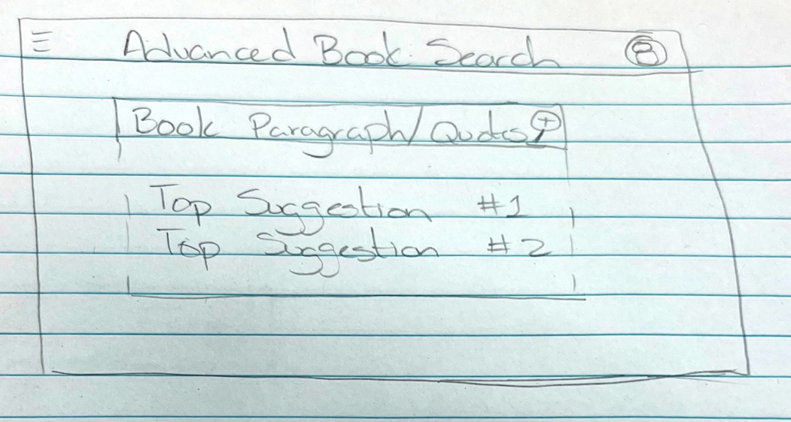

The feature of searching for a book using a quote or a sentence that is in the books is unique. This feature allows users to locate books based on the content itself, which wouldn’t be possible using a simple search. We think that this feature is especially useful when the user only remembers the content of the book and not the author or the name of it.

1. **Bookshelf**

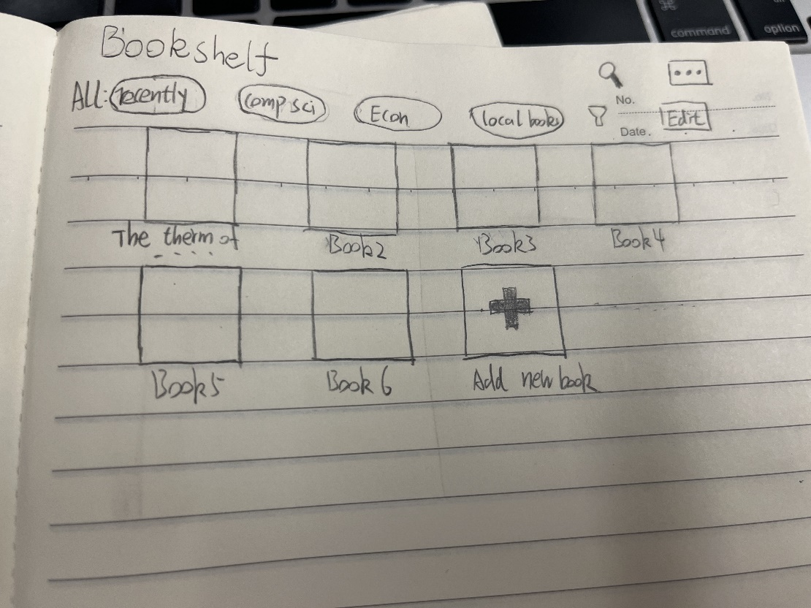

The bookshelf design facilitates the construction of a personal book list. Users can categorize their book within the bookshelf by category. This makes searching for a particular book more convenient and encourages reading. The interesting thing about the bookshelf is that it grows with the user. As the user reads and adds more books to this bookshelf, we can capture their preference.

1. **Book Social Group**

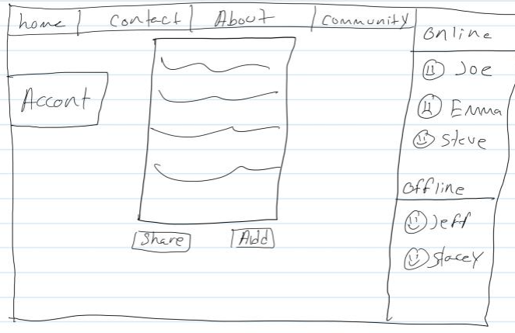The idea of a textbook store featuring social media components is unique in that it makes it easy to stay in touch with friends and create study groups. Calling and chatting features are also available to make communication more streamlined. Joining clubs devoted to a particular class or topic also speeds up finding and sharing textbooks. The addition of social aspects makes textbook shopping more interactive and group-oriented, improving the academic experience.

1. **Idea Polishing and Initial Proposal**

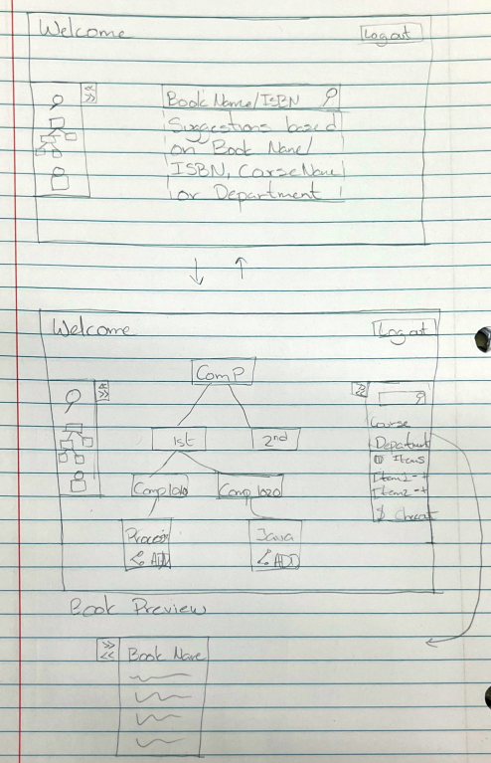

The sketch above represents our chosen idea for implementing an interactive bookstore application. We have decided to go with the tree-like bookstore interface combined with a basic search bar.

In general, the search bar allows a few different search queries, either by book name, book identification number (ISBN), course name, or department name. This feature allows users to search for specific books or narrow down the search results. As shown in the sketch, when user applies their search query, suggestion will be constructed based on what they have entered. For instance, entering “Comp” would result in Computer Science (as department), Computer Introduction (as a book name) or Computer Practice (as a course name). The main point of offering a search screen is that users can directly search or narrow down the tree structure that is displayed after the user clicks the search button to finalize their search for provided parameters. This feature shows the connectivity between two screens as search parameters from the search bar are used to create the tree structure displayed on the second screen.

The tree structure on the second screen emphasizes the concept of discoverability, allowing users to visualize the connection between textbooks and course. This structure is built upon a hierarchy of department -> year -> course -> textbook. Nodes can be moved around which help users organize their search view. Moreover, every node can be expanded and minimized freely so that users can choose what to see in their search. For nodes that can’t be expanded, they will be colored gray. The tree-based structure representing user searches is a great visual representation of what users are searching for and how it connects to their overall department/courses allowing them to explore various other options. The tree is incorporated with the ability to move nodes around as well as expand them, which helps the interaction be more intuitive and easier to learn.

The second screen also includes a variety of features like its own search bar along with the display of current items added to the shopping cart for check out. The search bar here is generalized to searching for only parent nodes of the tree the courses or departments as it's designed for exploration of the books through an interactive tree structure. Though this feature may seem as if it’s blocking the user’s action of searching for a specific book, it doesn’t block the user in any sense as they can at any time switch back to the first screen using the left-side menu to search for a specific book or extremely narrow down the search using the ISBN parameter.

The second feature included is the shopping cart, as shown on the second screen. After navigating to the specific book, the user can decide to add the book to the cart by either clicking add or drag the book to the cart, finalize the quantity, and proceed to the checkout. The cart contains a summary of the total item bought, the total price as well as a list of items added. We believe that features provided in the cart panel will help users have an easier time making purchase decisions.

Another feature that is incorporated into our design is allowing users to read a summary of a book in the right-side panel which actively contains a search bar. By clicking on a node that contains a book, a preview panel will replace the search panel (the first panel on the second screen). This preview panel contains basic information about the book, such as book name, author, and version. It also displays some of the first pages of the book so that the user can read at least the content page and be sure that they find the right book. This panel can be closed and the original panel with the search bar will show up again.

Overall, these features provide the user with the flexibility of navigating through the application and in general enhance their experience while purchasing or simply exploring books. The interactive bookstore enhances user experience by personalizing the way content is delivered as users can decide their preferred search option along with how they want to organize their search result.

1. **Low – Fidelity Horizontal Storyboards**

We create a fictional character, let’s call him Robert. Robert knows about the new UM bookstore website from a friend. This is good news as Robert wants to buy some books for his new semester. Robert’s friend gives him an account for the website. We will be documenting Robert journey through the website.

1. **Login interface story board**

When the user first visits the website, the first interaction they encounter is the login interface. This login interface is designed for easy and efficient access to the site.

1. **Existing User Login**If the user already possesses an account, they can easily log in by providing their registered email and password. Upon successful login, they will be redirected to the main page of the website, granting them full access to the platform.

Robert already has an account from his friend, so he just needs to login, the following step is taken:

* 1. Robert enters password and email and click log in or select continue as guest.

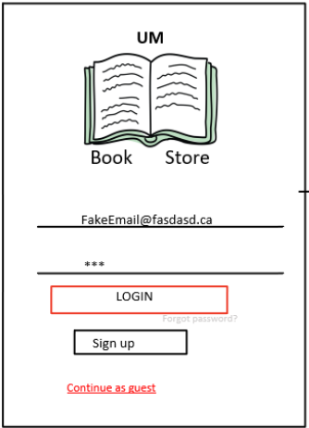

* 1. On successful login, Robert is taken to the welcome page.

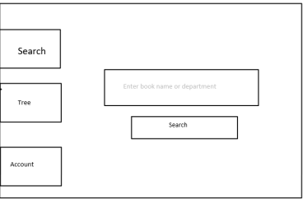

1. **Sign up.**

For users without an existing account or those seeking to sign up for the first time, there is an option to click "SIGN UP" at the bottom of the login interface. Selecting this option will direct them to the registration or sign-up page, where they can create a new account and join the platform.

Robert forgets his friend’s account, so he wants to make a new one.

* 1. Robert goes to the login page and click sign up.

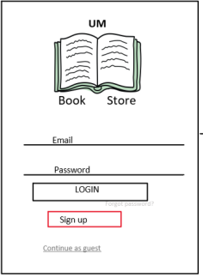

* 1. Robert is taken to the sign-up page.

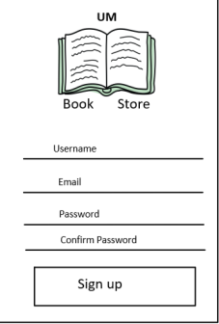

2.3 Robert in their info and click sign up.

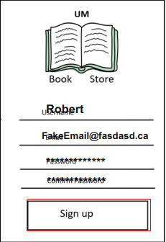

* 1. Robert successfully created a new account. He is taken to the welcome page.



1. **Continue as Guest**

In scenarios where a user prefers not to create an account or sign up, there is an alternative option to "Continue as Guest." Choosing this option will grant access to the website's main page without requiring user registration, allowing them to explore the site's content as a guest.

Robert forgot his friend’s account and his newly created account. He thinks that having an account is a hassle, so he decided to not create another one.

* 1. Robert goes to the login page and clicks ‘continue as guest’.

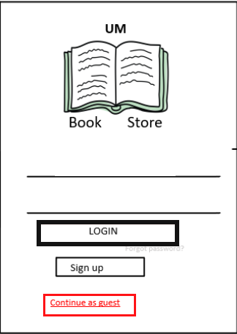

* 1. Robert successfully gets to the welcome page, as a guest account.  
     

1. **Book Tree Interface**

Upon a search for their required textbook via the main page search field, users will be directed to the Tree interface. If the user clicks the Tree button on the left of the screen without searching for a department first, the page will be blank. This interface is designed to present a structured hierarchy, guiding users from their department to the specific Year, Class, and finally, the Textbook they need. The tree interface is designed to be explorative. Users can see the connection between textbooks and their corresponding course and year level.

1**. Department View**

At the root of the tree structure, users will initially see their department. Years 1-4, representing the academic years, will be displayed as child nodes under the Department. Users at any time can drag and drop departments listed on the right side of the screen to replace the current selected department.

**2. Year Selection**

Users can click on any of the four academic years to reveal a more detailed view. Clicking a year will expand the tree to display all the classes available for that particular year.

**3. Class Selection**

Once the user selects a specific class, the interface will reveal the required.

textbooks for that class. If a class does not have a designated required textbook, it will be grayed out.

**4. Textbook Details**

At the leaf node of the tree, which represents the specific textbook, users will find detailed information about the chosen textbook. Users can add the textbook to their cart for purchase or share the textbook link to other media.

Back to our friend, Robert. He has successfully logged in (whichever method he used). Now he wants to explore some books before deciding. He decided to go straight to the Book Tree page.

1. Robert drags a COMP node out from the left panel and expand it.

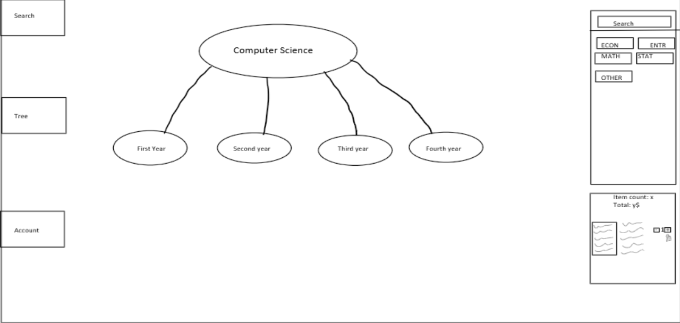

1. Robert then double-clicks on First year.

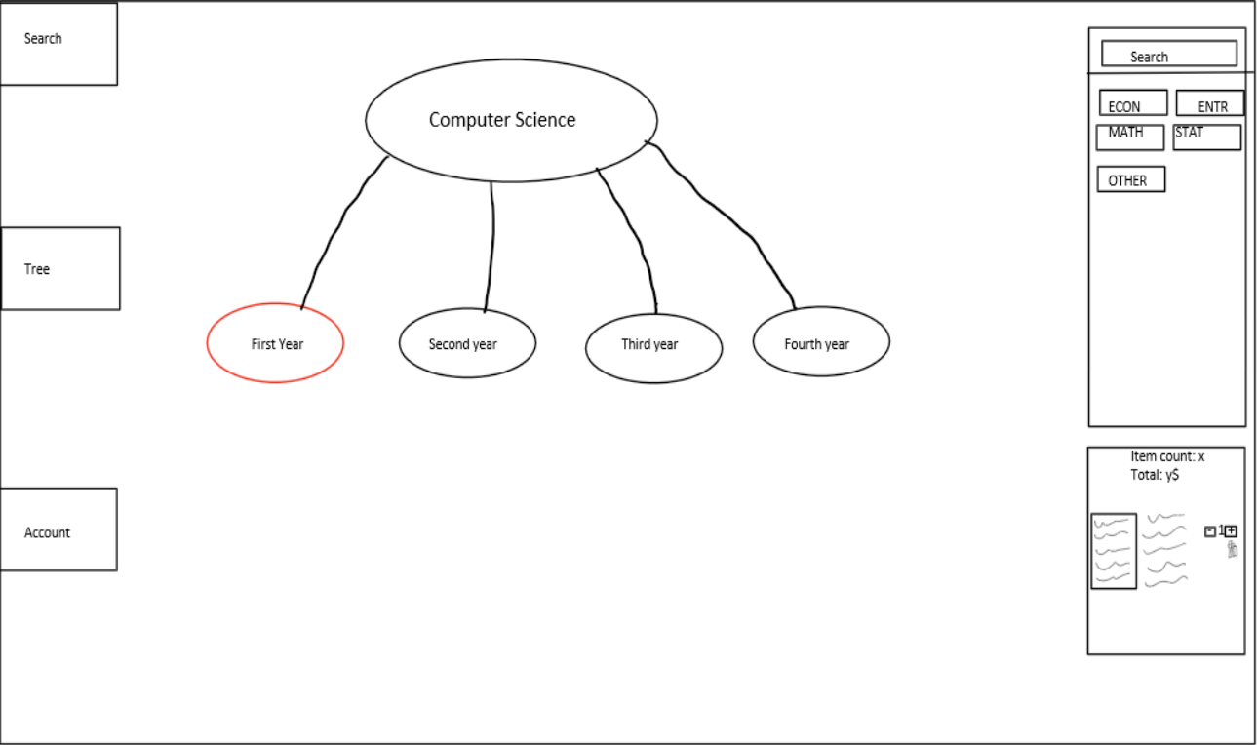

1. The first-year node expands into some courses. Robert hasn’t seen comp 1020 ever in his life so he is curious. Robert double-clicks on Comp1020.

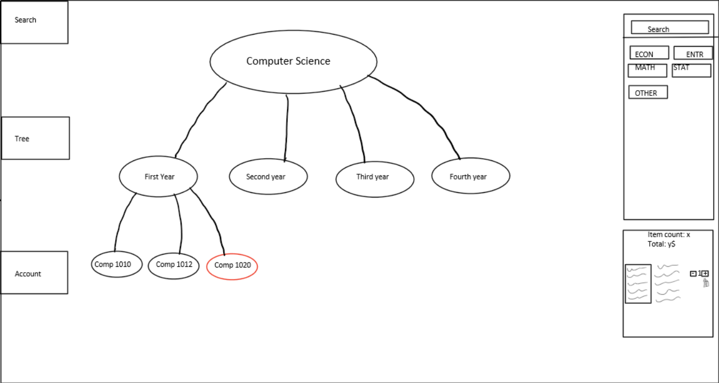

1. Robert saw the textbook Intro to CS2. He wants to know what this book is about, so he clicks on the book. The information is then shown in the left panel. Robert is satisfied with what he found now, and he feels it is fun to interact with the tree structure.

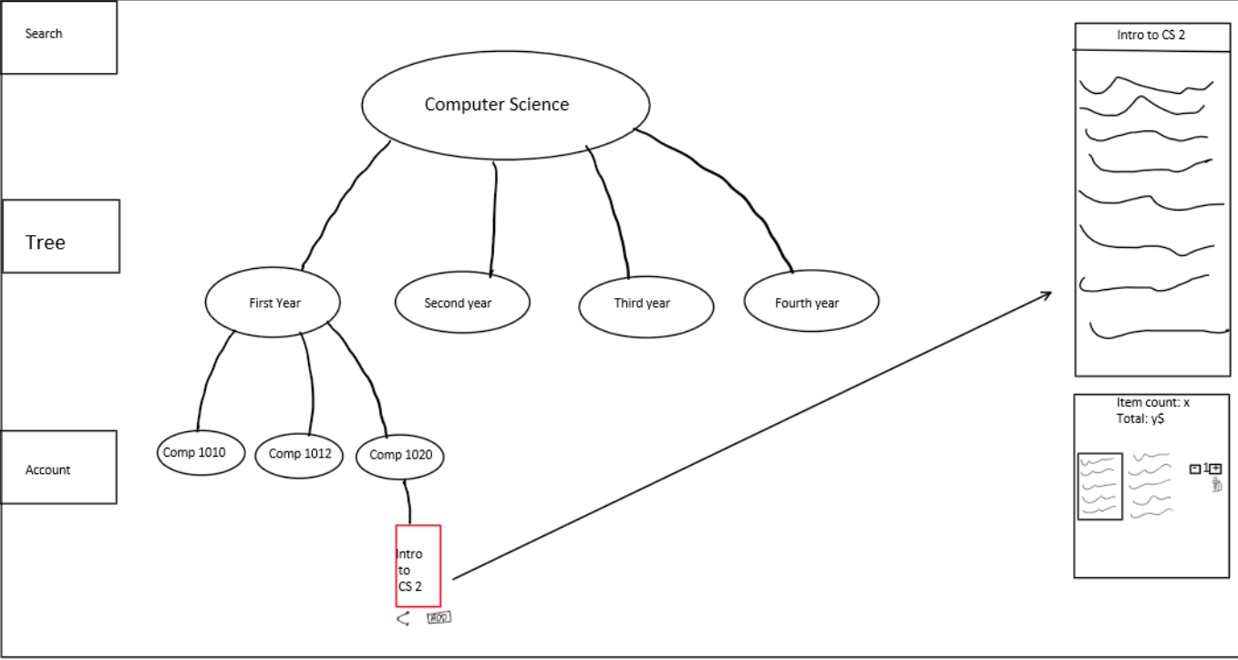

1. **Book Search**

The welcome page of the application prominently features a search bar for easy book discovery. Upon entering a search term, the system swiftly displays relevant results, guiding users to their desired books. When clicking on a result, user is guided to the Book Tree page. As explained in the previous, the Book Tree interface is designed to be more explorative. However, the query from the search result can be used to construct a Tree before hand so user can immediately see the book they want and the connection of that books with their corresponding course, year, and department.

1. Robert is now sure about what he wants after reading the syllabus. He knows the name of the book, so he doesn’t need to explore anymore.

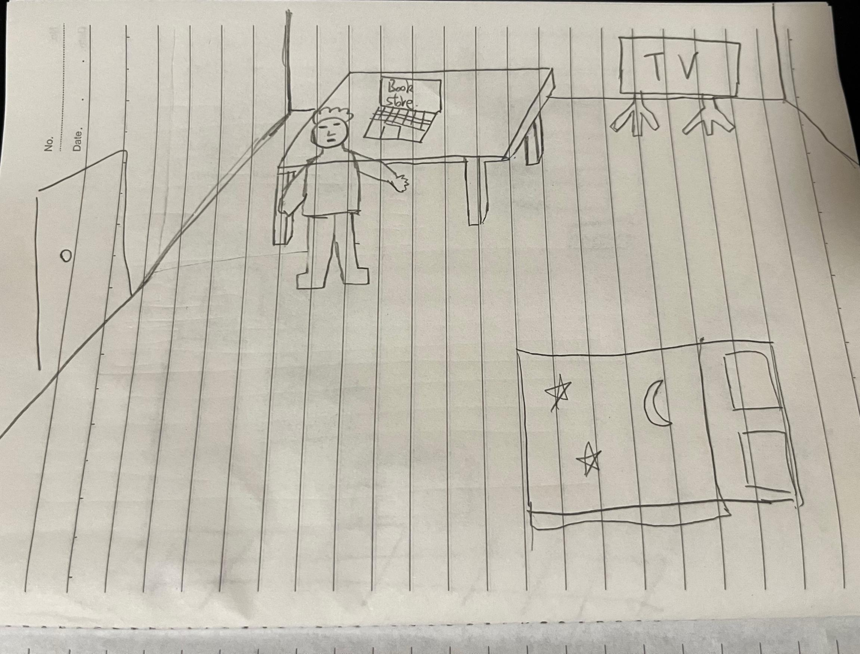

1. Robert arrives at the online bookstores’ home pages. Robert knows what he needs to do as he has experience with logging in (like, 4 pages before this)

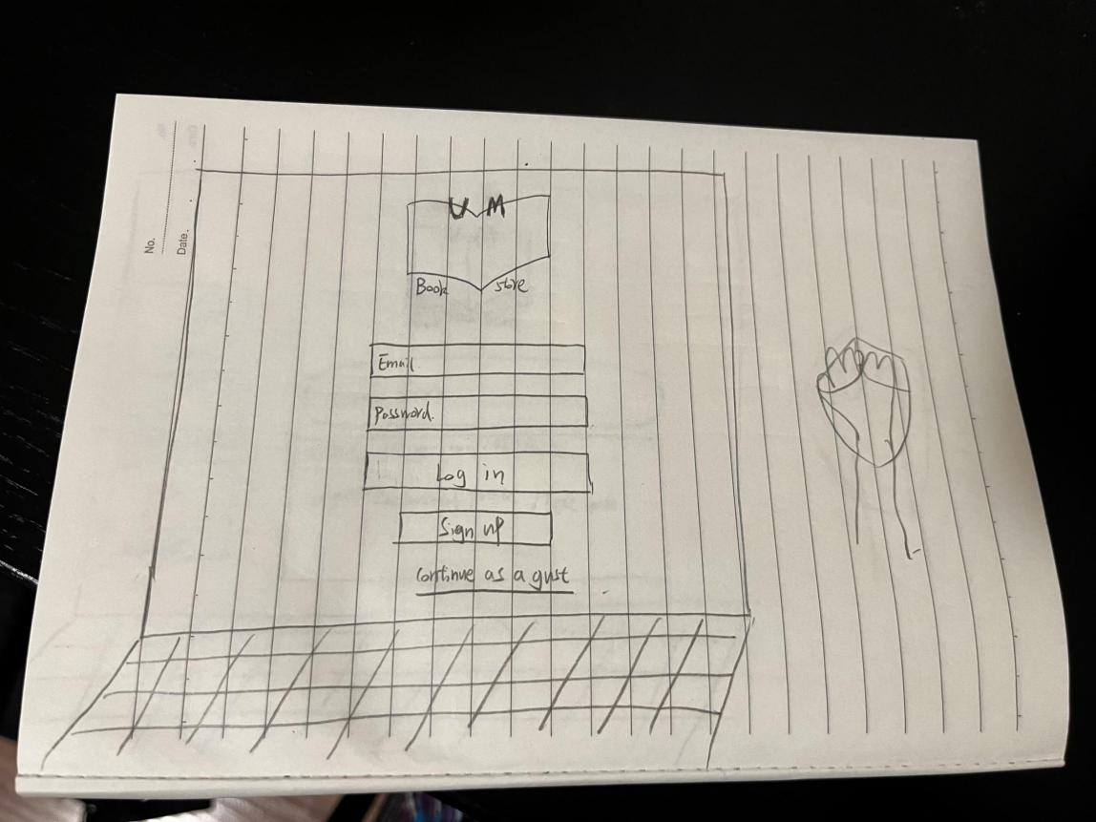

1. Robert logs into his account. The login page is straightforward, and Robert quickly inputs his credentials to access his account.

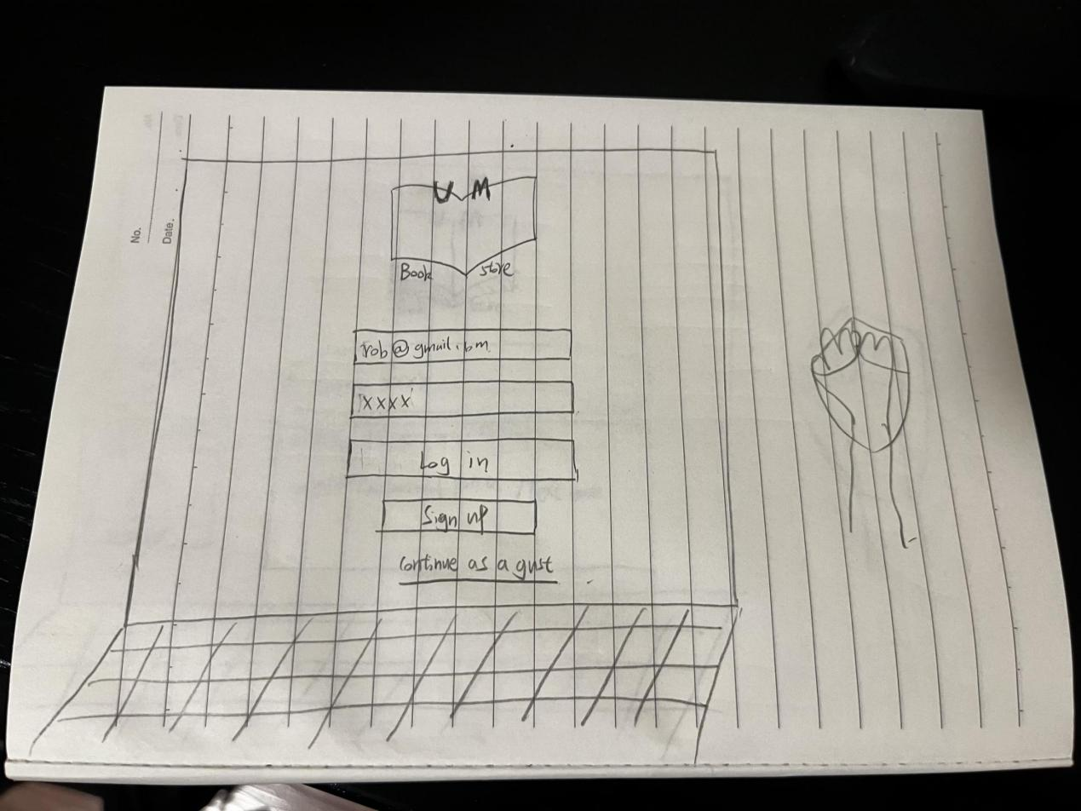

1. Robert begins his search. He knows the key works is COMP XXXX. Robert types it into the search bar, and it gives him some suggestions. Robert clicks on one of them.

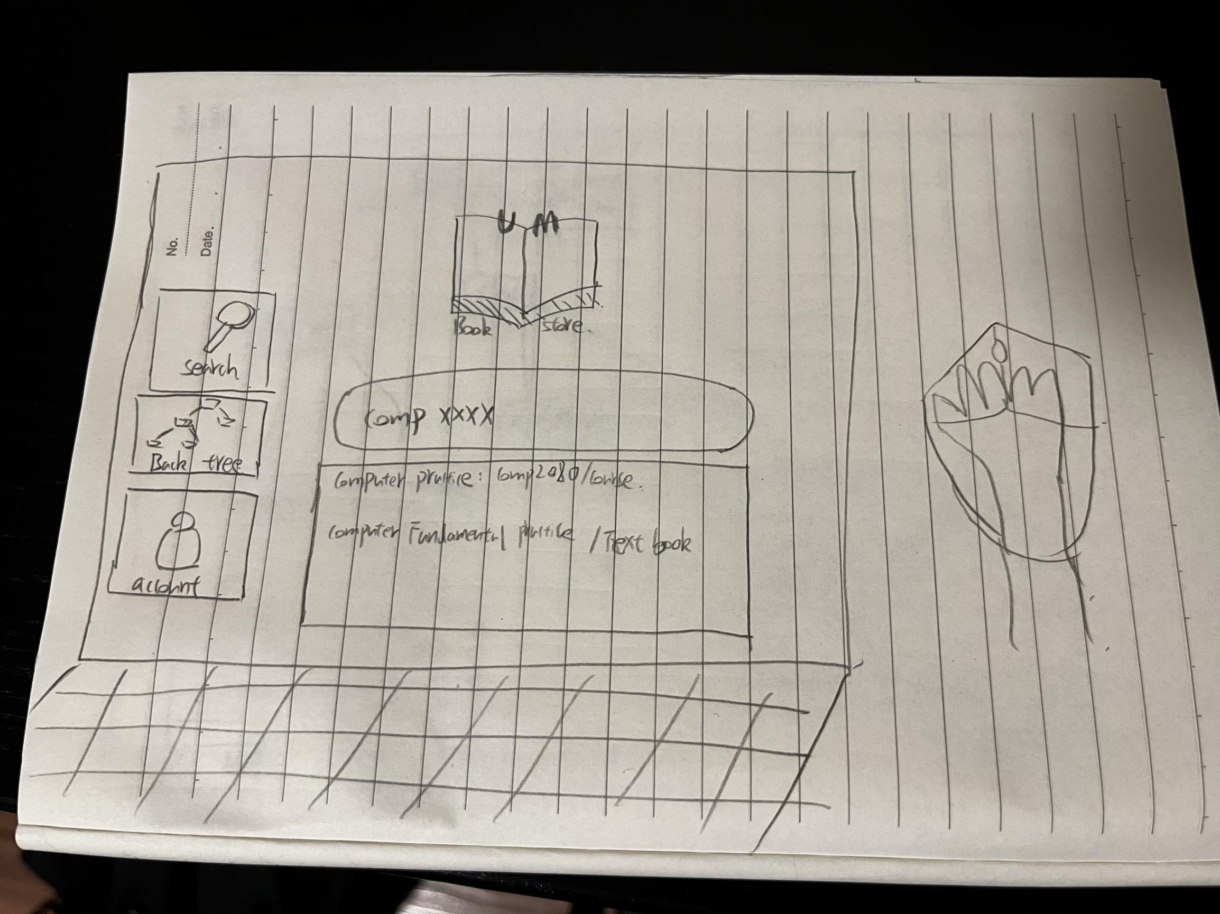

1. The website redirects Robert to the Book Tree page. A structured tree of books pops up and guide Robert to exactly the book he wants.

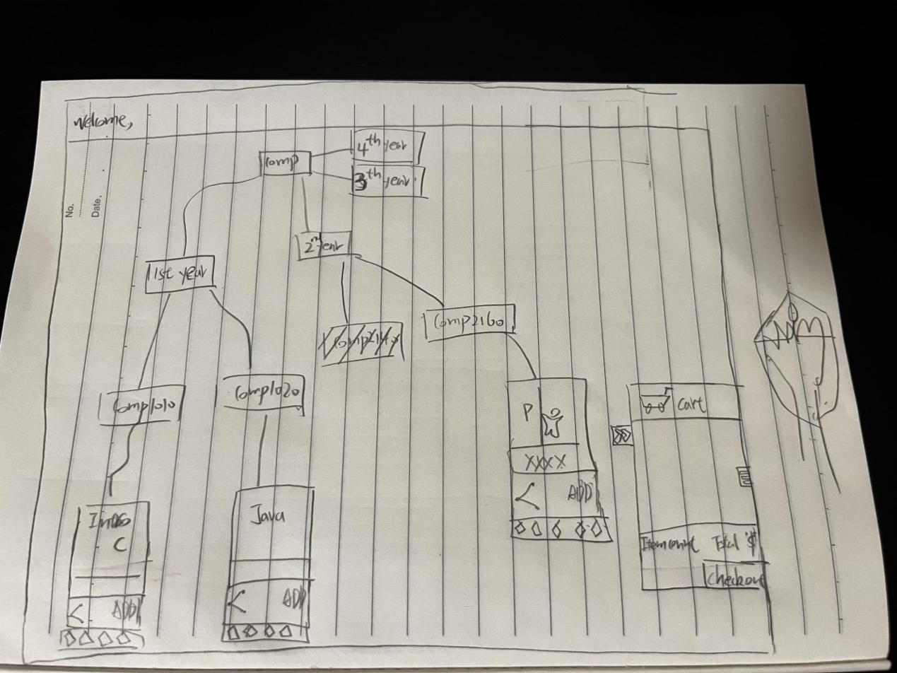

1. **Add to cart and check out.**

Upon identifying their preferred books, users can effortlessly add them to their shopping cart. Subsequently, the app navigates the users to the checkout page, summarizing the cart's contents and the total amount due. The checkout process is secure, offering multiple payment options for users to select from. Once the payment is made, confirmation of the successful transaction is provided.

1. Robert is on the Book Tree page. He wants to add the book he found in the previous section to the cart. Robert simply clicks the add button and the book seamlessly transfers to Robert’s cart.

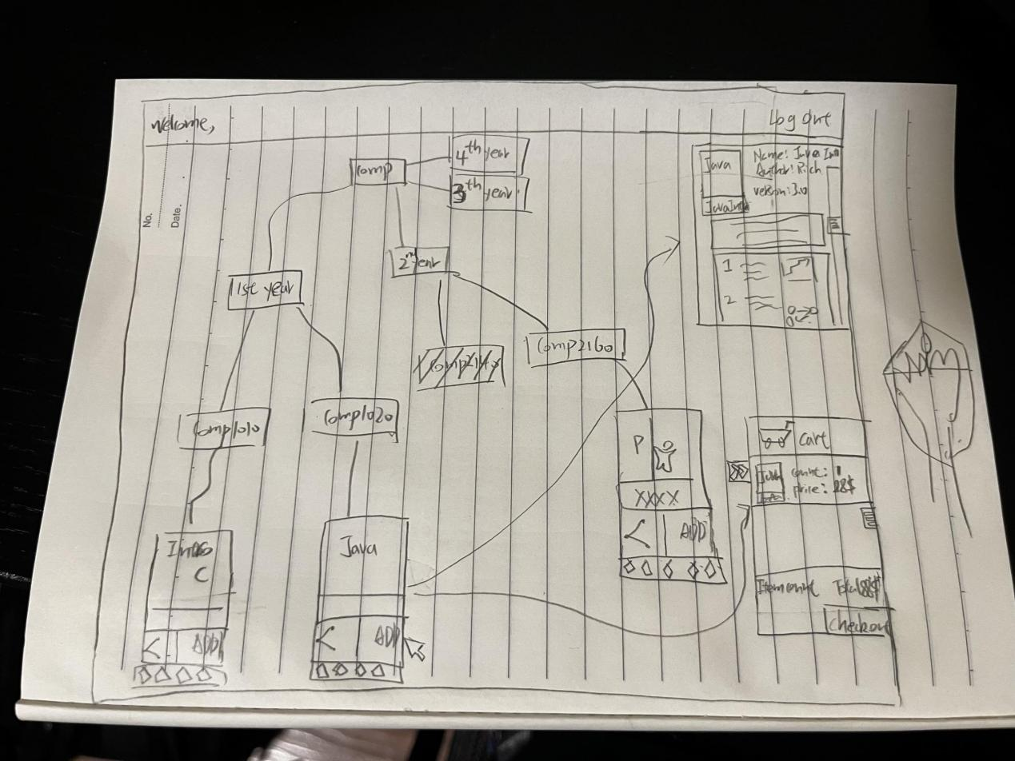

1. Robert is confident that he got the right thing. Robert clicks the check-out button on the cart.

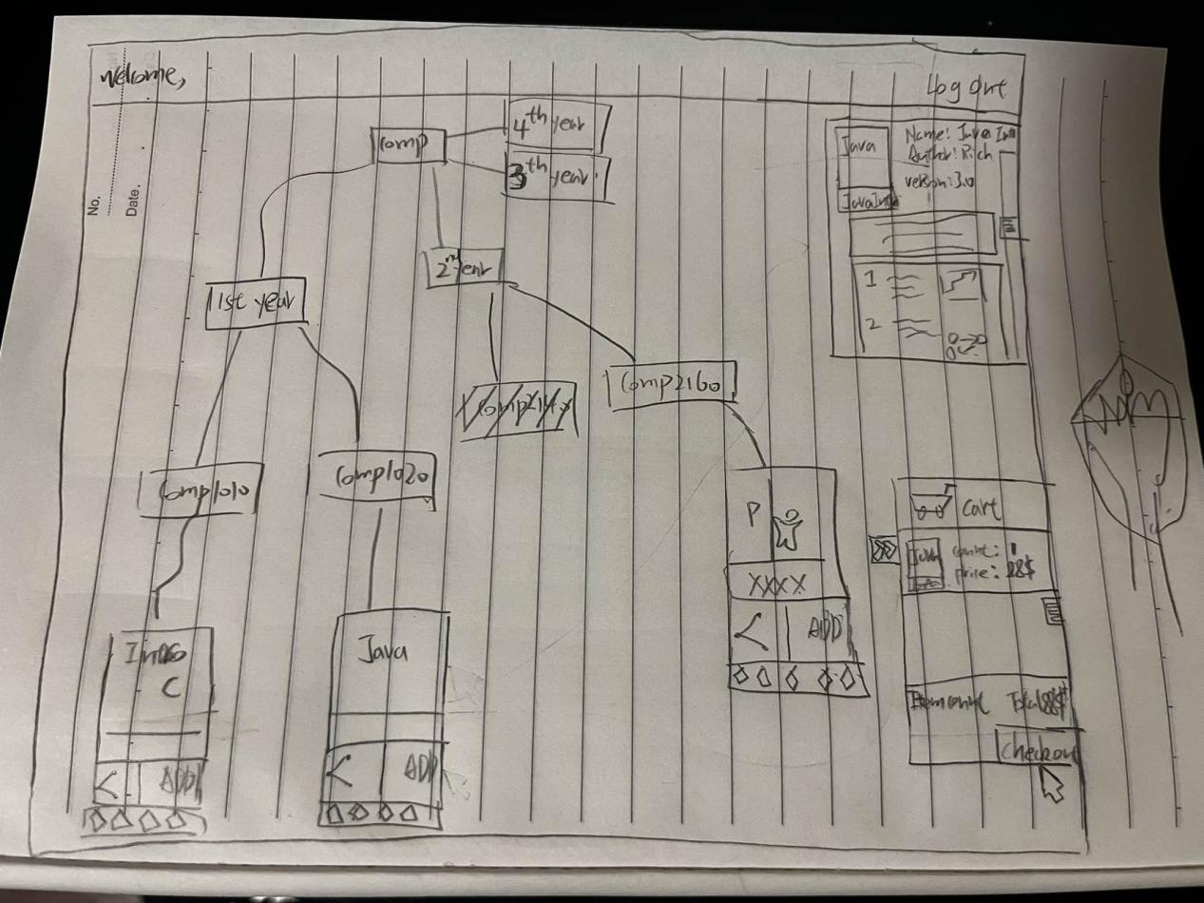

1. The check out process begins. Robert is presented with a summary of his cart, with an item count and a total. A list of what is in the cart is also displayed.

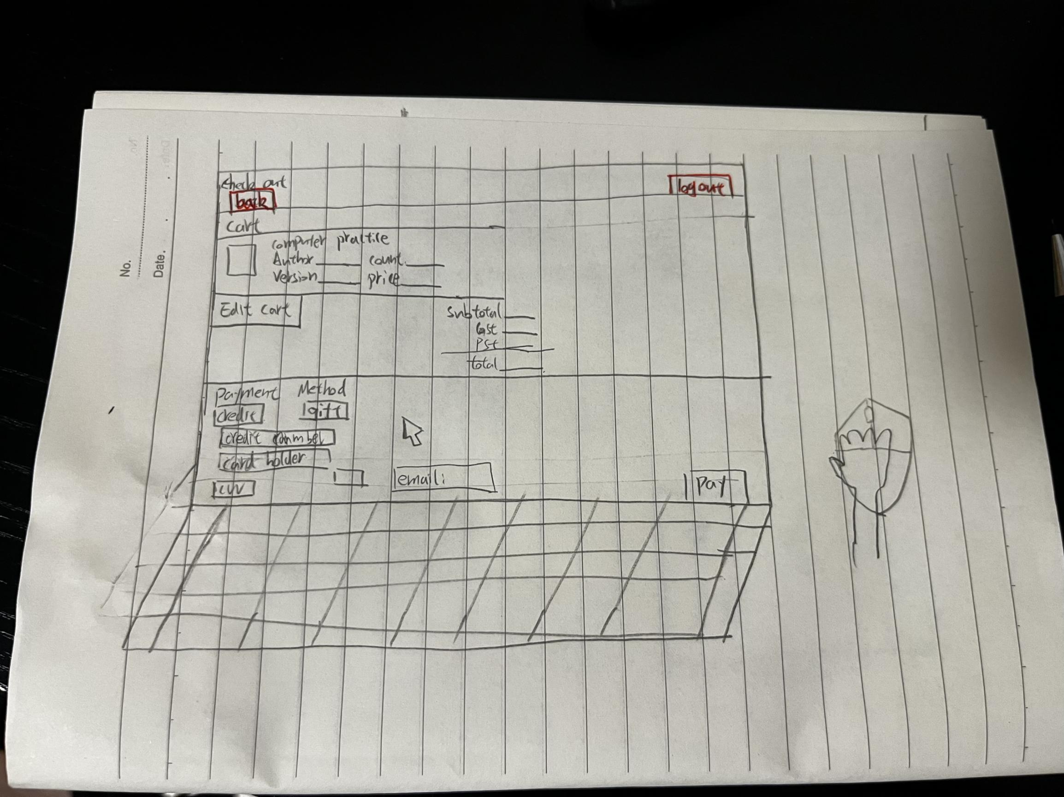

1. Robert chooses his preferred method of payment, enters the information, and confirms the purchase. Robert only needs to wait for the book to arrive. Yay!

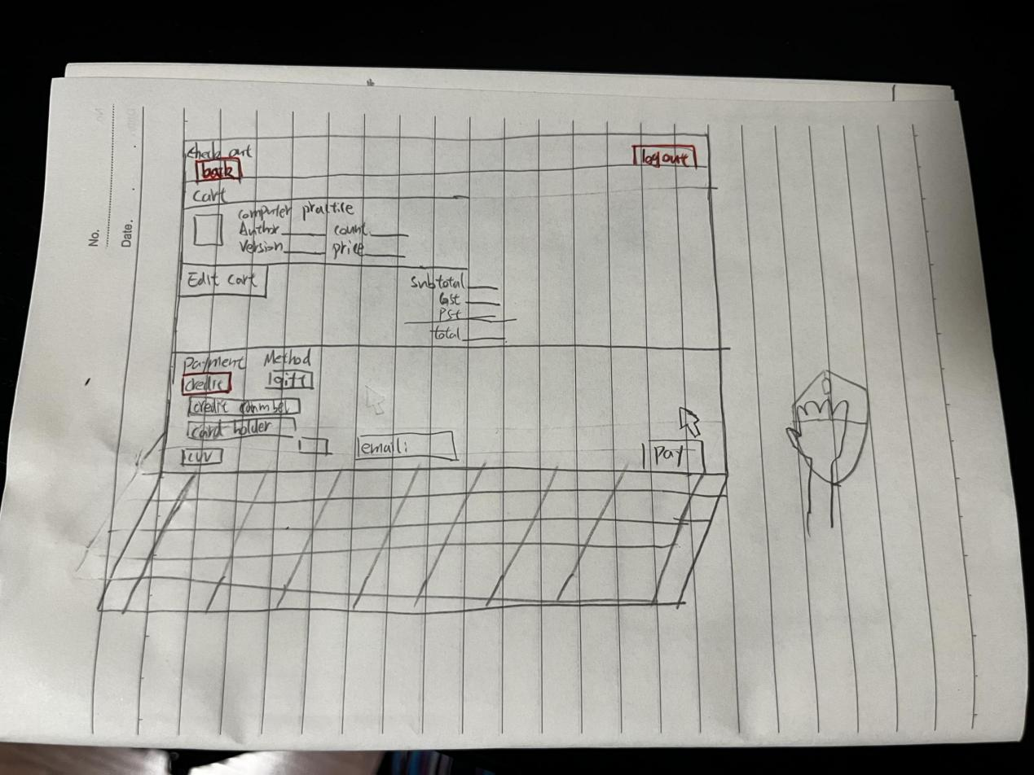

1. **Sharing and Rating:**

The website allows users to rate and share their acquisitions. Users can swiftly navigate to their personal book list, observing their purchase history and browsing records. Additionally, the website includes a sharing feature, enabling users to recommend their favorite books to friends.

Jack asks Robert if he likes the book he bought on the website. Robert goes to the website and promises that he will give a rating and share it with Jack.

1. Robert's return to the website. Upon revisiting the website, Rob is automatically directed to the search screen. Robert clicks on the Account button to access his personal book list.

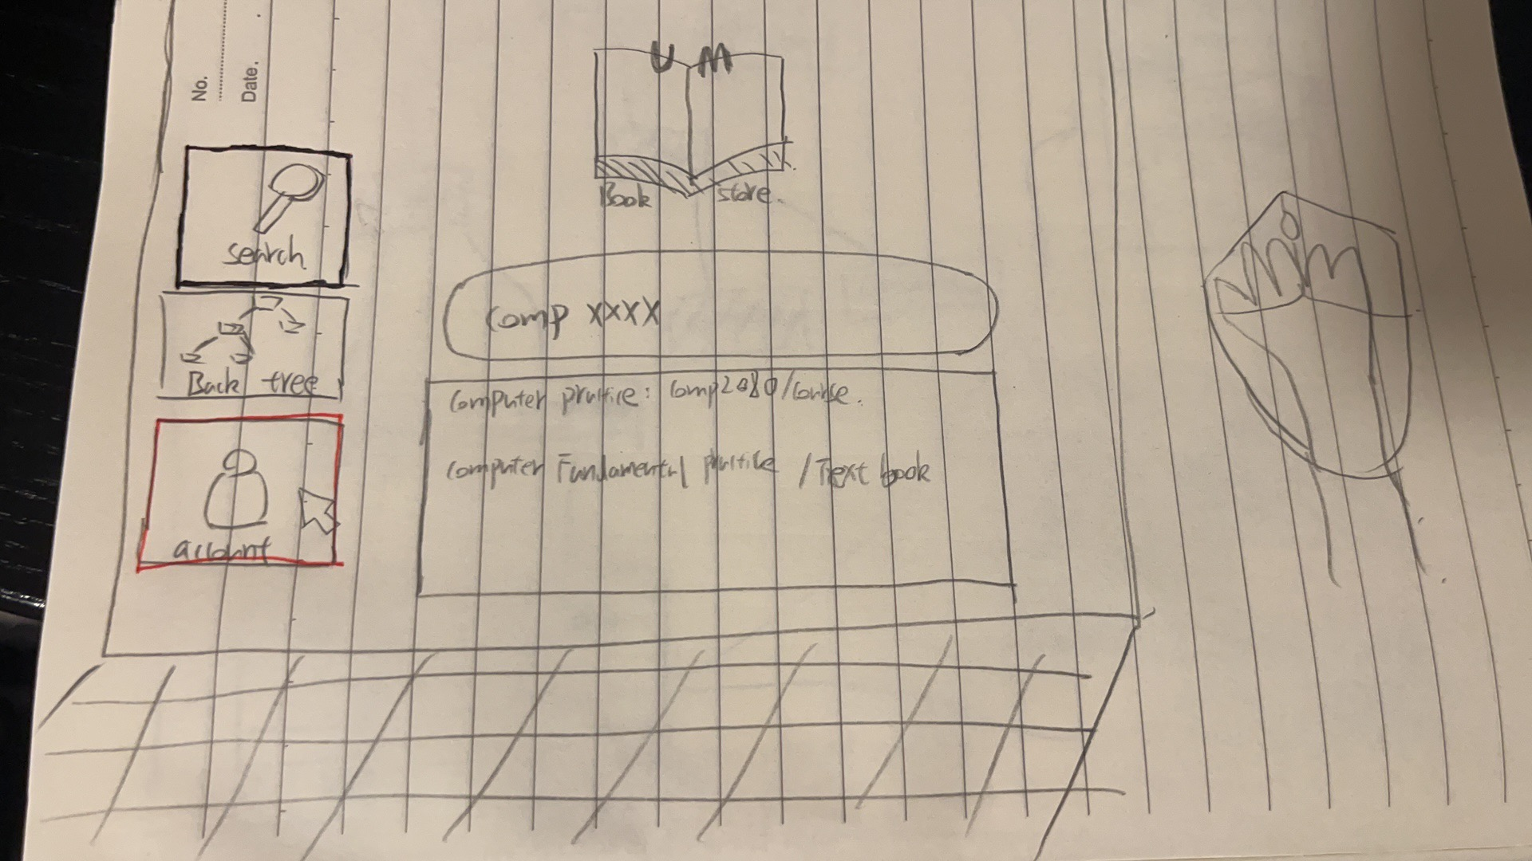

1. Robert is looking at his list of books. There is only one of them. Robert hovers the mouse to check the information of this book. He wants to make sure that this is the correct book. A text box appears and tells Robert what he needs.

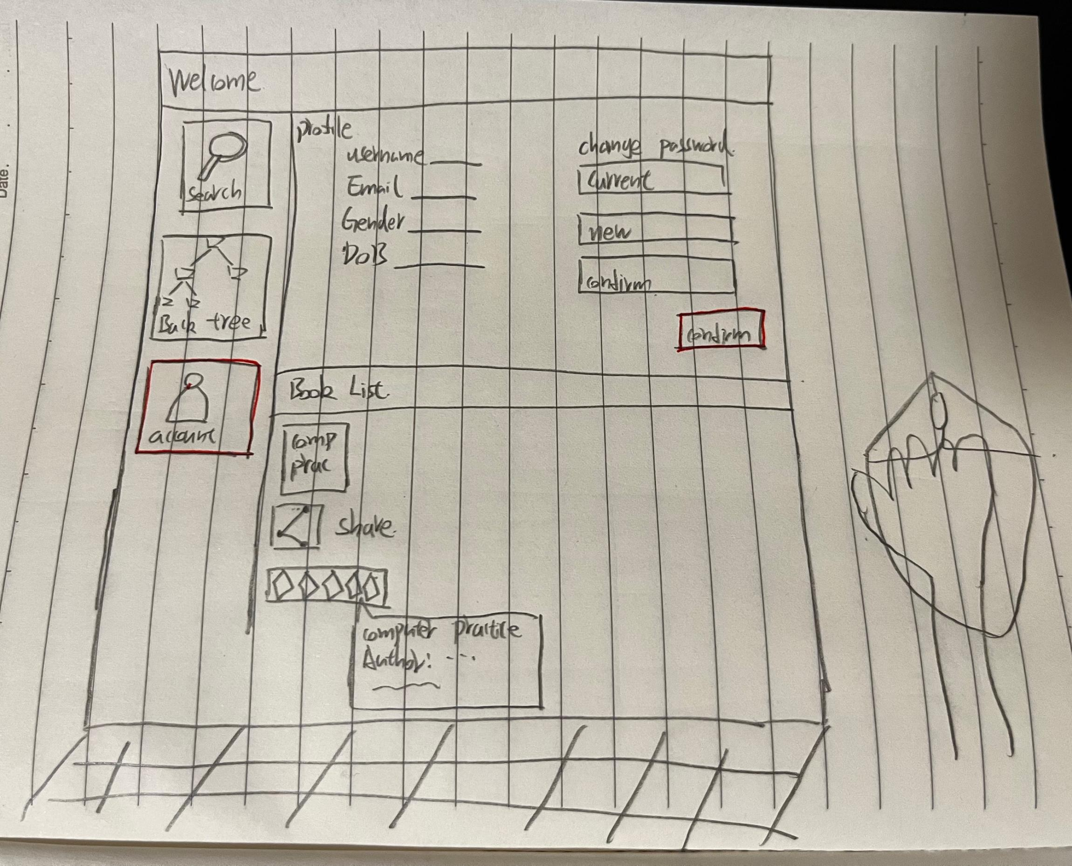

1. Robert sees the book he just bought. He wants to rate it. Robert clicks on the start icon and drags it. The bar is magically colored yellow as Robert does the action. Robert wants to give it 3 stars.



1. Robert decides to share the book with Jack. He clicks “Share” and a link to the book magically pops up. He copies that link and sends it to Jack and feels happy that he has shared the love of reading.

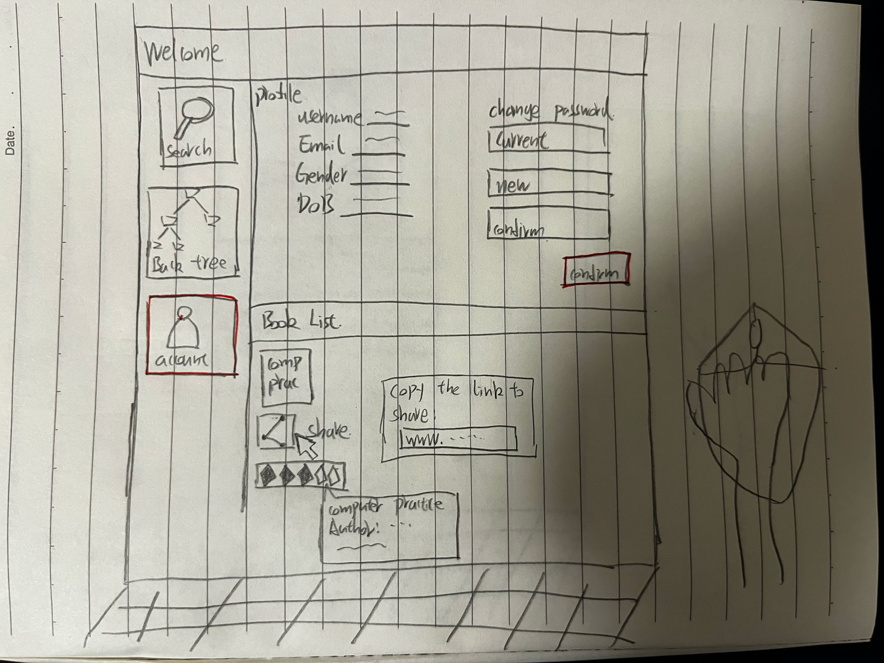

1. **Low - Fidelity Vertical Paper Prototype**

The prototype contains 6 pages :

+ Login

+ Create account

+ Search bar page (we call it welcome page)

+ Book Tree page

+ Account setting (profile)

+ Check out page.

1. **Login**

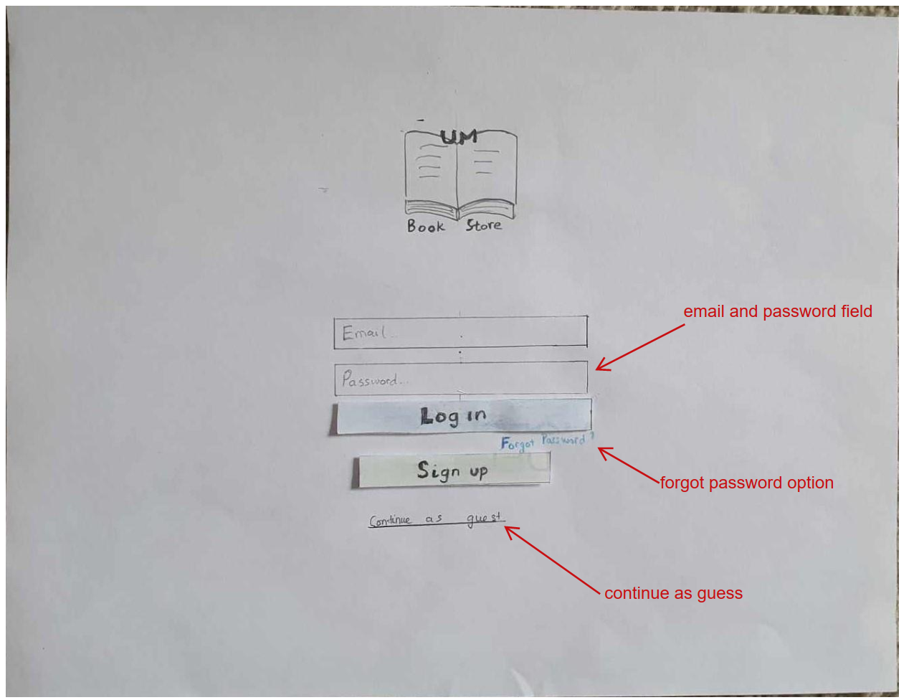

When user is first redirected to the page (by google or whatever search engine), they are greeted with a login page. The login page is essential since we must save a personal list of books for user, we need to facilitate the concept of an account.

User can log in by entering their email and password and the designated field. If the password is wrong, or the account doesn’t exit yet, an error message will be displayed under the password field. If everything is fine, user can click login and they will be redirected to the Welcome page. If they happen to forget their password, user can click the blue text under the login button (the button in blue) and an email with their old password will be sent to the designated email address.

If the user doesn’t have an account and doesn’t want to make one, we have the option to continue as a guest. If they are a guest, the account setting/profile section and the rating feature is naturally not available. For the prototype, we will assume that the user is signed in so that we can demonstrate these features.

For user who wants to create an account, they will click sign up, which takes them to the Create Account page.

1. **Create Account**

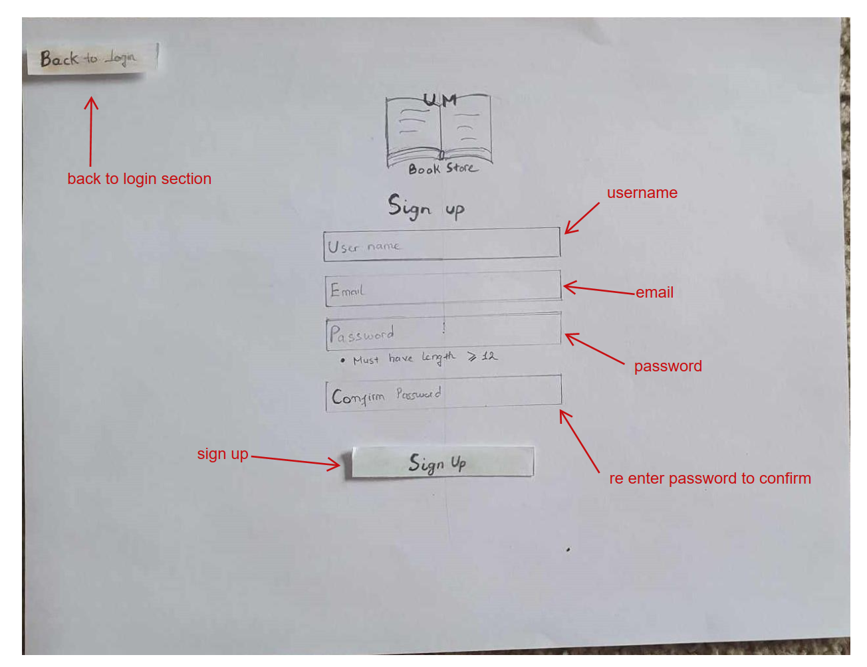

The sign-up page has 4 fields.

+ username: the display name for user

+ email: email used for login

+ password: the password for this account

+ confirm password: user need to re enter their password to confirm that they have the correct password.

If the user doesn’t wish to create an account anymore, clicking the Back to Login button will take them back to the login screen.

If there are no error, user can proceed to click sign-up. An account is then created, and user is redirected to the welcome page.

If there is error in user input, they will show up before user click on the sign-up button. This is to inform users error as soon as possible to make their sign-up experience seamless.

The error in this section can be:

+Wrong email format (missing a @ or missing a .com). We only show the example of missing an @ for simplicity.

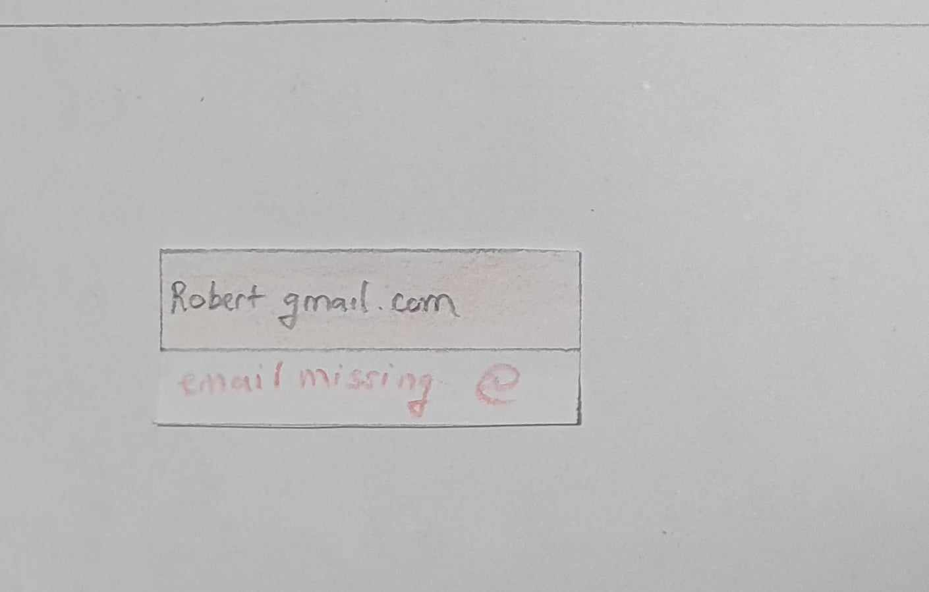

+ Password does not match during the password confirmation phase.

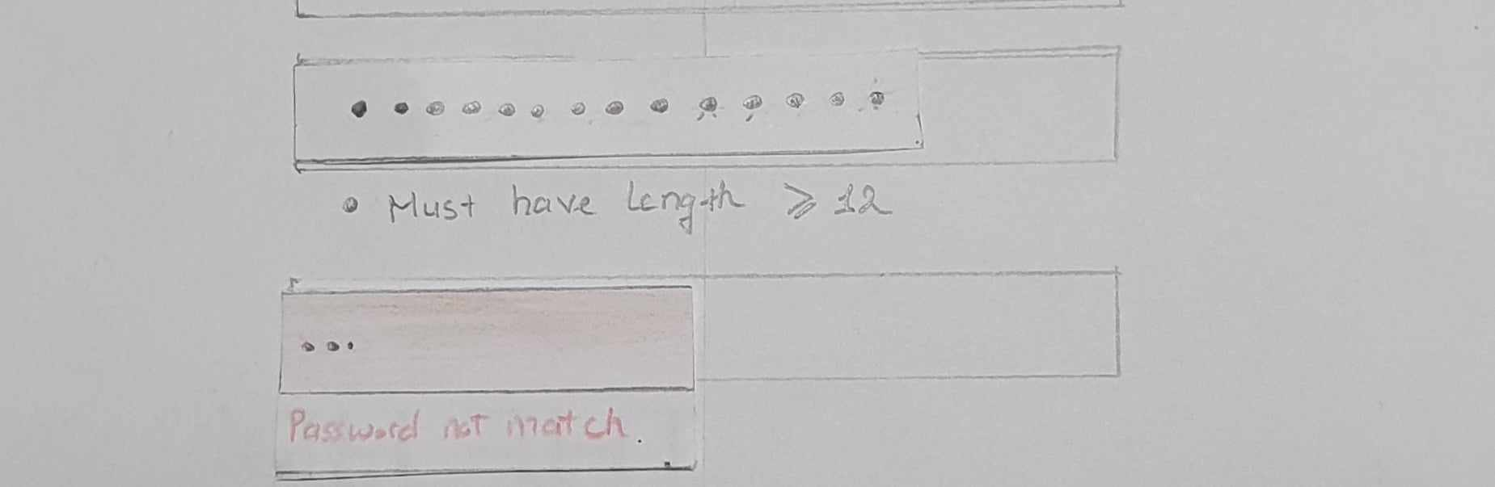

+Password is too short. (we required every password to have length >= 12)

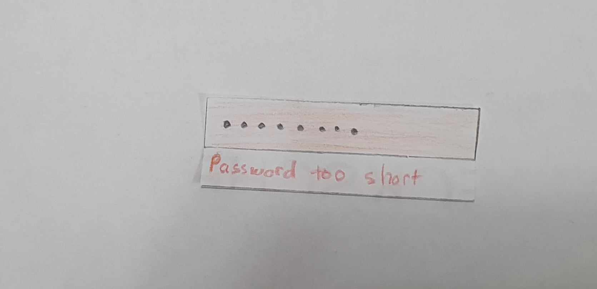

1. **Welcome**

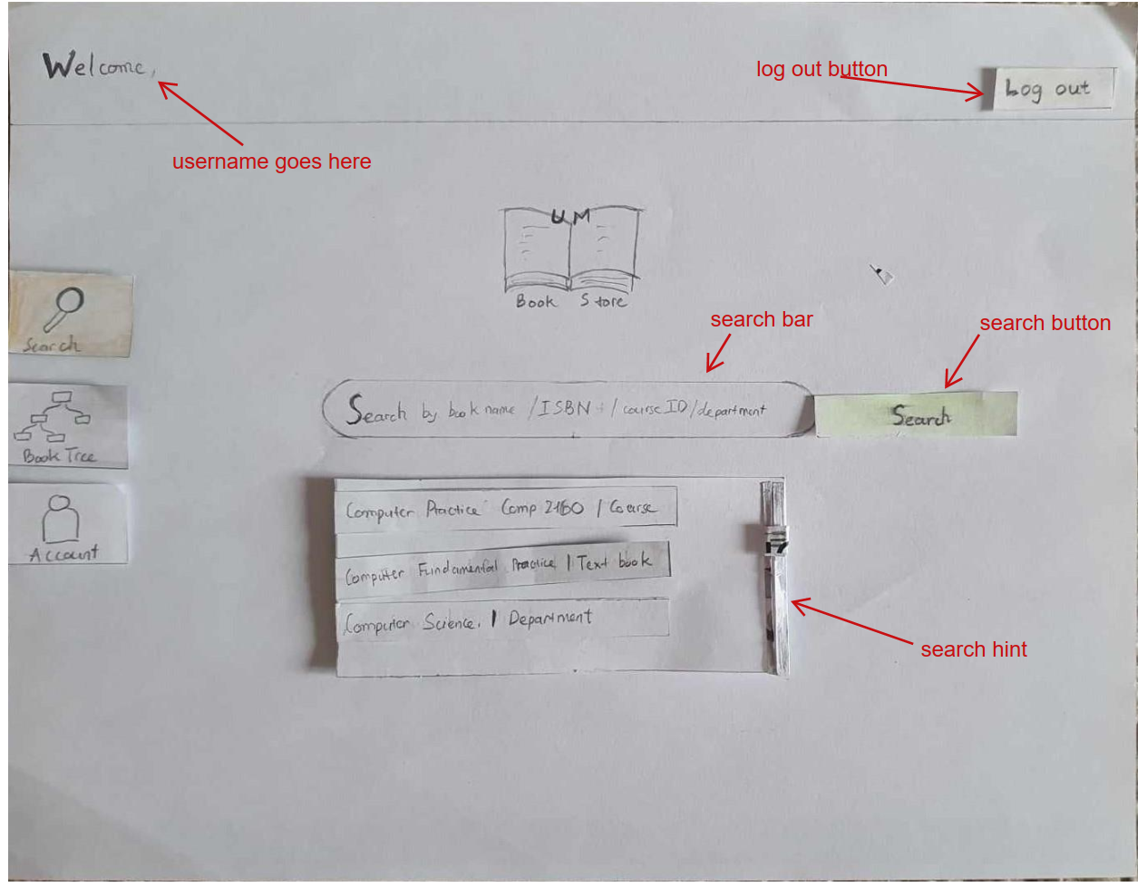

If the user successfully logs in or signs up, they will be directed to the welcome page. The welcome page is consisted of a header, a left side breadcrumb and a search bar with a search button.

The header says welcome, <username>. This is to confirm that user has successfully logged in to the correct account. If user decides to continue as guest, this header shows welcome, guest instead. There is also a log out button on the right that redirects user to the log in page.

The breadcrumb on the left-hand side is our main navigational tools between pages. It contains 3 buttons for Search page, Book Tree page and Account page. Which ever page we are currently on, the button for that page is lit up. For instance, since we are on the Welcome page (Search page), the button for Search is lit up. Clicking on any of these buttons will redirect user to the corresponding page and lit the button up. This is to make sure user now where they are currently and where they can go.

The Welcome page, Book Tree page and account page will all contain a header and a breadcrumb on their left-hand side.

The search bar will accept a text input of any kind. As mentioned in the above section, when it receives a text, the search bar will output a list of possible hints with that keyword. For instance, typing “Comp” will make the hint section output Computer Practice (a course), Computer Fundamental Practice (a book) and Computer Science (a department). This feature helps user narrow down their search early on, which will support them during their exploratory phase on the Book Tree page. The hint section is also scrollable if too many results are returned. The user can click on one suggestion and that will redirect them to the Book Tree page.

After the user is satisfied with their query, the user can click on search button. This will redirect them to the Book Tree page with a pre-constructed tree. The search button will populate the tree with the first suggestion given by the hint section.

1. **Book Tree**

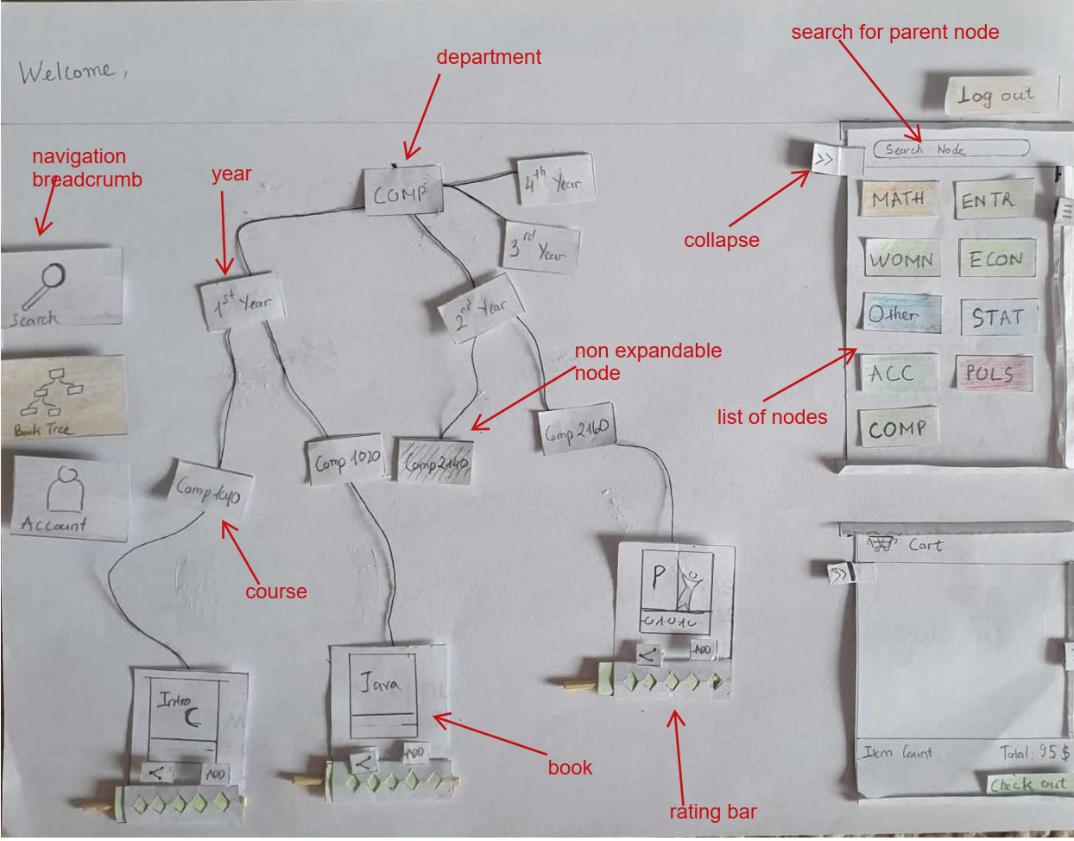

There are several cases that can happen before the user reach this page. If the user clicks the bread crumb right immediately after logging in, the tree will be empty. If the user query doesn’t return meaningful result, an empty tree will be created together with a message saying the website fail to find what they need and they are free to explore. Otherwise, the tree will be pre-constructed with the result of the query. For instance, if the user selects Computer Science (a department), a tree with one node ‘COMP’ will be constructed. If the user selects Computer Fundamental Practice (a book), the tree containing the node of COMP, second year, COMP 2160, and the book is constructed.

The Book Tree pages is separated into 3 sections, the canvas (draw the tree), the first panel (search for parent node or preview book) and the cart.

**+ The canvas**

The canvas contains the tree, which is a bunch of nodes connected by threads. The canvas can contain multiple trees (meaning it can have multiple query result). User can freely move the canvas (which move the entire tree or anything else on the canvas). Every node is also moveable, and the thread will be adjusted to still reflect the connection between nodes. User can also drag the mouse to select a group of nodes and move it around. Every node is expandable by double clicking and minimizable by also double clicking again. For any node that is not expandable (aside from the book node), it will be colored gray. The tree like representation makes it easier to explore other books and see the connections between all the books. This helps user explore the book in one department while also constructing their plan of buying book. Moreover, use can also organize their search by moving the node around or have multiple queries at the same time.

**+ Search for parent node panel**

This panel is for searching the parent node. In this case, parent nodes are the Department (since every course must be under a department). User can search for a parent node by typing the name of department and the result will be shown in the panel. The panel is scrollable in case too many results are returned. Nodes in this panel can be drag out to the canvas to construct a new tree. This makes multiple query possible, and the interaction is intuitive.

**+ Preview Book**

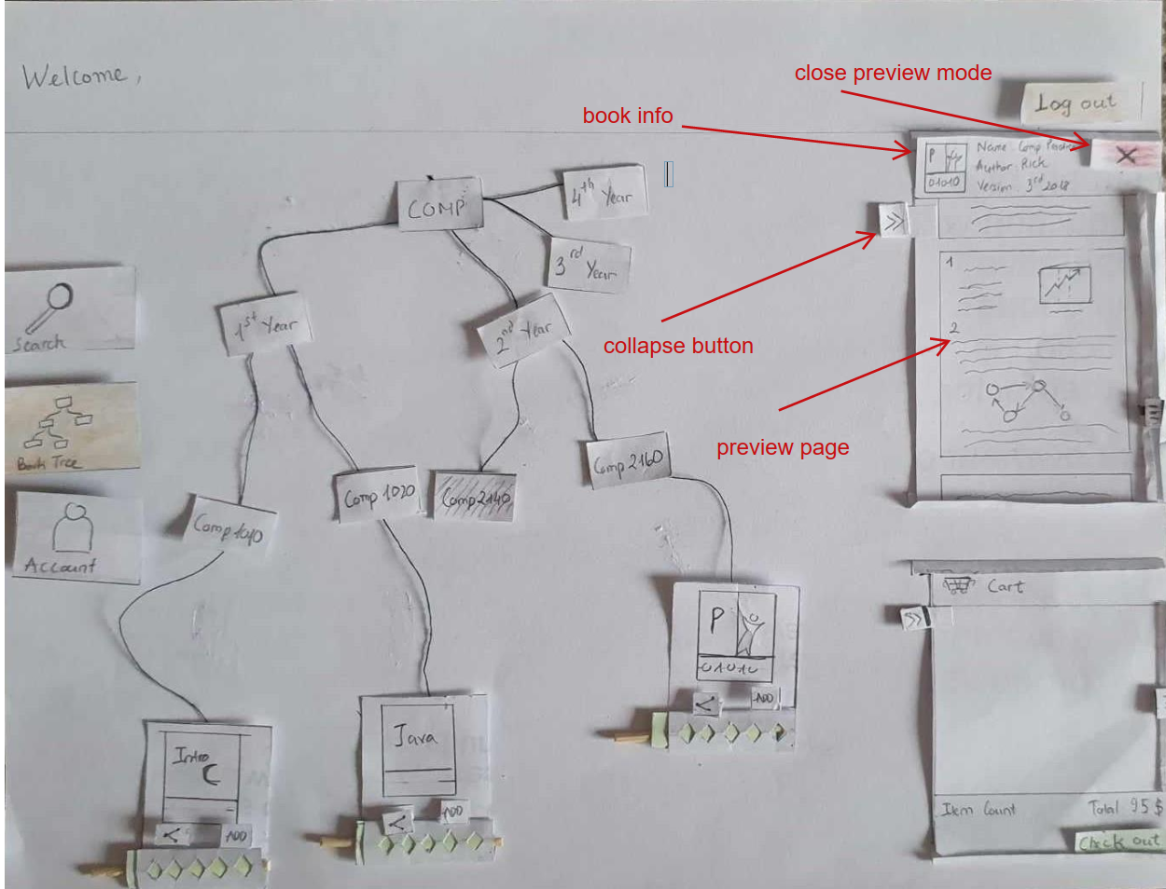

If a book is selected, the search panel will be replaced by a book preview panel. This panel contains the book information on the top, namely the book’s name, the author and version. A close button is located on the top right corner of the panel, clicking on which will make this section return to the search panel. Some of the few pages are shown under the header. User can scroll through the first few pages to be sure that they find the correct book.

**+ Cart**

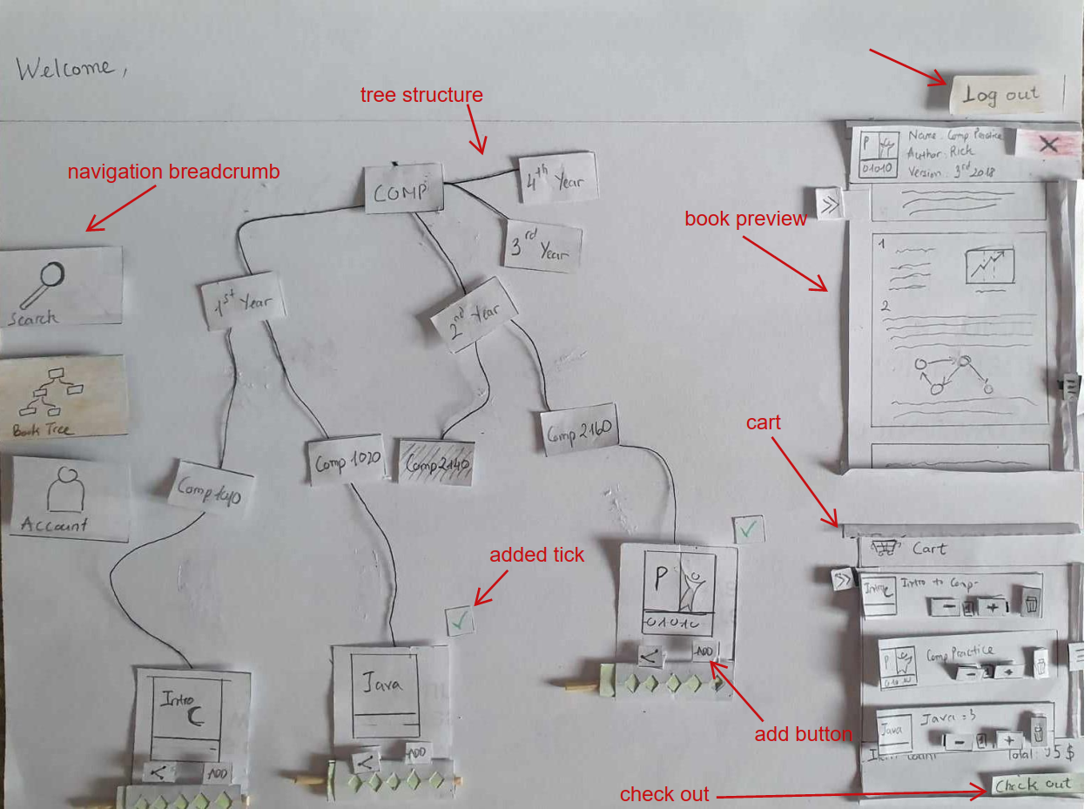

The cart contains a list of books that have been added to it. A summary of the cart, with the item count and total (before tax) is included at the end. There is also a scroll for the item list in case it is too long to show in one go. At the end of the cart, there is a check out button which redirects user to the check out page. A book can be added to cart in 2 ways: drag and drop it to the cart section or clicking the add button. Added books will have a green tick on them. The item in the cart is also interactable.

The panel on the right hand side is collapsible using the collapse button (with the symbol (“>>”) on it.

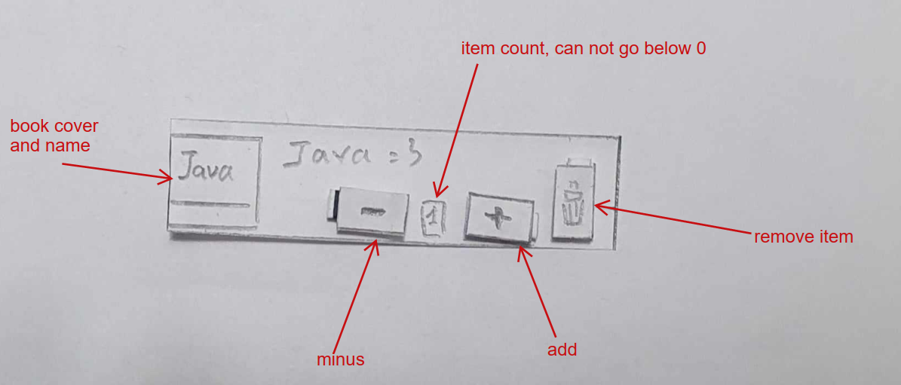

Each item will contain a book cover and name. There are also buttons to add or subtract the number of book user want to buy. The number of books is shown in the middle of the two buttons. This number can not go below zero as adding a book to the cart with a count of zero doesn’t make sense. User can remove the book by clicking on the button with the trash bin icon.

The book can also be rated using the yellow bar. The maximum rating is 5 stars while the minimum rating is 0. Book can also be shared by clicking the share button. A pop up with the link to the book will show up on the screen. User can then copy that link and send it to a friend. The link will redirect user to a pre-constructed tree that leads to the book. The pop up will disappear if user click out of it (meaning click somewhere outside the area of the pop up.

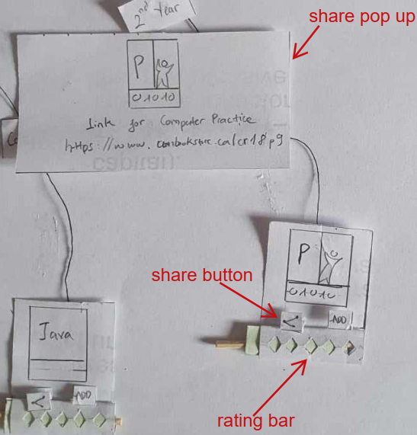

As we mentioned in the previous section, parent nodes can be expanded or minimize by double clicking out them. There is also another option to select which children to show and hide. When user right click on a parent node (this only works for parent node that is expandable), a menu will show a list of children available with a check box for each child. User can check which children they want to show.

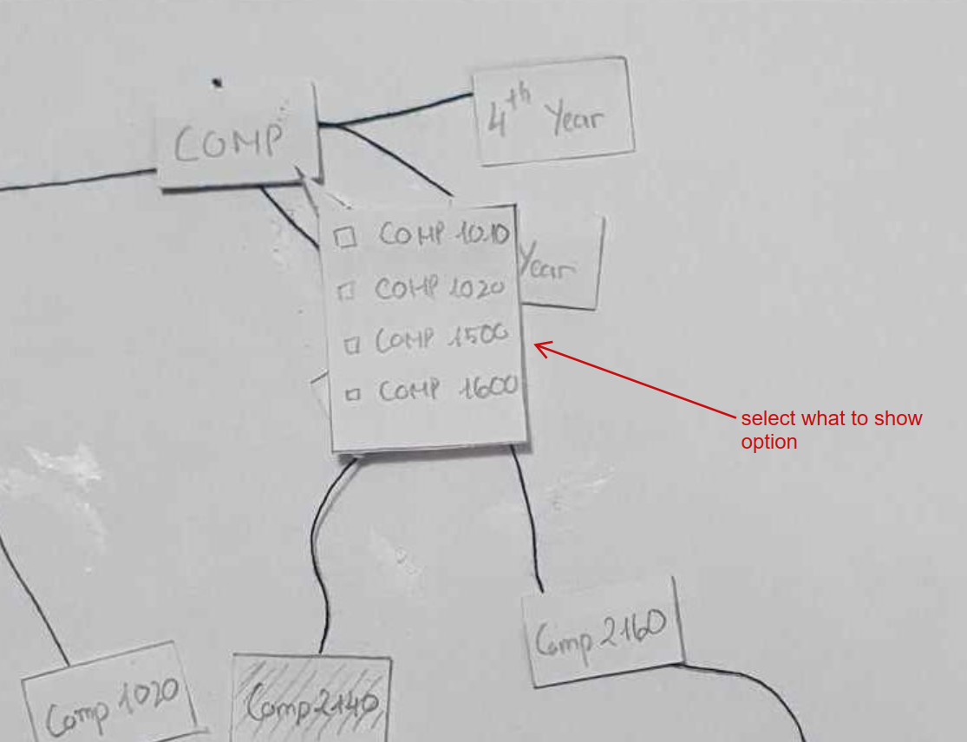

1. **Account setting/profile**

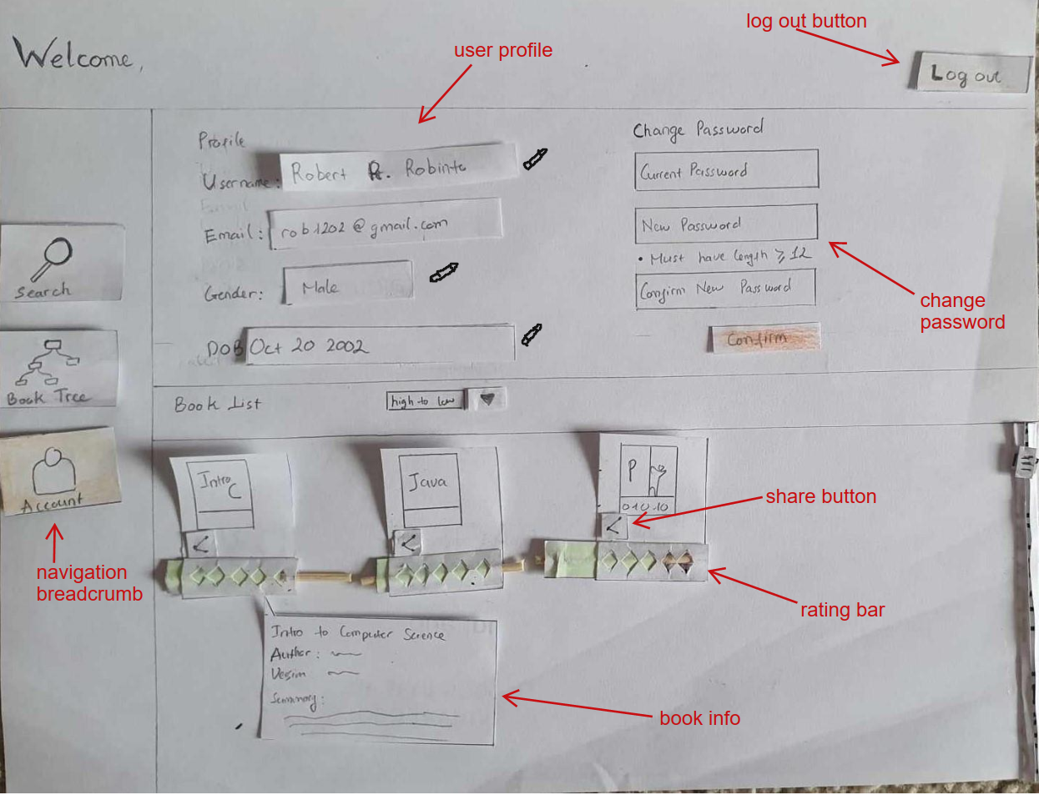

Using the breadcrumb, user can navigate to the Account Setting page. This page is divided into 2 sections: profile and personal book list.

+ Profile

The profile contains basic information, namely username, email, gender, and Date of Birth. These are in an input field so that they can be edited. These fields can be edited by clicking on the pencil symbol and when finished editing, click the pencil again will update them. Editing the gender field will prompt a drop down to show up. Editing date of birth will cause a mask to show up to ensure that user enter their birthdate in the right format.

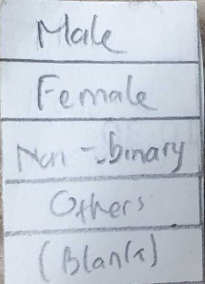 

Gener drop down Date of birth mask.

Use can also change their password. User will enter their old password, then enter their new password and confirm it. Error such as password does not match, or password is too short can show up as shown in the sign-up page.

The second section is a personal list of books. Every book that user has rated will be included in this list. The book item has a share button and a rating bar, which works similar to how they work in the Book Tree page. The only difference being when user hover their mouse over the book, text box showing the book information and summary will show up. This box disappears when user point away from the item. The list can also be sorted by using the drop-down button on the header. There are 4 options for sorting: high to low (rating), low to high (rating), alphabet, by year (meaning by 1st,2nd,3rd,4th year).

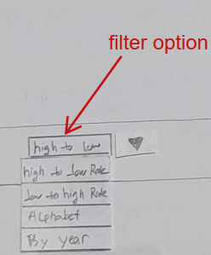

1. **Check out**

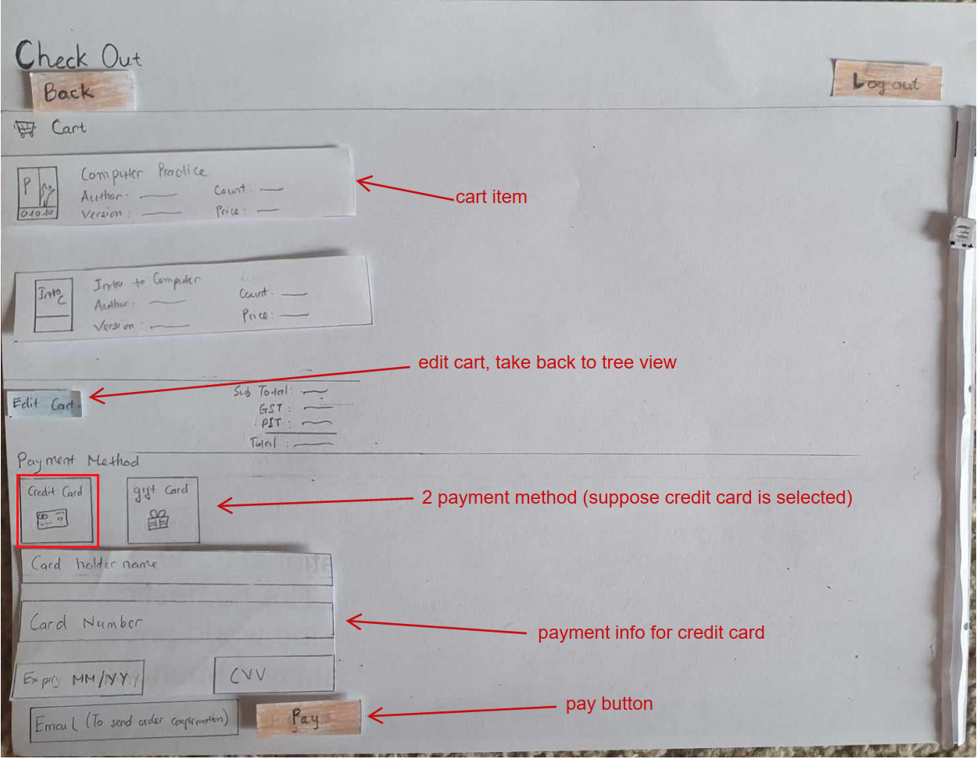

If users click check out in the cart from the Book Tree page, it will redirect them to a Check out page. This page contains a summary of what is in the cart. A cart item contains the book cover, name, author, version, count of book and the price. At the end of the cart section is a calculation of total with detailed tax. There is also a button for edit cart that take user back to the Book Tree cart or the Back button which also take user to the Book Tree page. User can do both, which ever is more intuitive. The reason we have a back button is in case we expand this website where user have another way to go to check out, this back button will be useful.

After confirming the cart information, user can select a payment method. 2 Payment methods are available: by credit card or by a gift card. The credit option will prompt user to enter information such as card holder name, card number, Expiry (MM/YY) and CVV. The other option, gift card, will only prompt for a code.

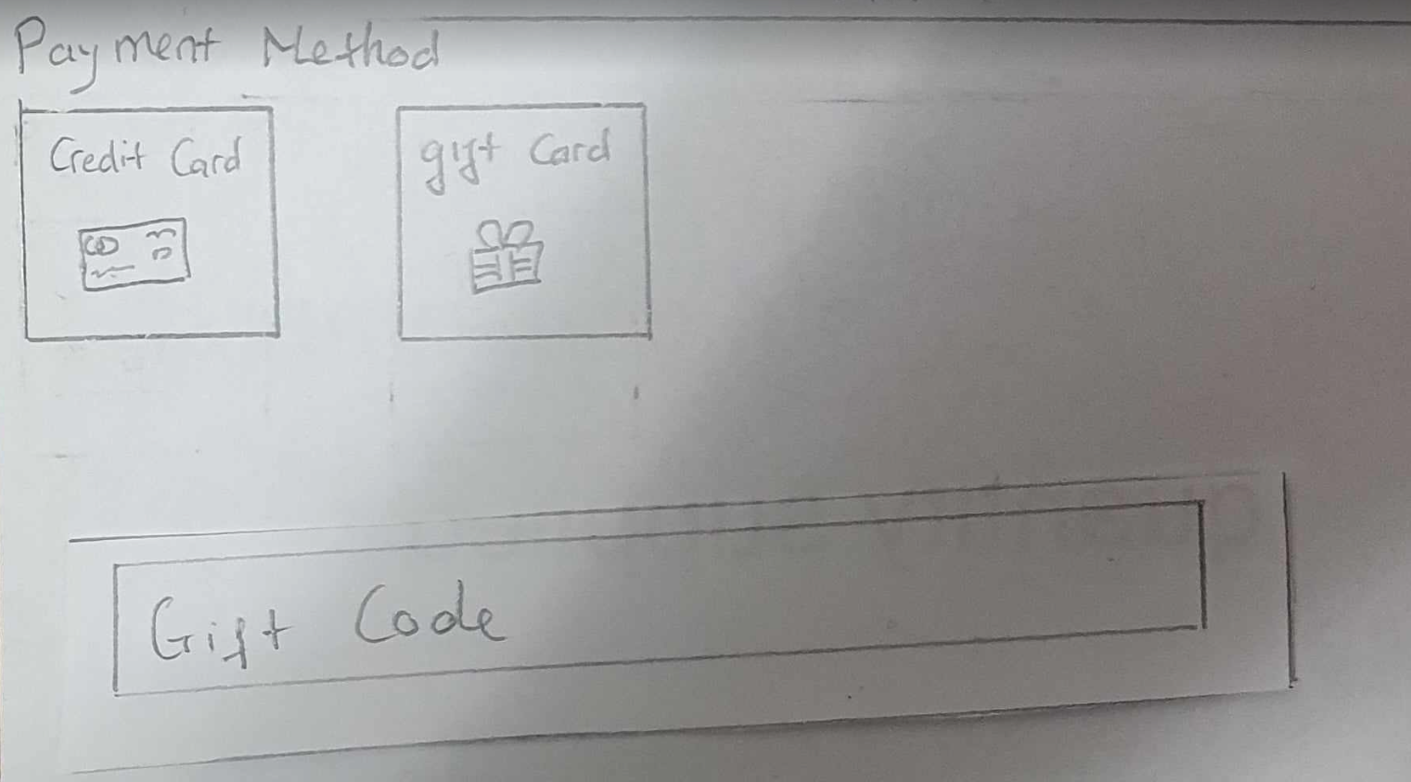

After all the fields are filled, user must enter an email address, to which the website sends and order confirmation too and then they can click pay to finalize the payment. A confirmation will appear.

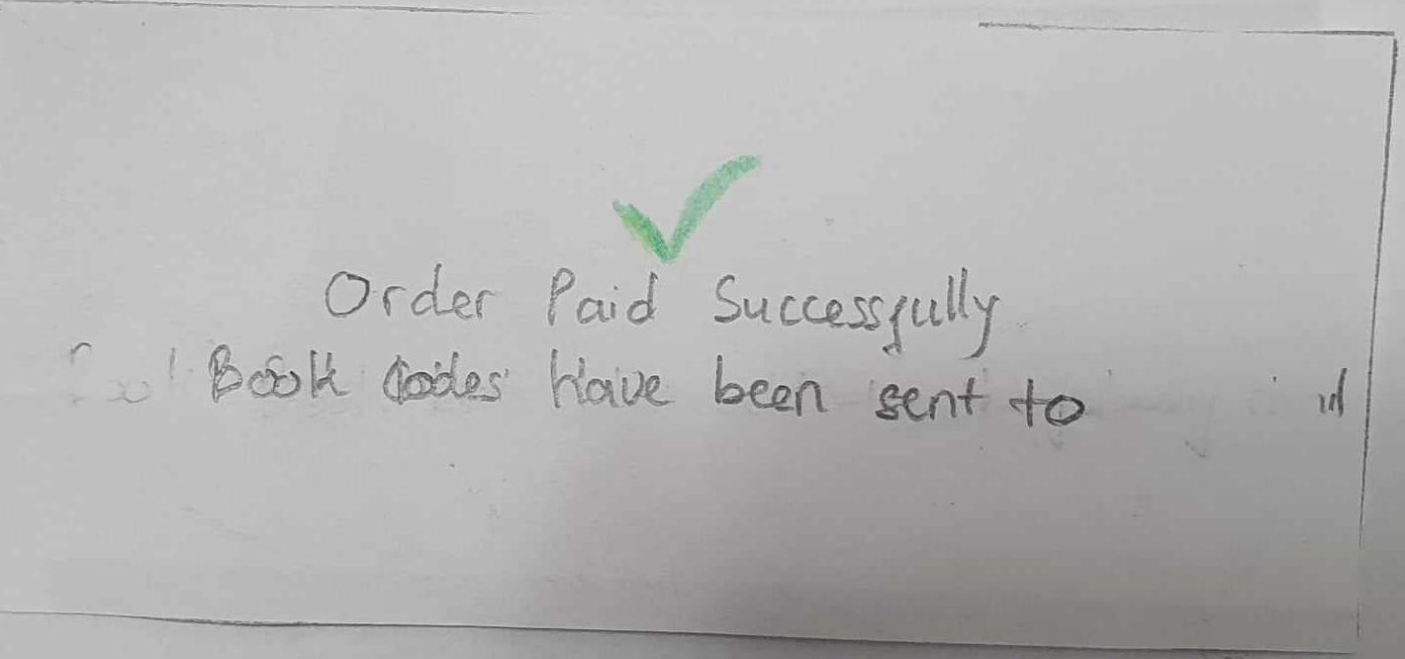

After user click out of this confirmation box, thus making it disappear, the website will return to the welcome page.

1. **Informal Prototype Evaluation**
2. **Interview with Tomato**

Tomato is a middle-aged male who is happily married with 2 kids. Tomato works in the healthcare field, providing support to those in need.

Tomato's first impression of the prototypes was very positive. He found it visually appealing. He liked the basic colors used and how easy it was to interact with. Signing up and the login page was very intuitive for him. The search feature was initiative and modern and he liked how easy it was to navigate. Tomato also enjoys playing with the node in the Book Tree page by moving them around. He also enjoys the fact that the book can be previewed. Tomato likes the fact that he can rate and share book within the account page. He also likes how more information of the book is provided to him when he hovers over a book.

However, Initially, Tomato needed clarification when looking at the tree interface in the storyboard. He was confused about what the different boxes and arrows represented, but after we gave him hints about the idea of it being a hierarchy in the form of department -> year -> class -> textbook, he easily understood. Tomato is also confused by the option to select which children to expand as it is not intuitive to him.

1. **Interview with Alpha**

Alpha is a male around 25 years old, a senior in the Computer Science department at the University of Manitoba, fonds of online shopping.

He finds the Book Tree functionality interesting. He also appreciated the clarity of ”book description” and “cart” display in the tree structure. He also likes the inclusion of ratings in the tree structure. Alpha thinks that the login and sign-up section is intuitive to use. He also like the fact that he can easily view all his information and change his password in a small section on the Account page. Alpha enjoys playing with the rating feature and sorting books by different order in the Account page.

However, he notices that there are some issues with the prototype. The ‘Forget Password” option was not clearly visible, suggesting it should be positioned below the password and above the login button. He is also concerned about the potential cluttering of the tree structure, especially for courses with multiple textbooks, like economy. He also suggests presenting a regular search result first and then providing an option for users to view the tree structure instead of automatically bringing them there. There is also an uncertainty over whether the book is digital or physical. He recommends that the website should clarify this beforehand or provide options during checkout. He also finds that the top part of the website is too empty.

1. **Interview with Pickle**

Pickle is a woman, around 30 years old. She has her own business at a Milk Tea store. She has never bought a book online.

Pickle finds the tree structure fun to interact with. She also appreciates the fact the link between nodes gives her more information in the book. She likes how the panel in the Book Tree can be collapsed to provide more space. She enjoys playing with the rating bar (which is made of paper). Pickle likes the search bar as it is easy to use and gives her meaningful suggestions. Pickle also likes the fact that the Check out section has been simplified and it is easy to fill in the information she needs. She appreciates the fact that there is an option to use the website without having an account.

However, she thinks that it is hard to use the tree. The expansion and closing of the parents’ node are overwhelming, especially when the node has multiple children’s levels. She also finds the right mouse click menu for node expansion too complicated as it takes so many clicks to get what she wants. She also raises some concern with the personal book list, stating that there is not an option to remove the book from the personal list. She also suggests that it would be nice if she could also add a book to cart from the account page.

1. **Interview with Sponge**

Sponge is a male, 21, studying engineering at a university. He has some experience with online shopping, albeit not with books.

Sponge finds that the overall prototype is easy to navigate. He finds that the tree structure is an interesting idea as he has only ever seen grid interface. The breadcrumbs tell him where he is and where he can go from there. He also likes the fact that the tree can be reorganized by moving nodes around. He likes the fact that he has a personal book list that has the sorting feature. He enjoys the fact that the node that is not expandable is gray out, so it is not confusing. He loves how he can select which children to show. He feels that the feature gives him more flexibility as to how he wants to use it. The search bar is useful as it shows relevant suggestions.

However, Sponge makes some valuable comparisons between our prototype and the UM bookstore. He is concerned that the tree structure will make it difficult to do the multi-query as the tree will get so complicated and hard to navigate. He points out that if a person wants to search for multiple books at the same time from different departments, the user might have to construct 5 different trees and the website will have too many unnecessary nodes. Having too many nodes on the screen can be confusing and distracting. He also notices that there is no indication whether the book is physical or digital and suggests that we should add this option in the check-out menu.

Overall, most of the interviewees think that the idea of a book tree is novel and interesting. They generally appreciate the connection between the book and the department. The interviewees enjoy moving the node around the canvas. They love the fact that they can organize their search result. They also feel that having the ability to read some of the first pages of a book is valuable as it tells whether you get the right books. Some users find that the option to continue as guest valuable. Others find that the login – sign up is intuitive (which is to be expected as we learn that design from Facebook login interface). Everyone enjoys the sorting function in the book list on the Account page.

As we have a more diverse pool of interviewees, we are given a lot of different perspectives about what is not working. Most interviewees think that the option to select which children to expand is hard to use and confusing. Some of them also are concerned that the canvas might get filled up with too many nodes and it will be difficult to look for the node they need. One interviewee raises a good point that this tree structure is more suitable for exploring but not so for exact finding. It would be difficult to search for multiple books at the same time using the tree structure as the tree gets complicated. Some interviewees also indicated that the website should be clear on whether the book is physical or digital in the checkout section.

In brief, the idea of a tree structure is appreciated, but more needs to be done to make it adaptable for multi query searching and to simplify the tree for more intuitive interaction.

1. **Appendix**

**G.1 Everyone sketches**

**Tano:**

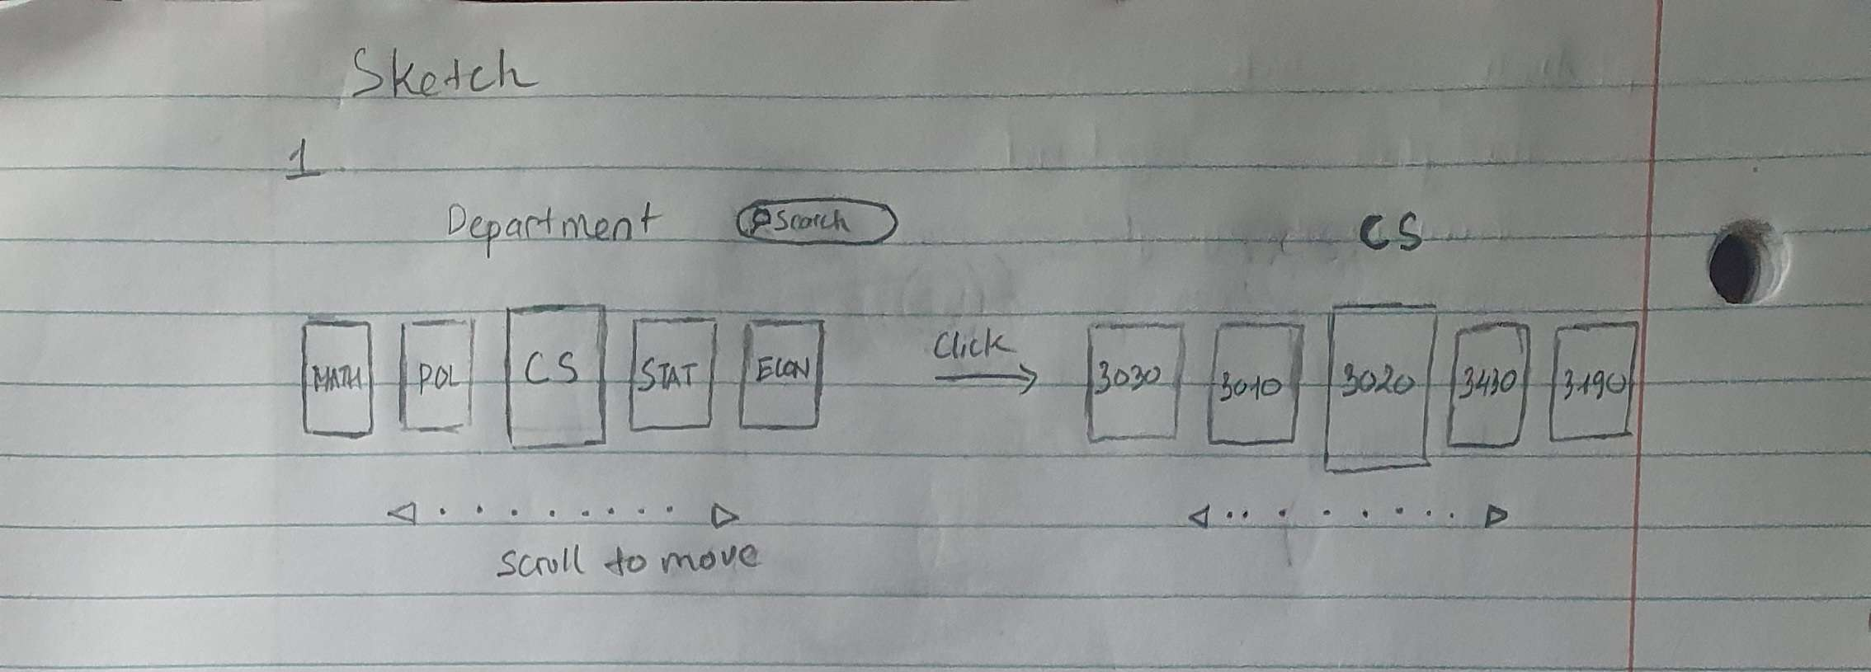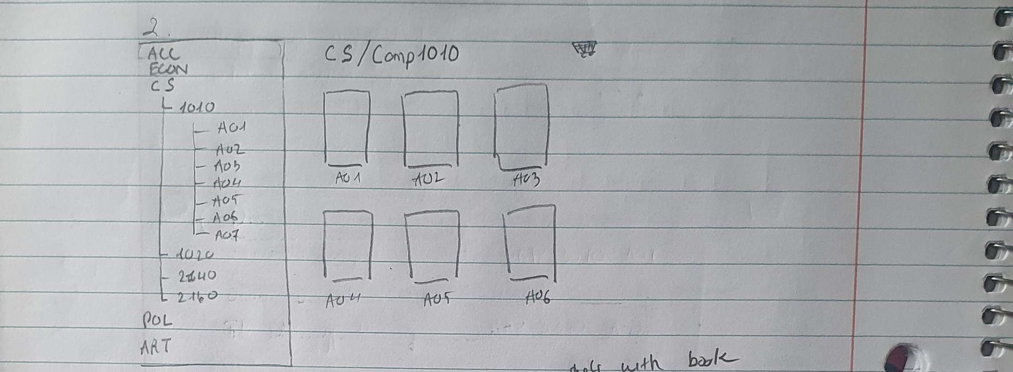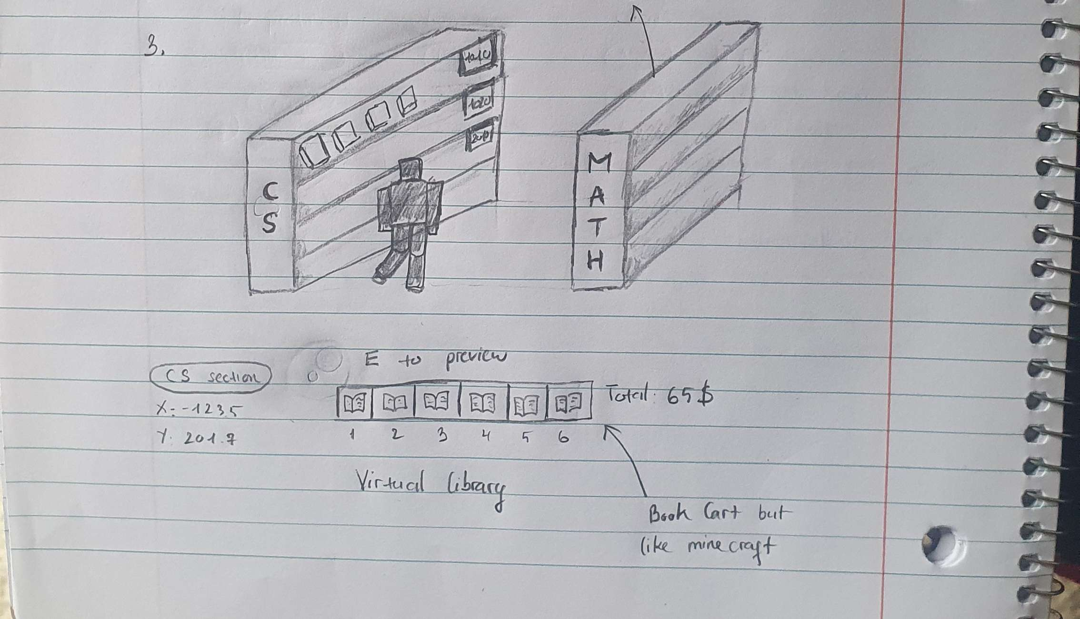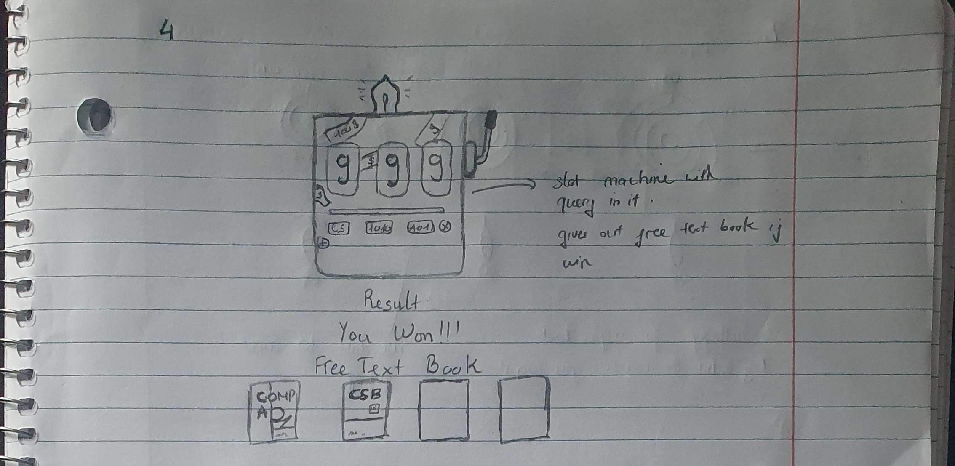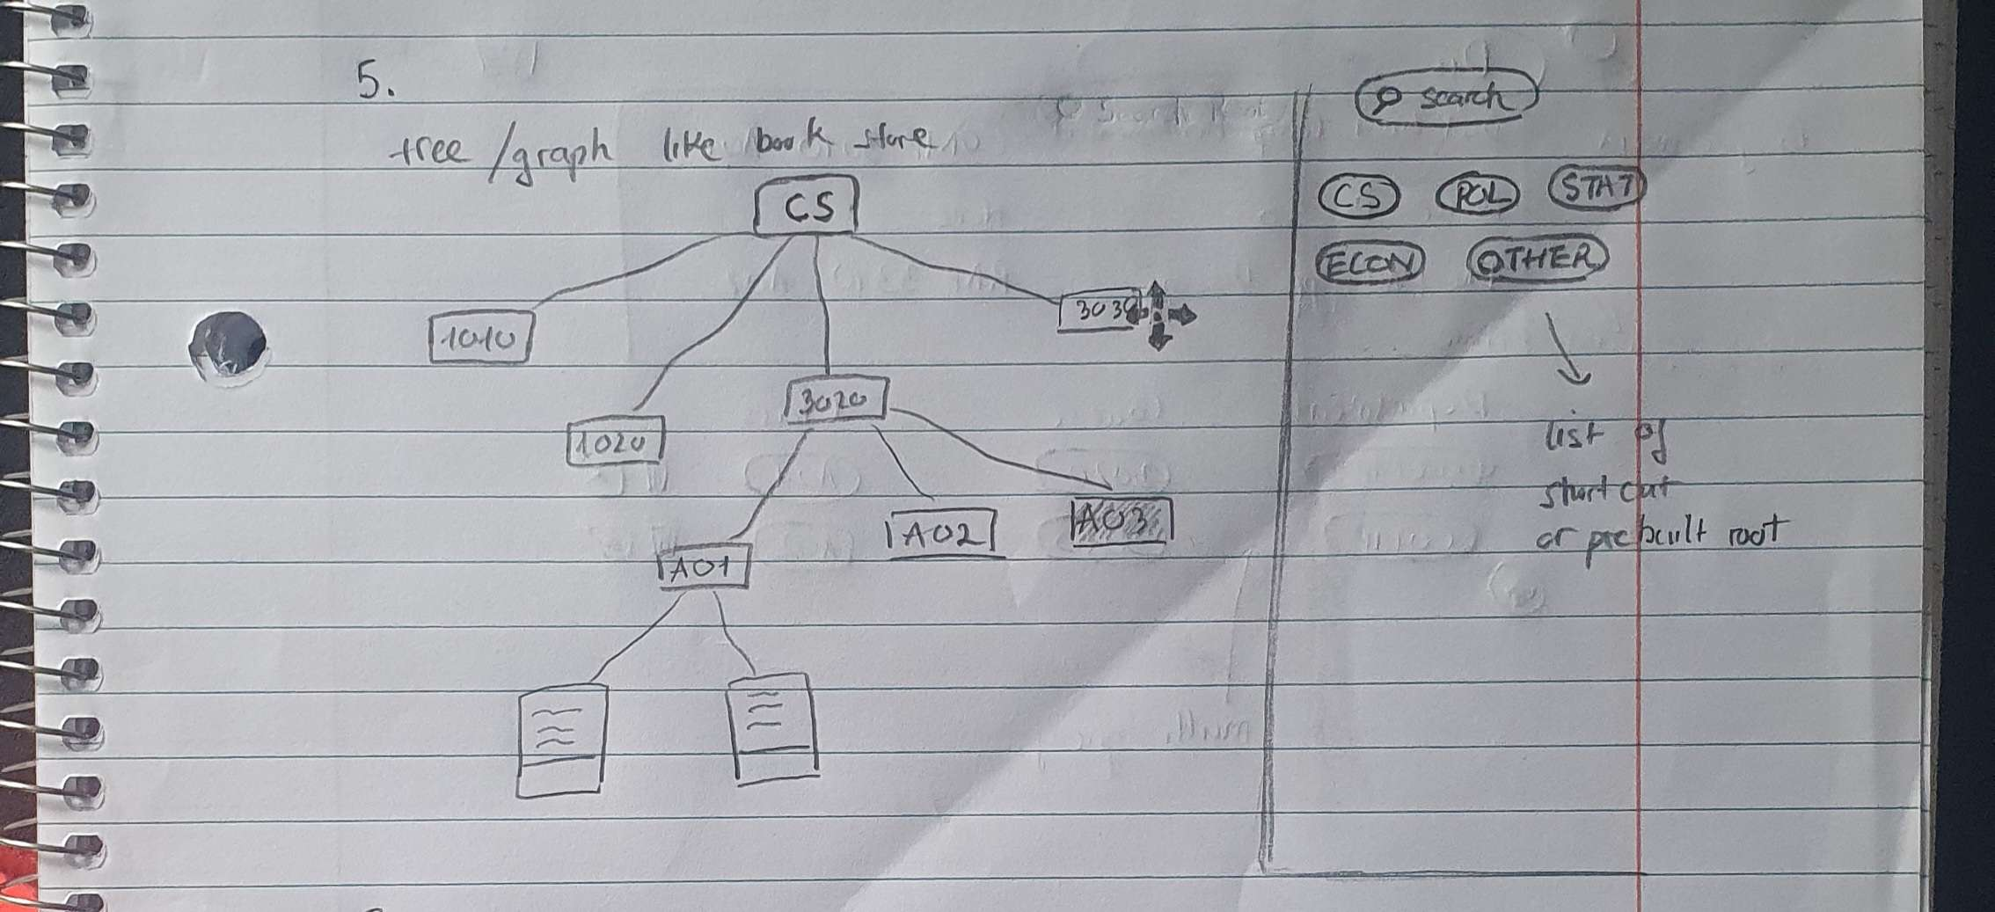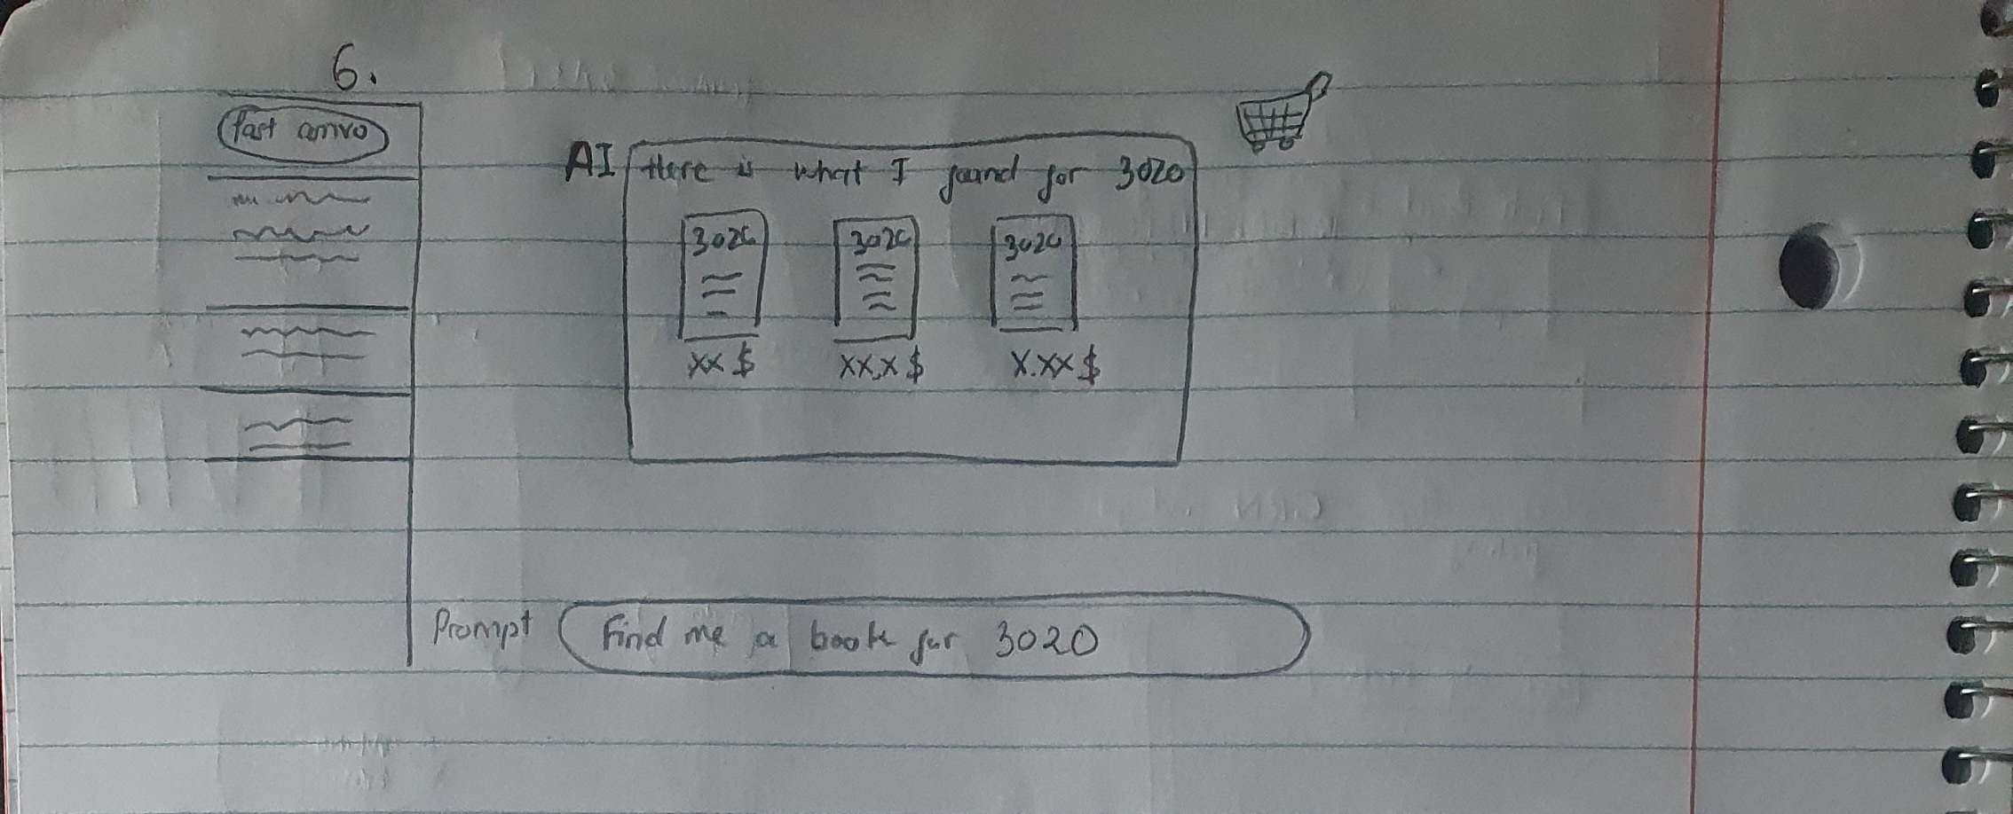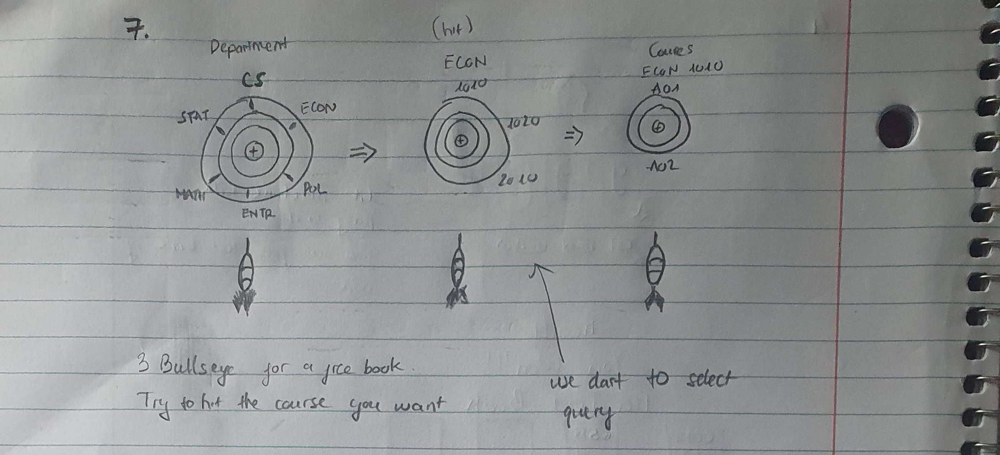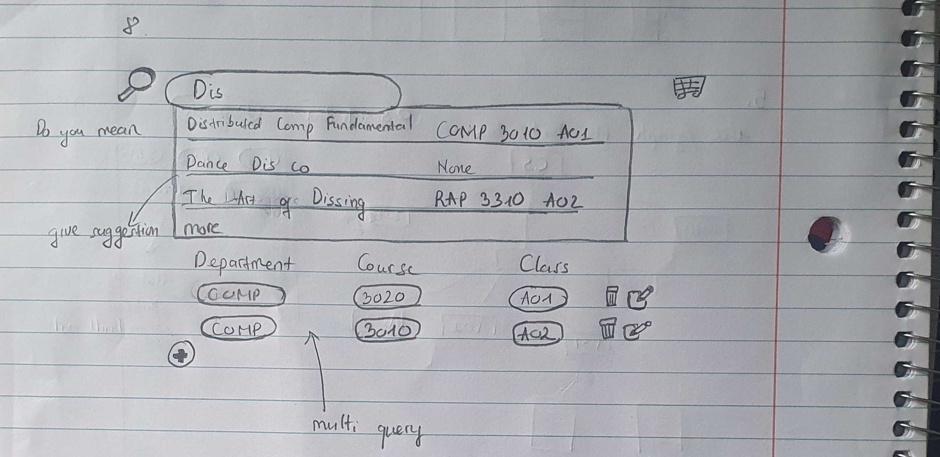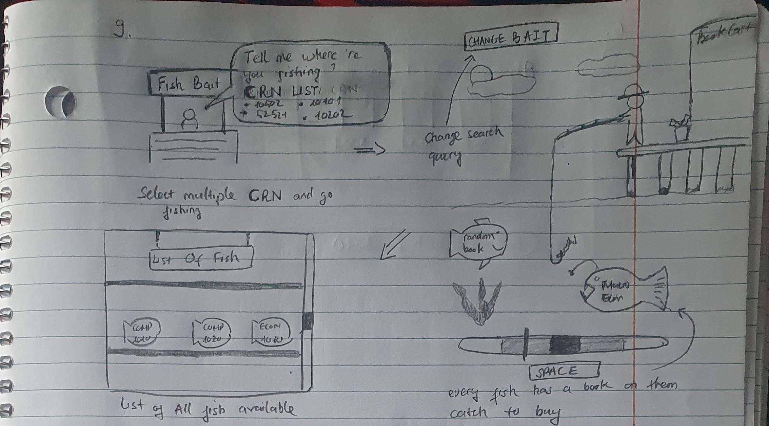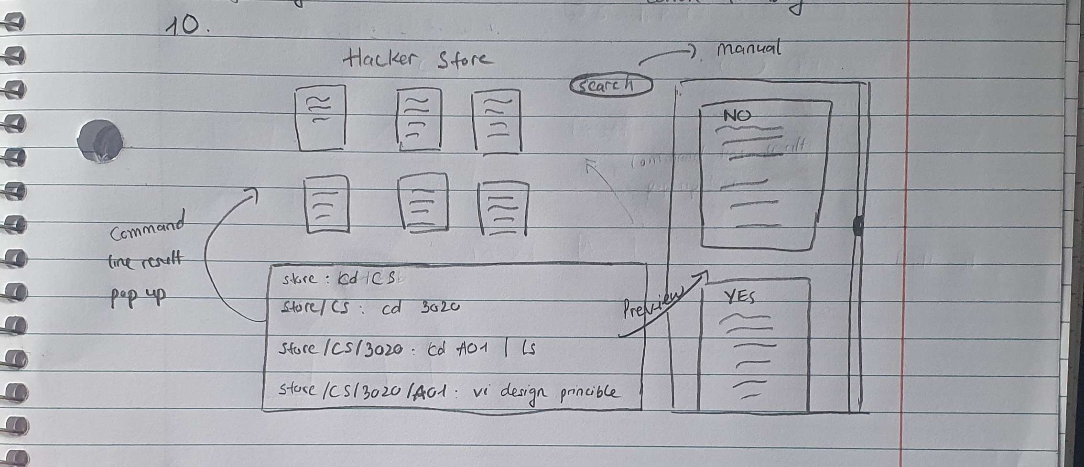

**Fyfe:**

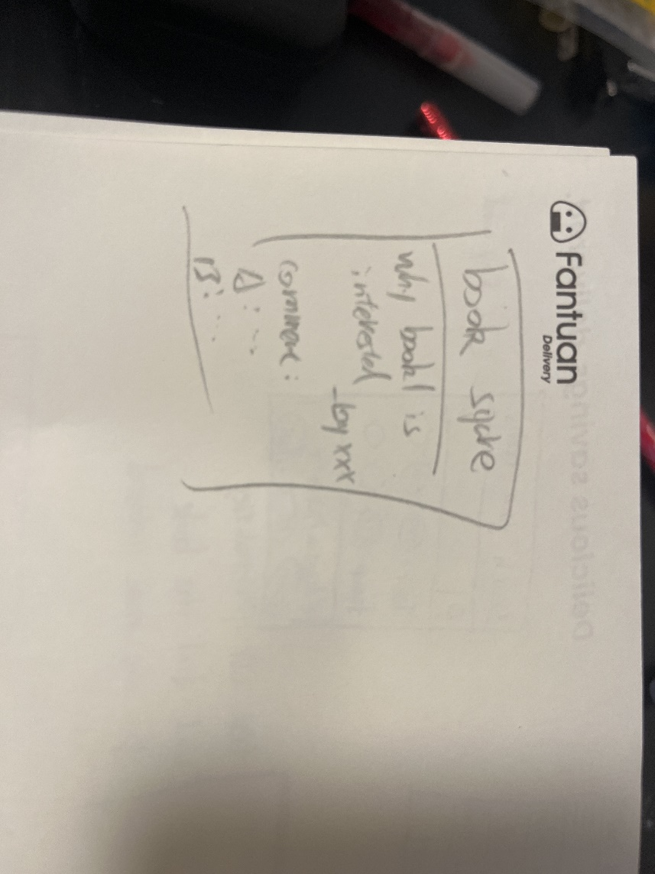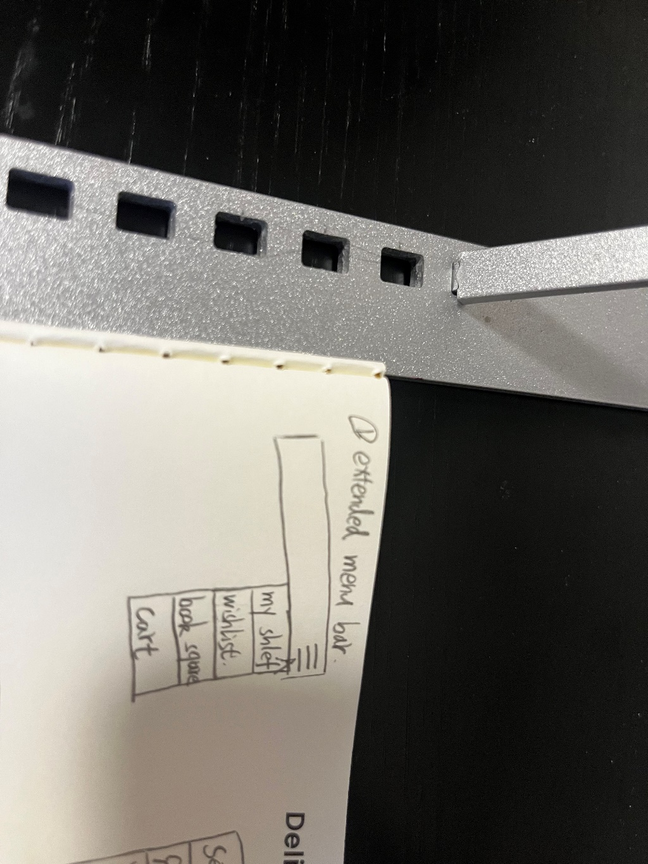

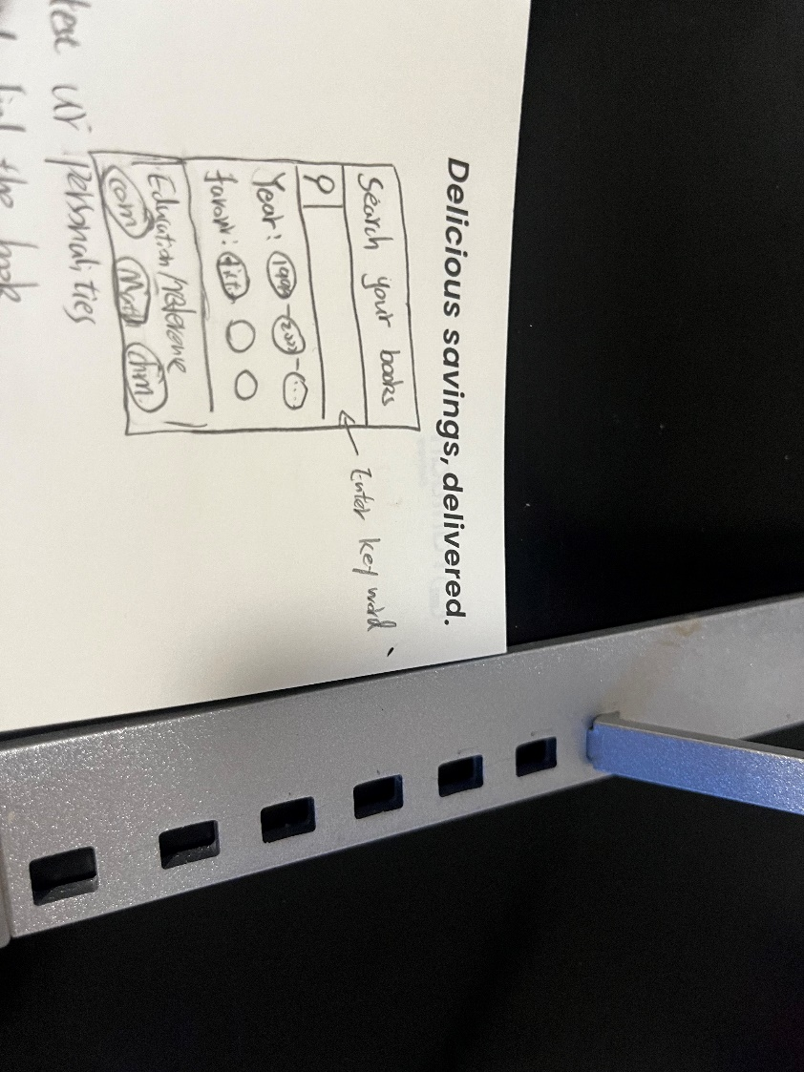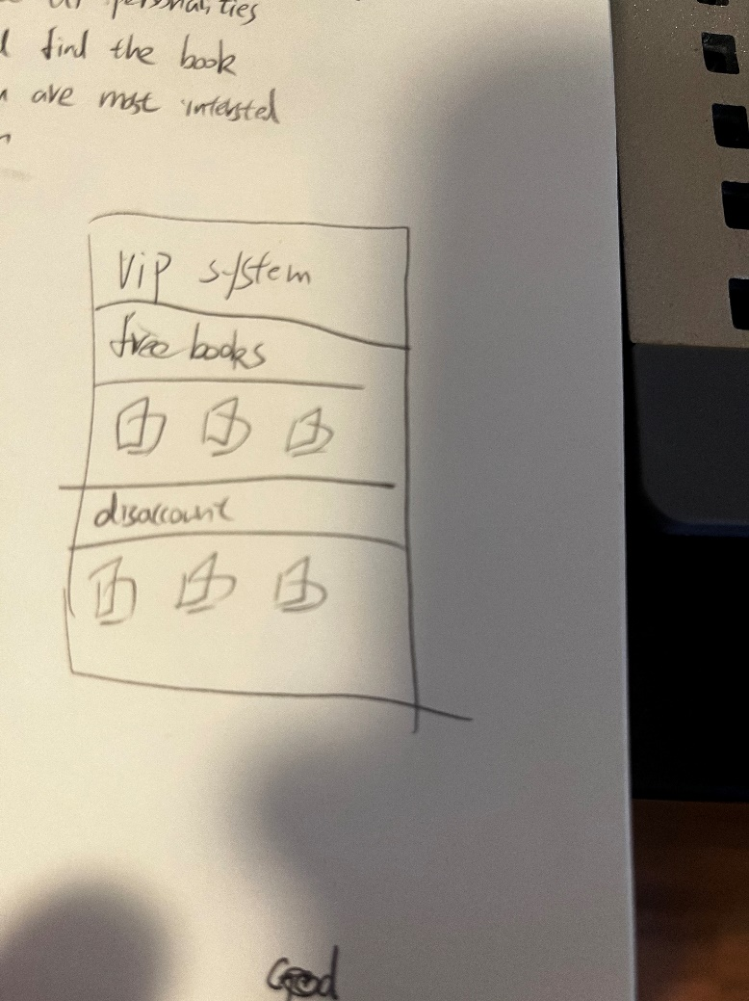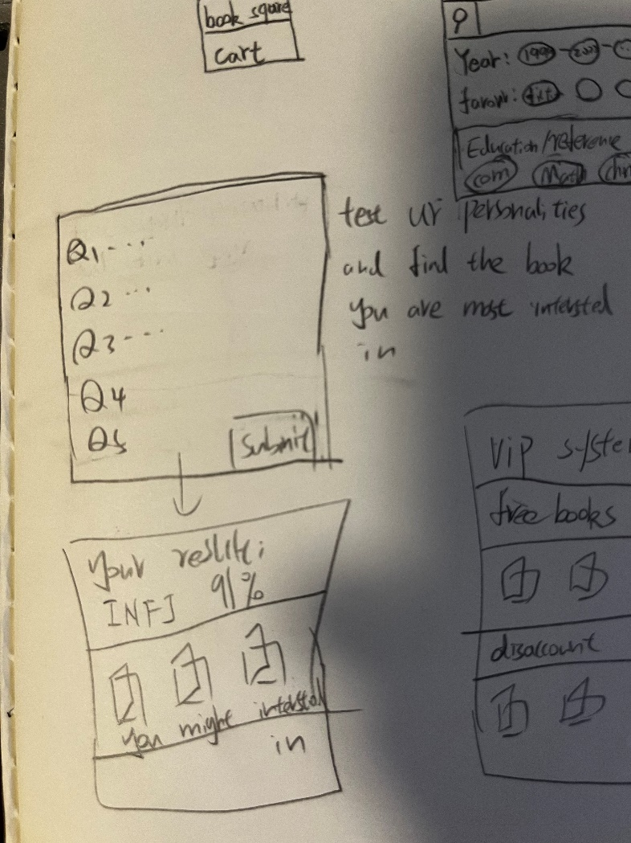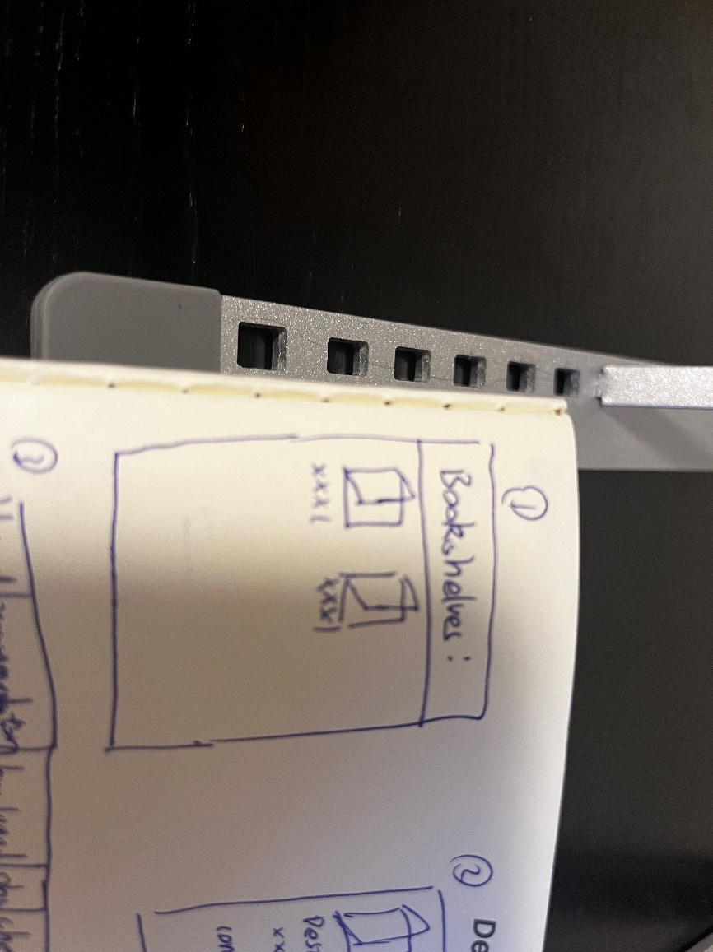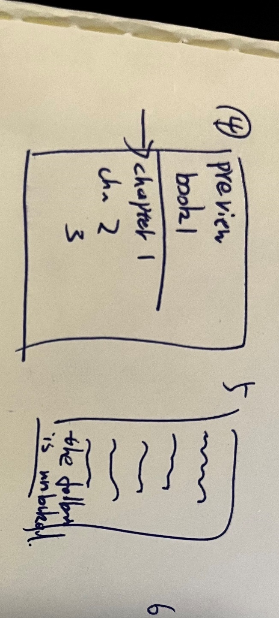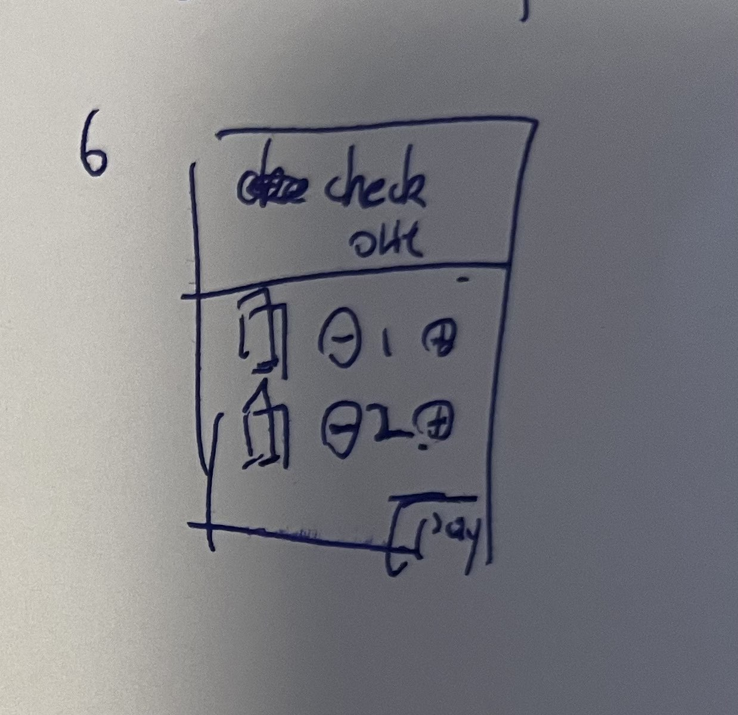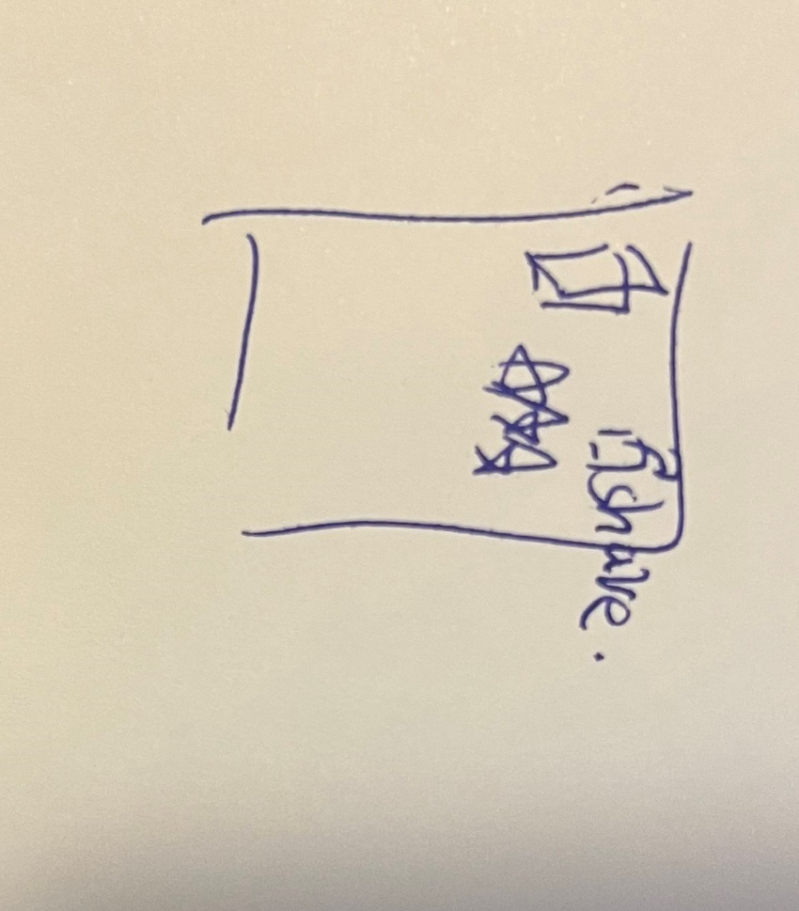

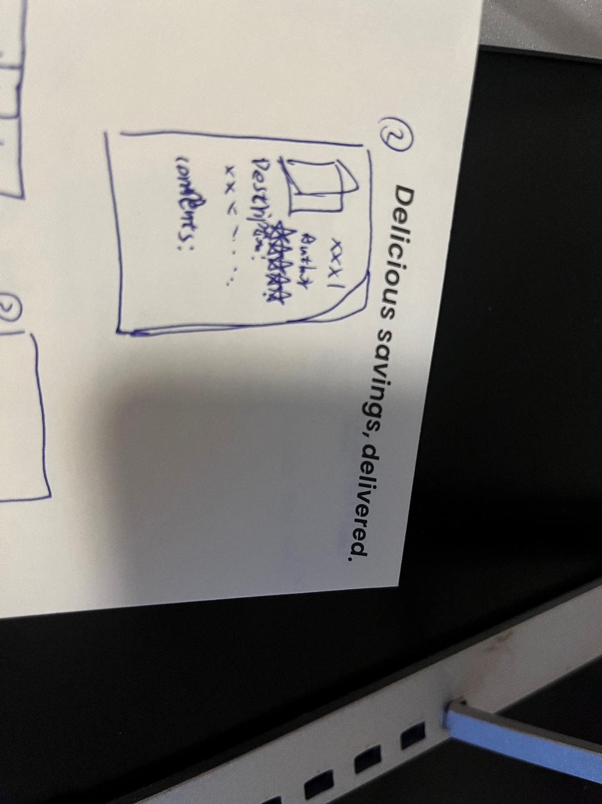

**Nishan:**

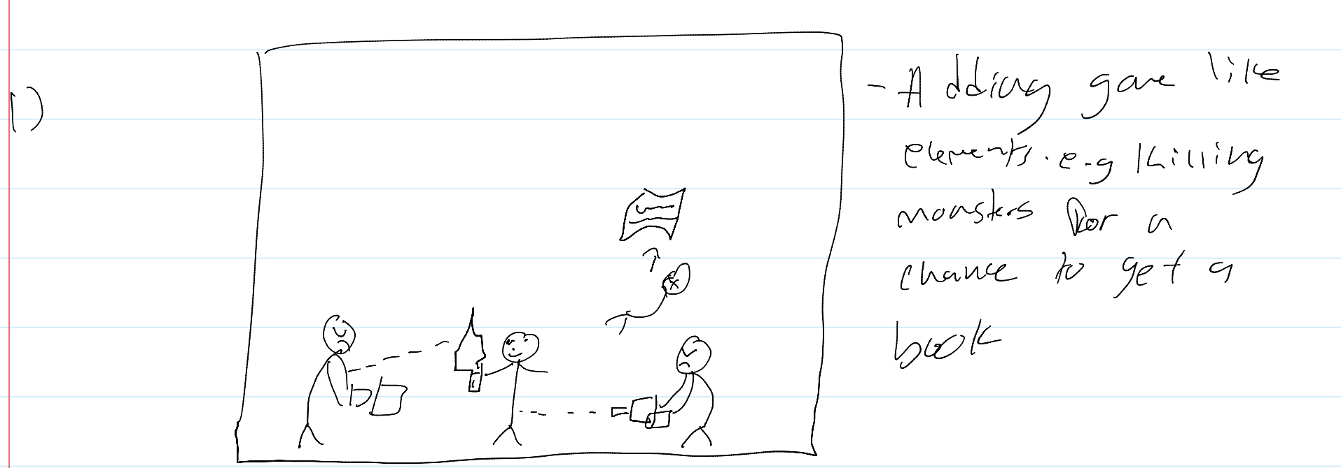

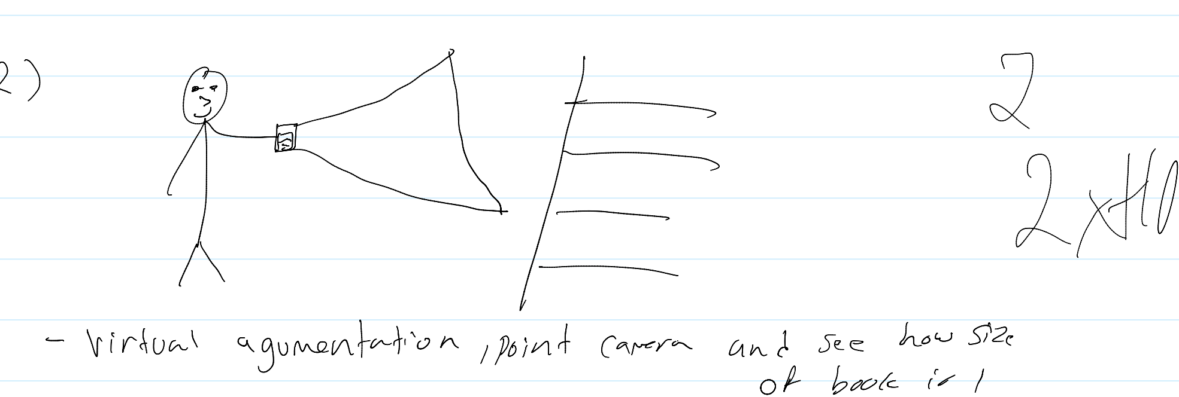

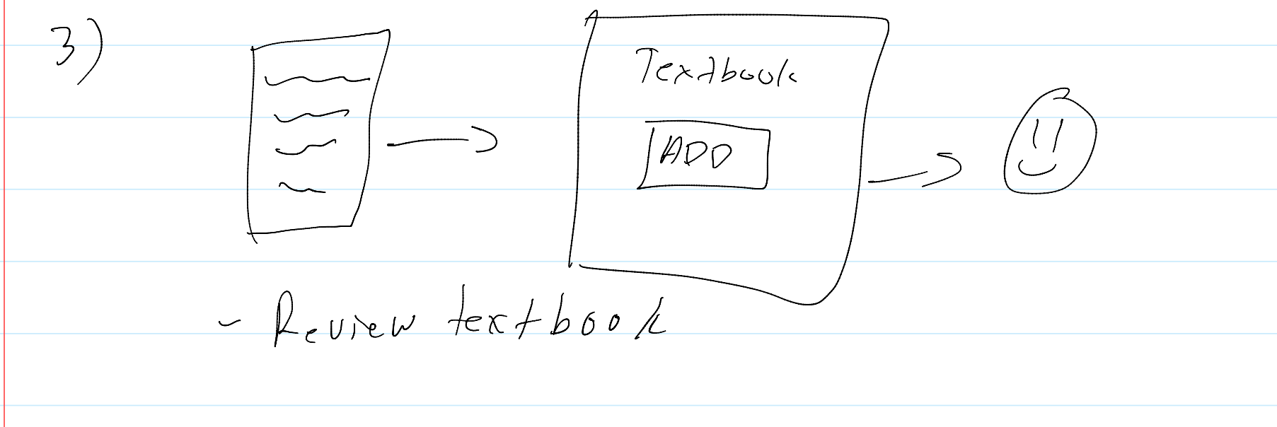

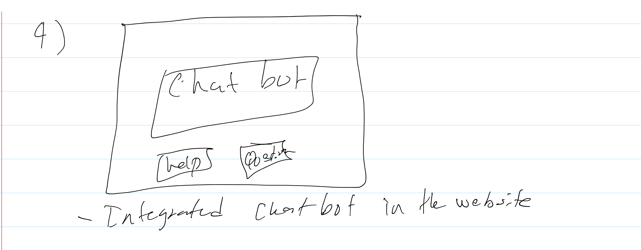

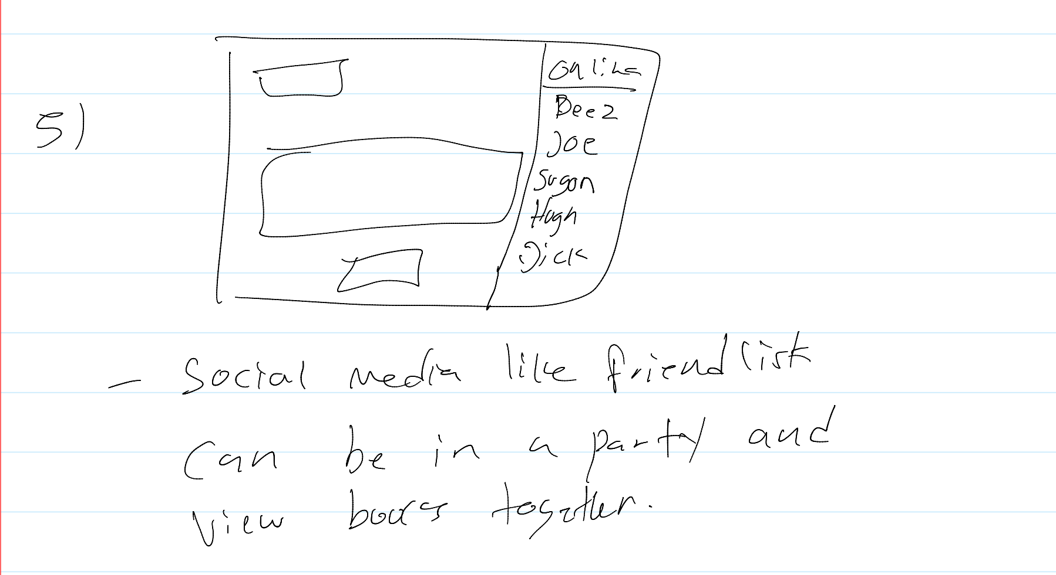

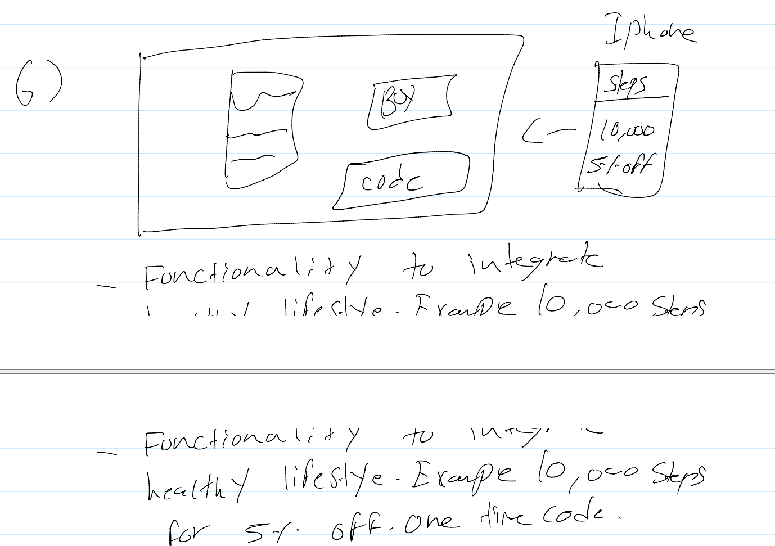

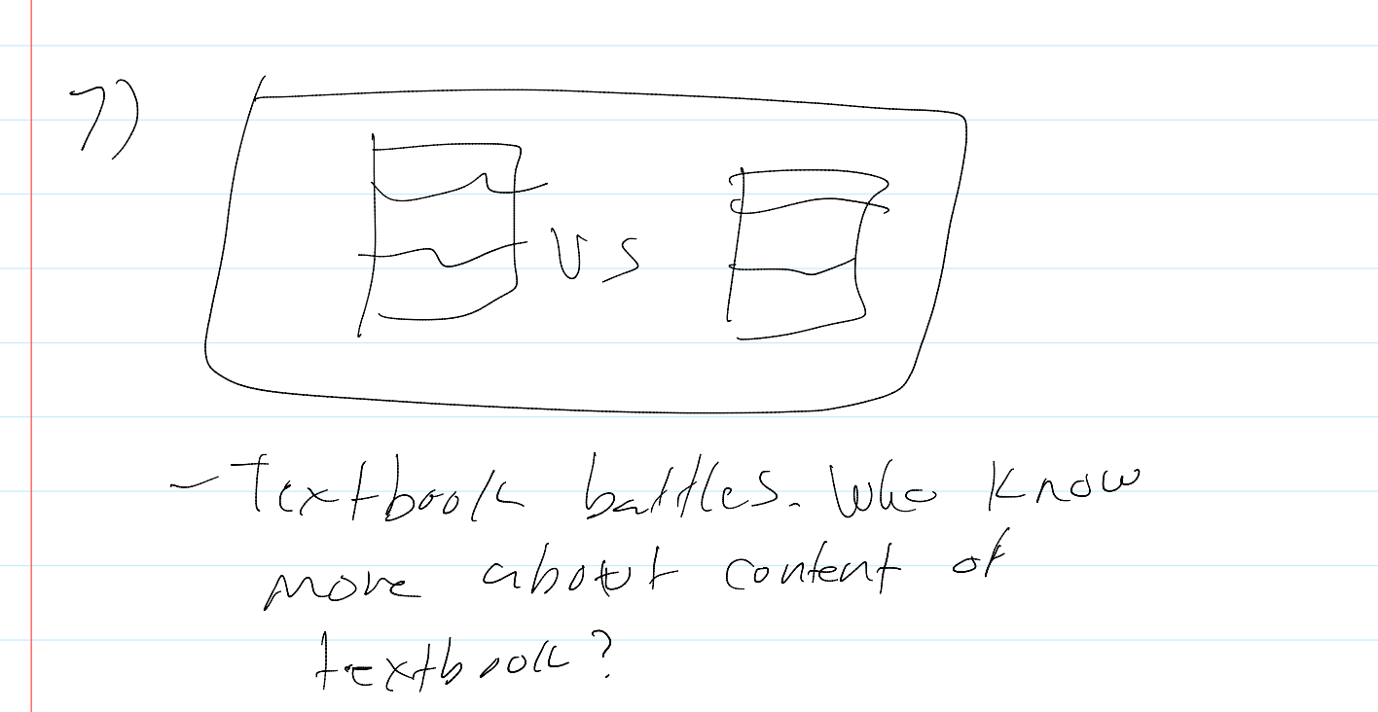 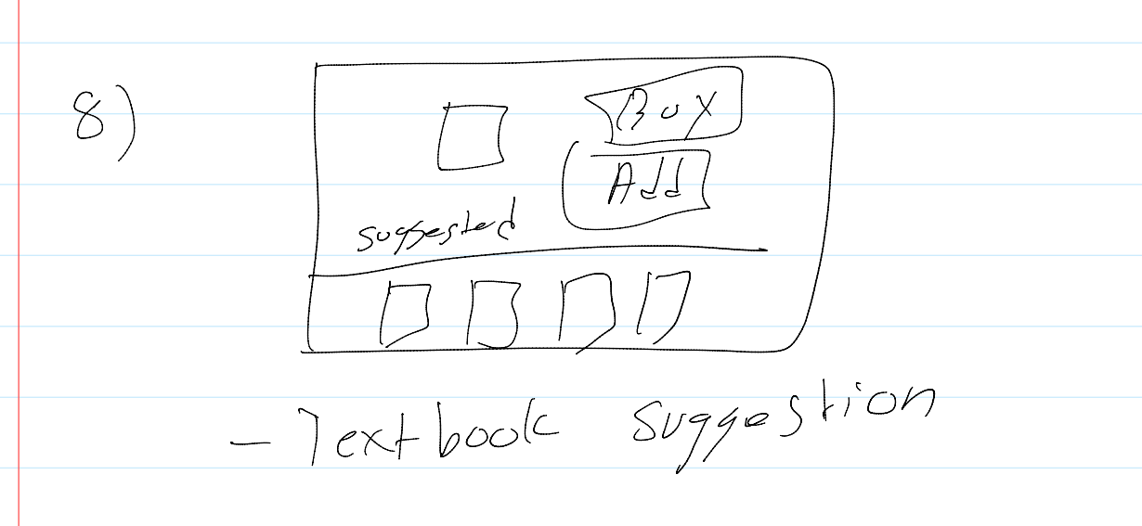 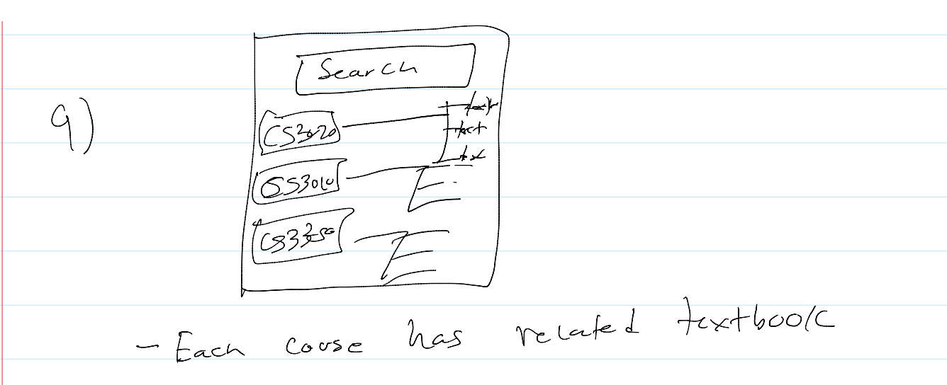 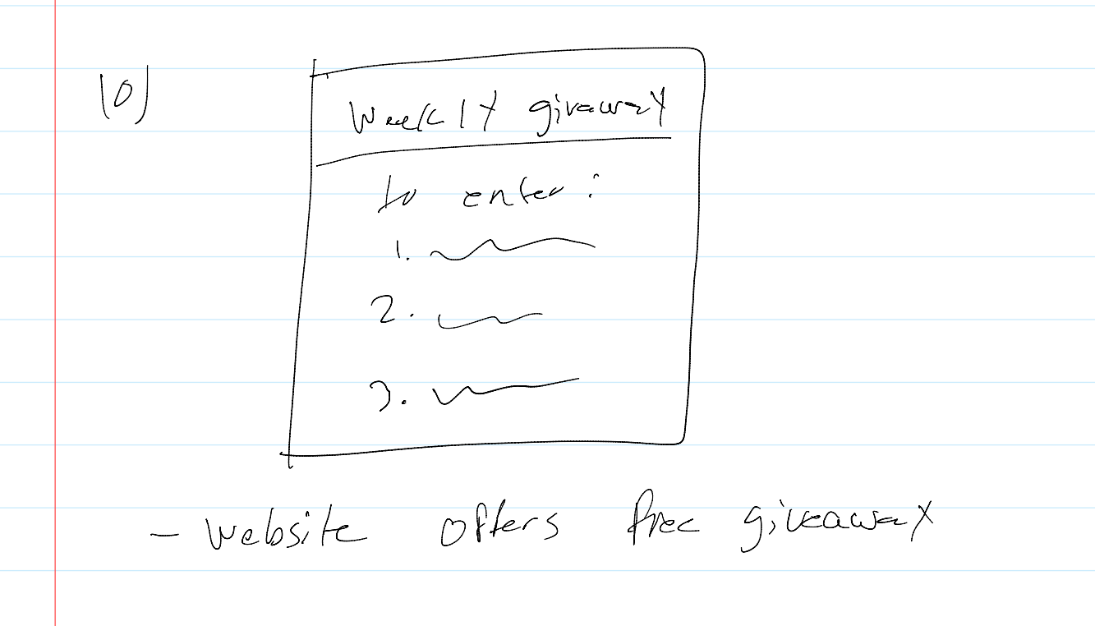

**Jas:**

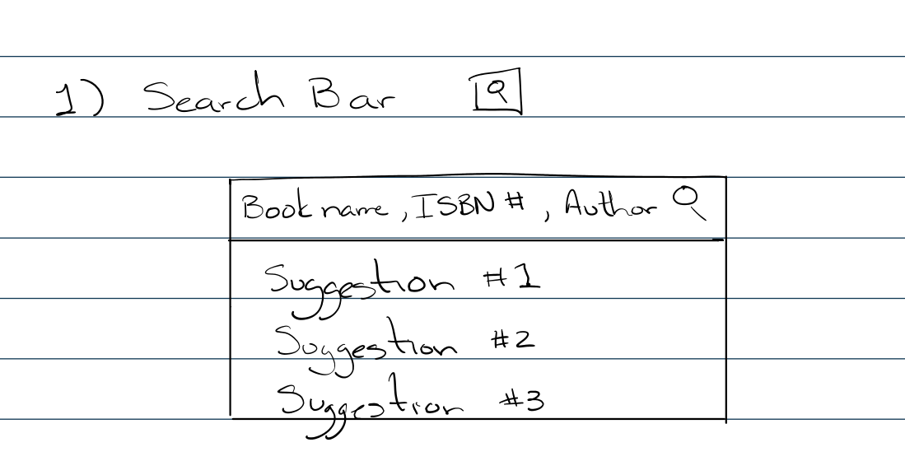 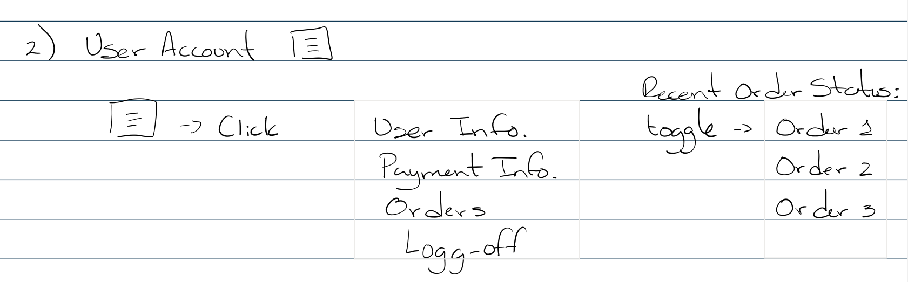

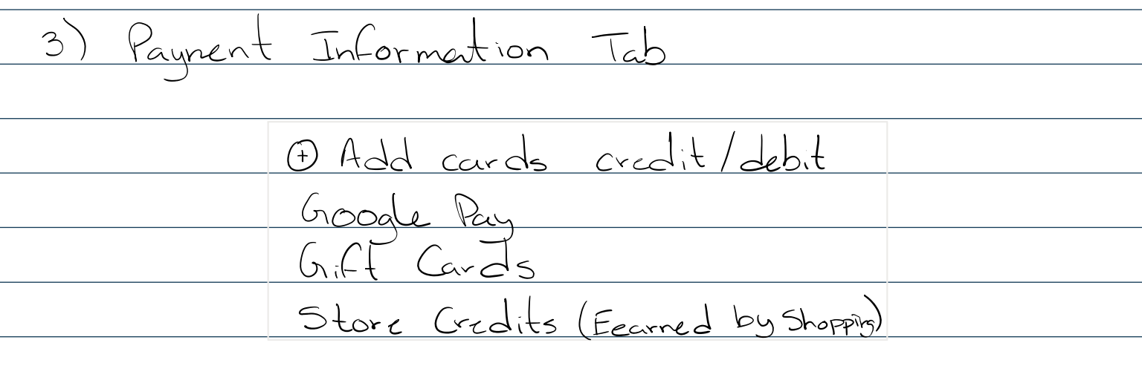

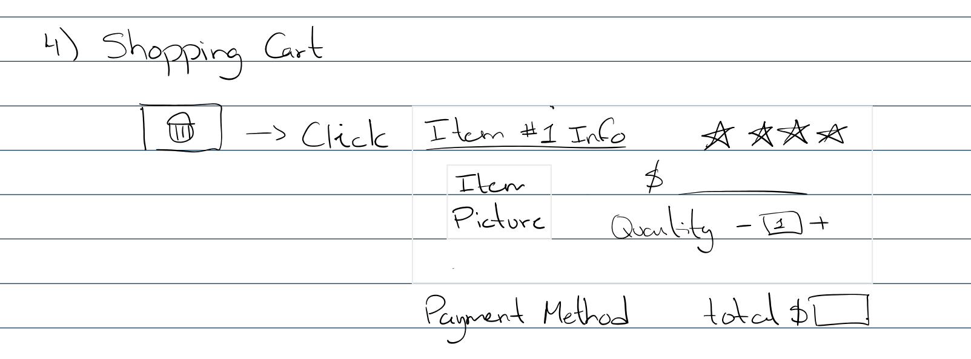

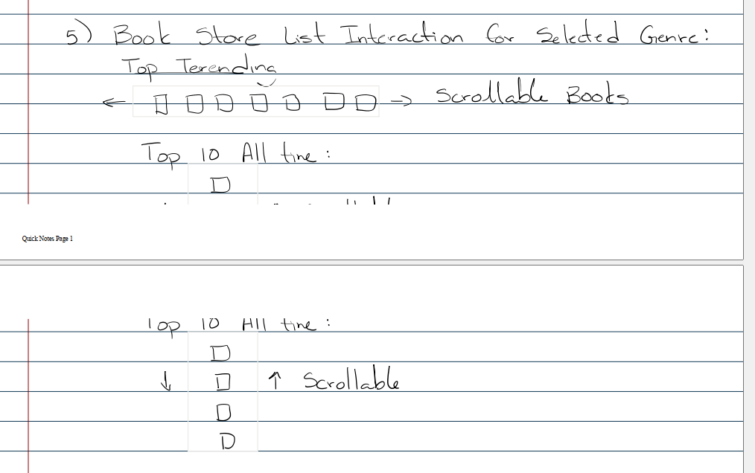

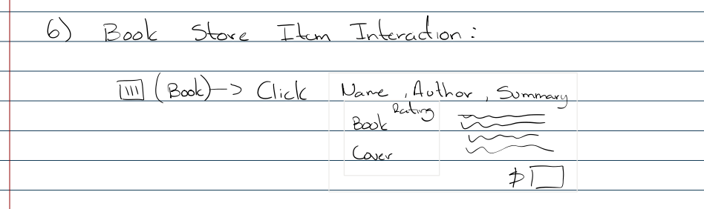

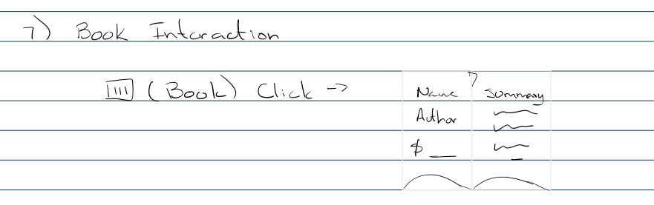

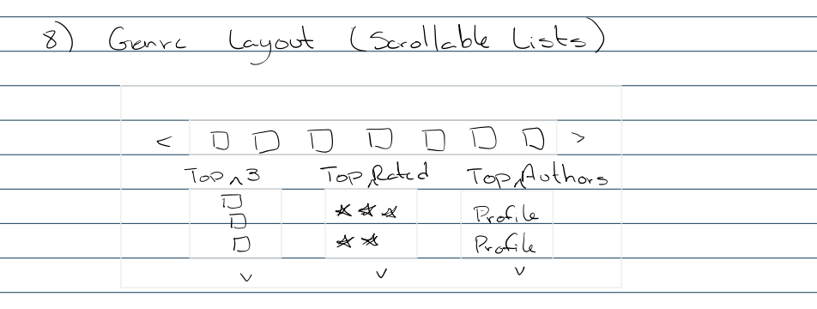

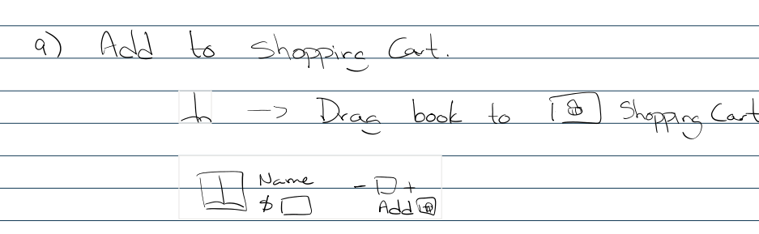

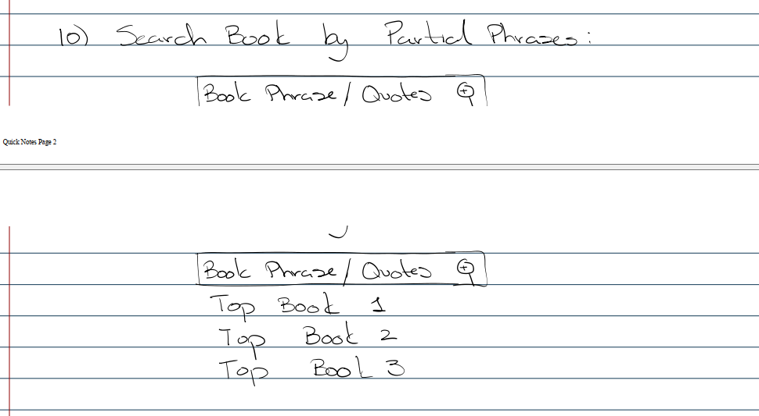

**G.2 Prototype**

**Login**

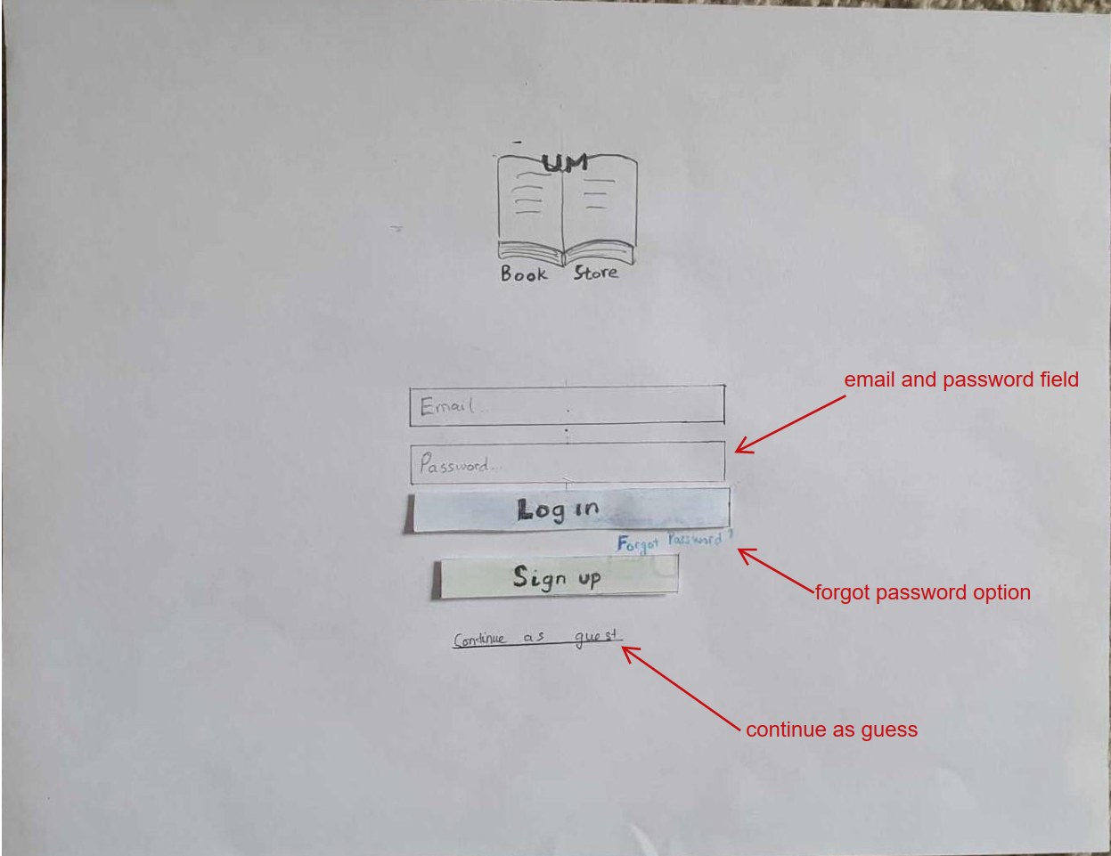

**Sign up:**

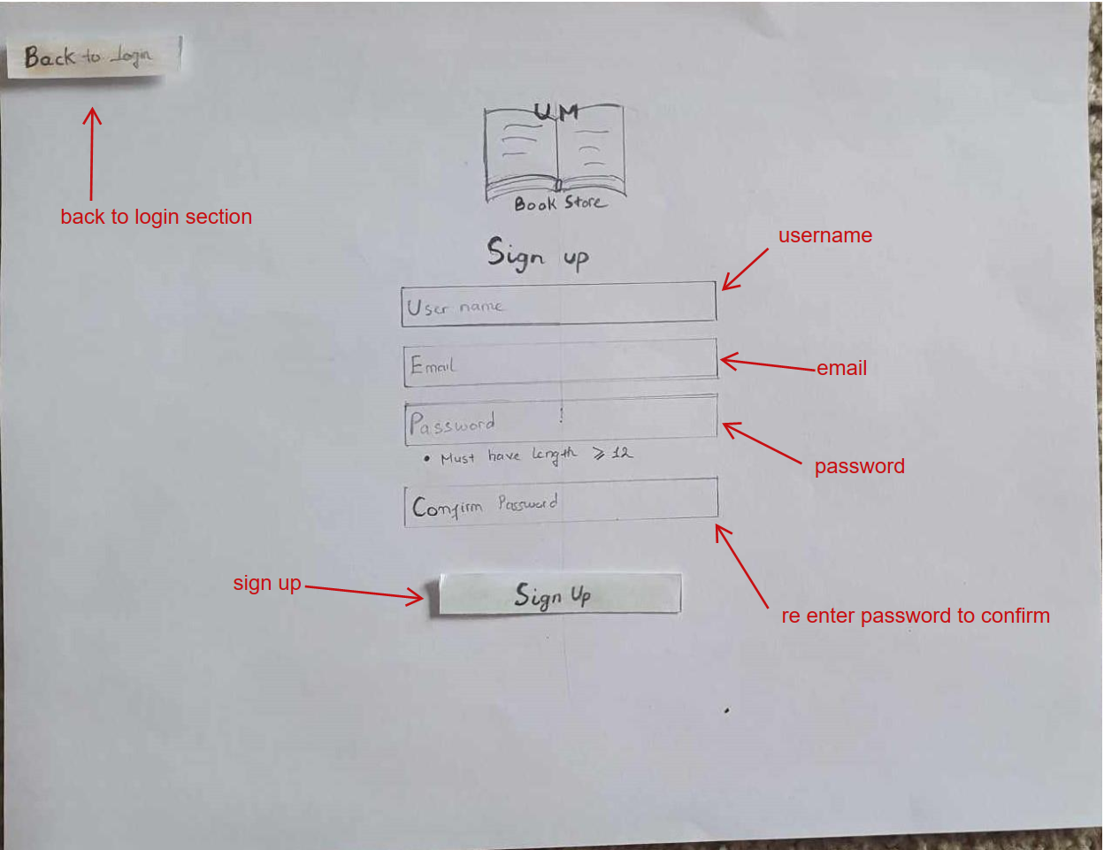

**Sign up Error:**







**Welcome page:**

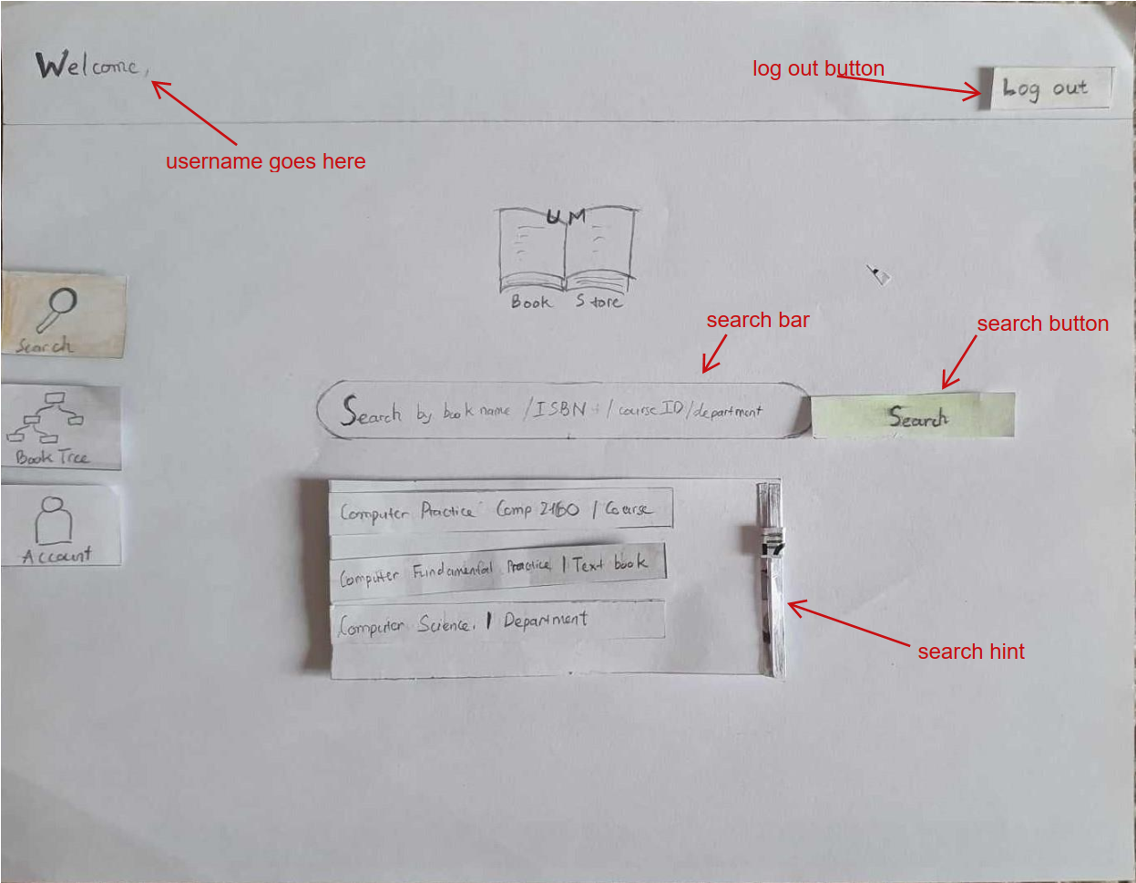

**Check out:**

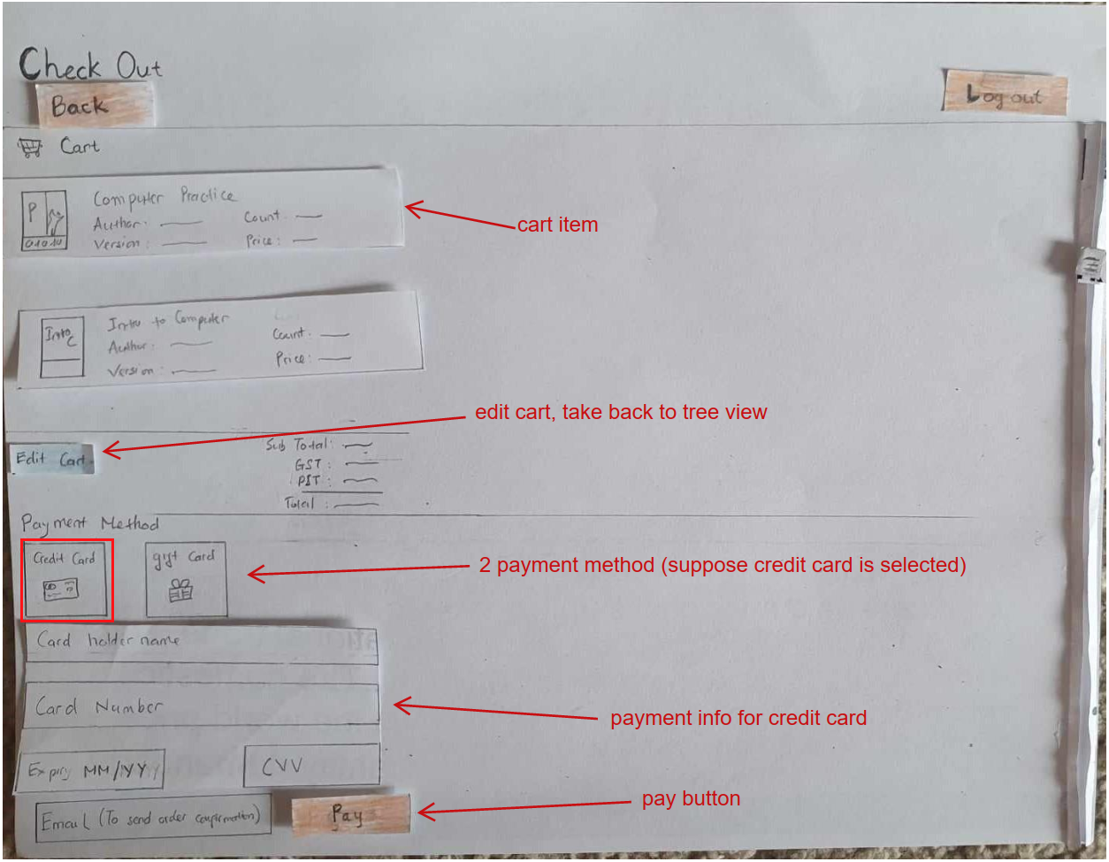

**Check out – Gift Code method:**

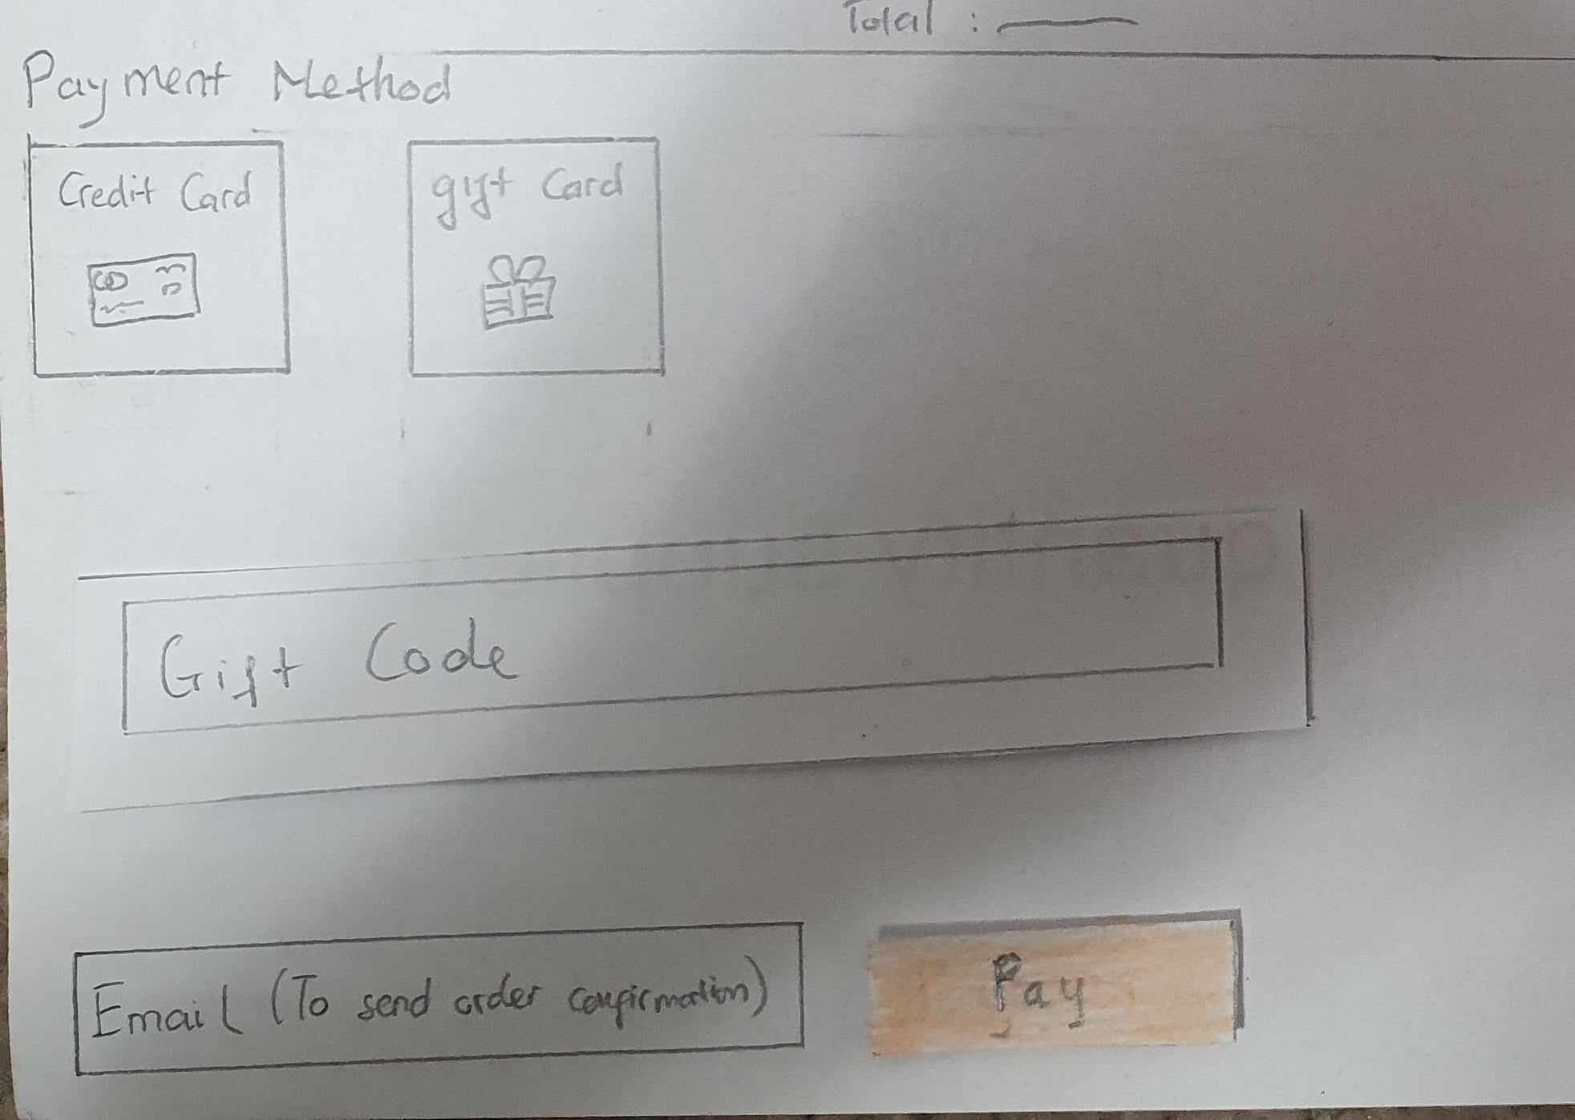

**Check out – Order Confirmation**

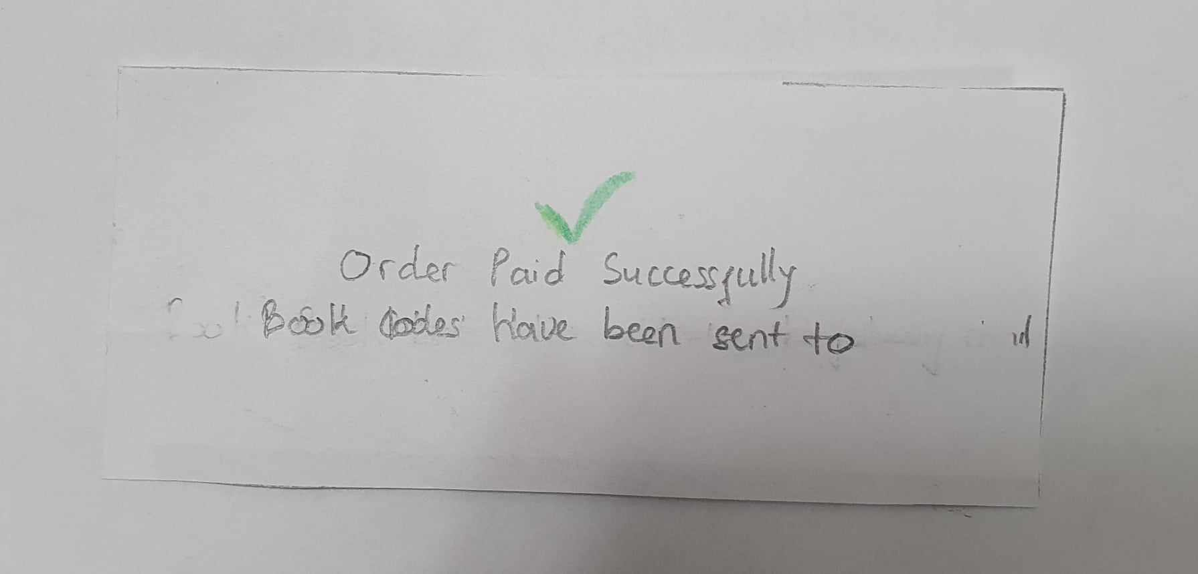

**Account**

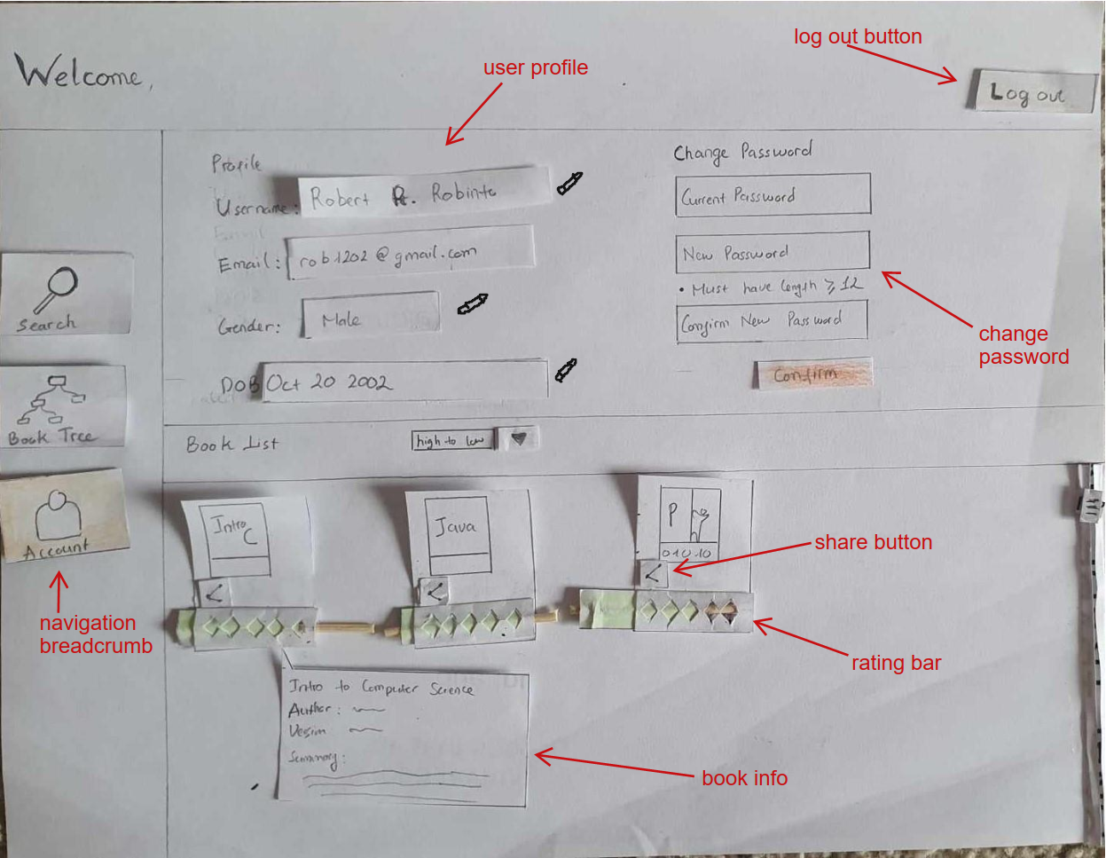

**Book Tree – Basic:**

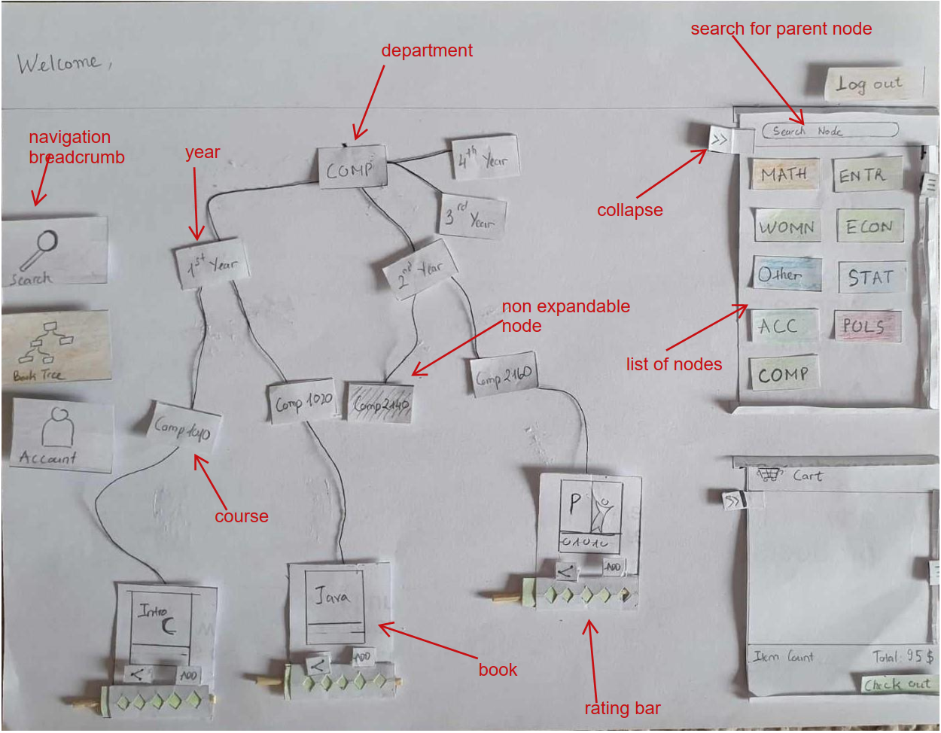

**Book Tree – with book review:**

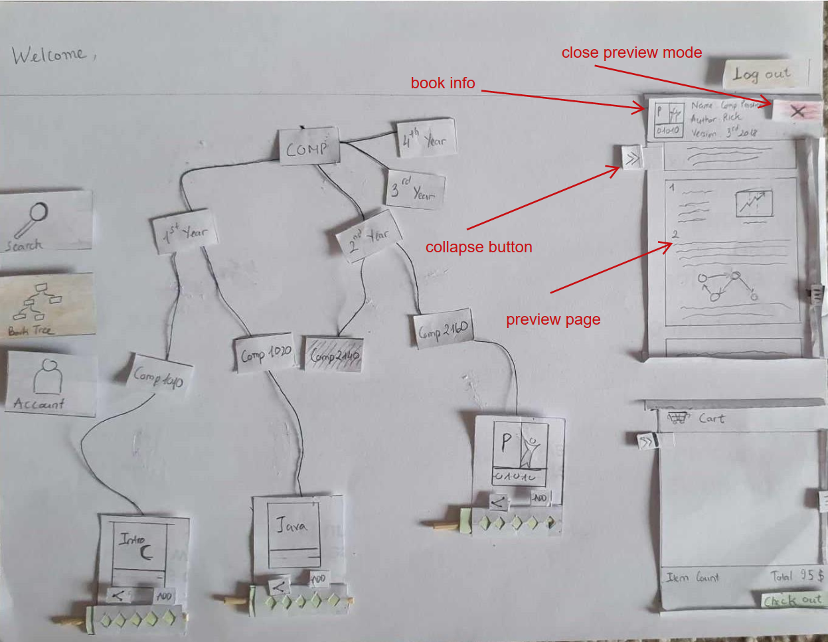

**Book Tree – Share Pop Up**

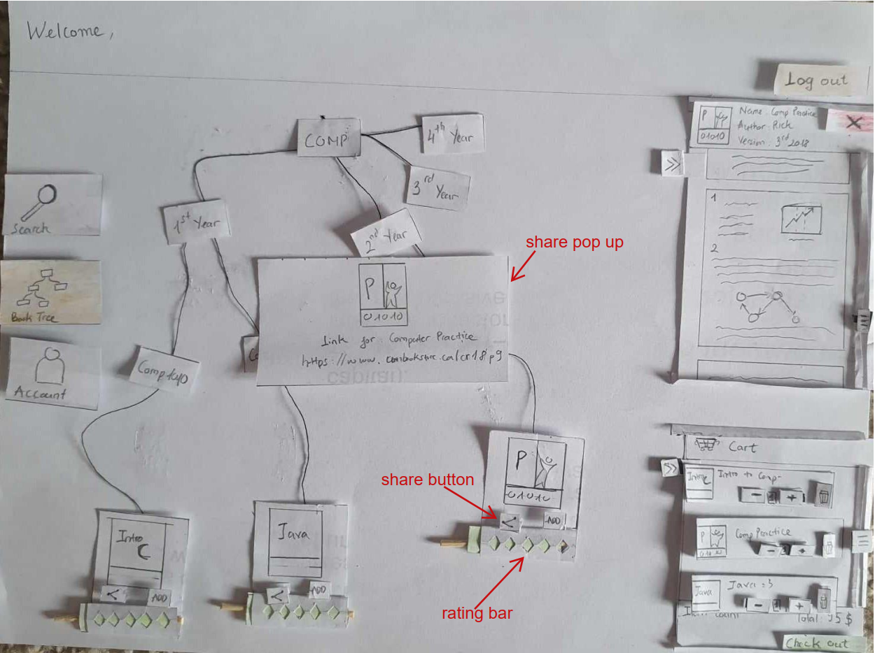

**Book Tree – Add to Cart**

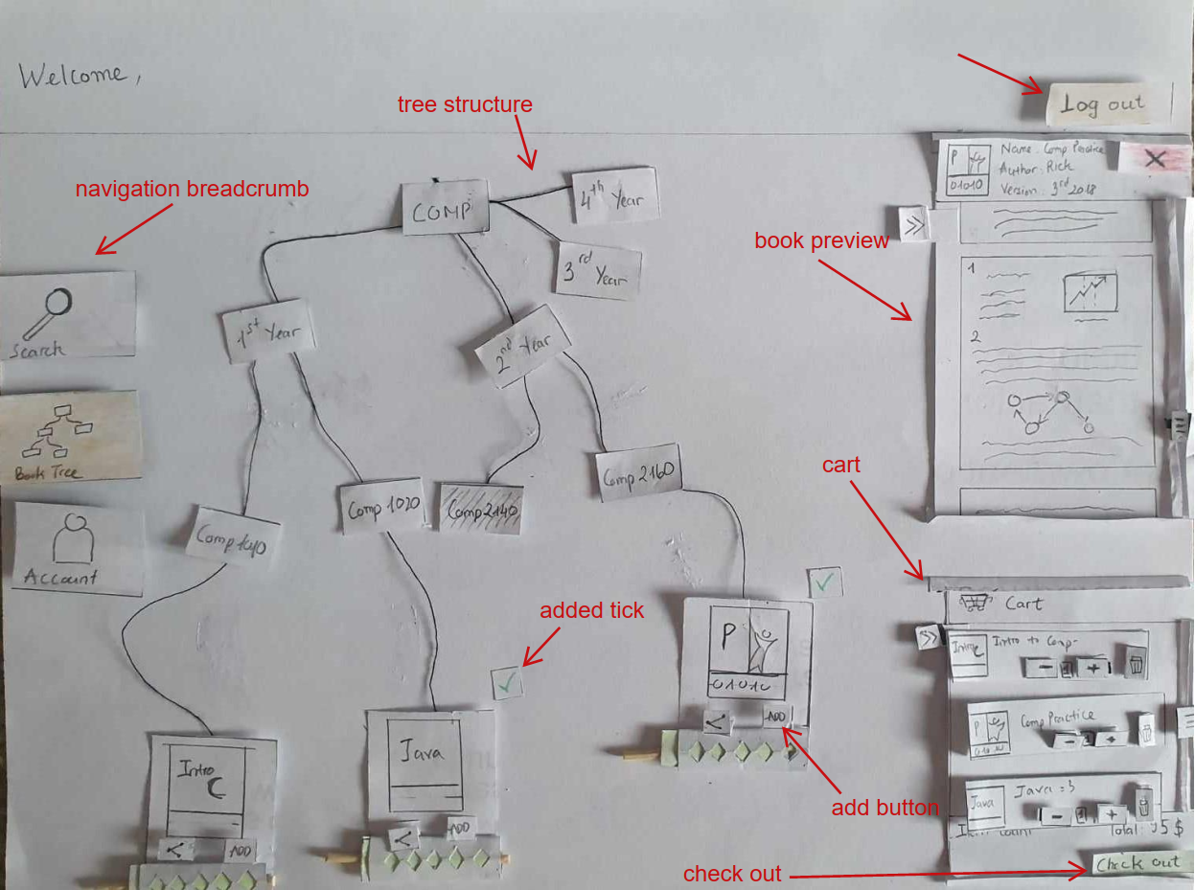

**Cart – Add Item:**

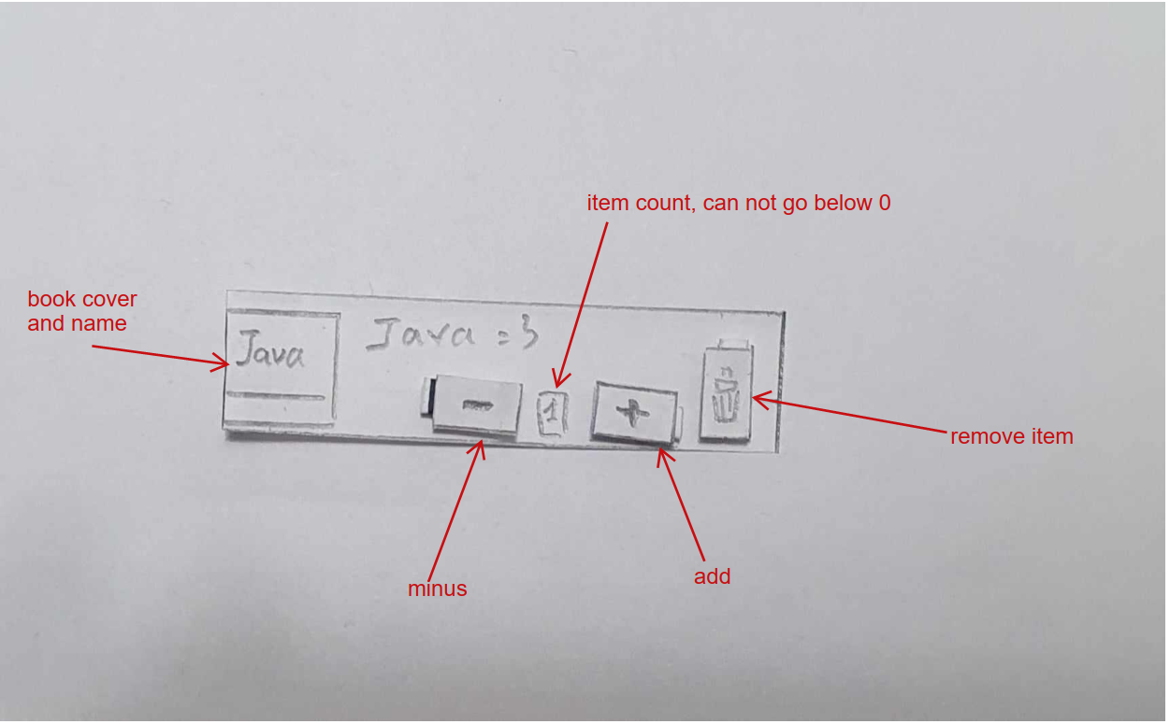

**Book Tree – Minimize Selection:**

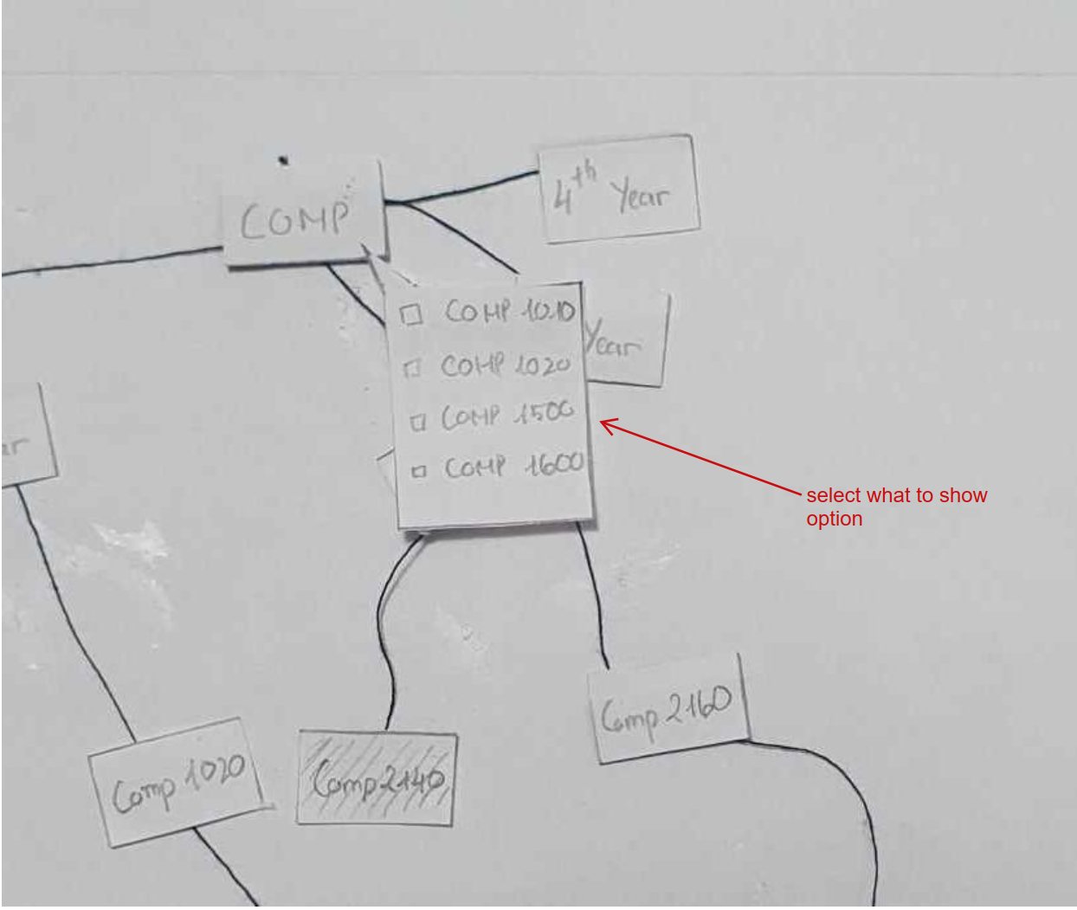

**Account – Filter**

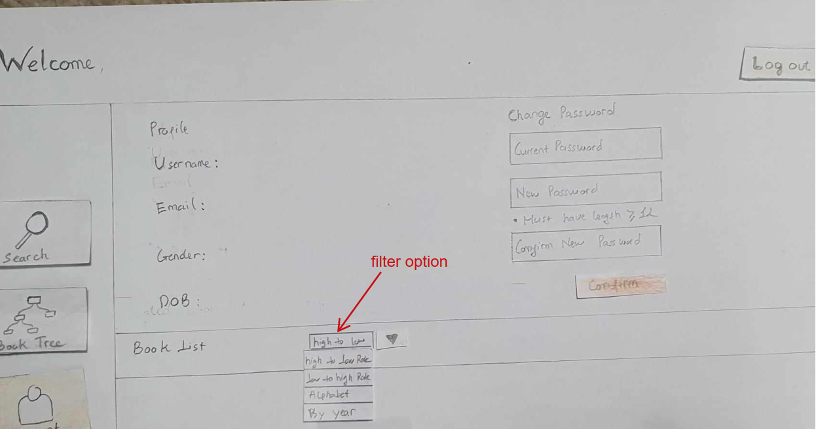

**Account – DOB edit mask:**

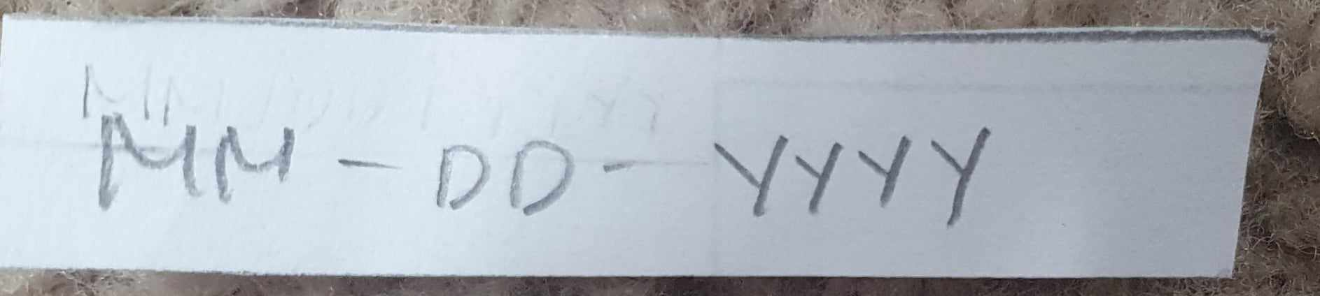

**Account – Gender selection drop down menu**

